Healthy Waterways Strategy 2018

Acknowledgement of Country
The communities, stakeholders and Melbourne Water, who together are responsible for implementing this Healthy Waterways Strategy, acknowledge and respect Traditional Owners and Aboriginal communities and organisations. We recognise the diversity of their cultures and the deep connections they have with the region’s lands and waters.
We value partnerships with them for the health of people and Country.
The communities, stakeholders and Melbourne Water, who together are responsible for implementing this Healthy Waterways Strategy, pay their respects to Elders past and present, and we acknowledge and recognise the primacy of Traditional Owners’ obligations, rights and responsibilities to use and care for their traditional lands and waters.

Contents
Healthy Waterways at a Glance 7
Executive Summary 9
Vision 12
Part A 17
Introduction & Context 17
1. Introduction to the Strategy 17
2. Important concepts and terminology 21
3. Regional overview 29
4. Regional Vision and Waterway Values 37
5. Threats and opportunities to waterway values 45
6. Policy environment 57
Part B 59
Strategy Development 59
7. Collaborative Design (co-design) 60
8. Lessons from the past 64
9. Scientific data, expertise and modelling 66
10. Setting priorities 80
Part C 82
Regional Summary 82
11. Cultural values 82
12. Economic values 84
13. Approaches and responses to region-wide threats
to waterway values 85
Part D 107
Catchment Summaries 107
14. Werribee Catchment region 107
15. Maribyrnong Catchment region
(including Moonee Ponds Creek) 123
16. Yarra Catchment 137
17. Dandenong Catchment region 152
18. Westernport and Mornington Peninsula region 166
Part E 181
Collaborative Implementation 181
19. Co-Delivering the Strategy 181
20. Approaches and concepts for delivery 191
21. Safety 194
22. Adaptive management 196
Glossary 207
Appendices 217
Appendix 1 217
23. Policies, agreements and legislation 217
Appendix 2 223
24. Roles and responsibilities 223
Appendix 3 230
25. Metrics for catchment summaries 230

List of Figures
Figure 1. The five major catchments of the Port Phillip and Westernport region 11
Figure 2. Document library 15
Figure 3. Elements of the waterway system 22
Figure 4. Healthy Waterways Strategy program logic 27
Figure 5. Five major catchments of the Port Phillip and
Westernport region 30
Figure 6. Examples of waterway values across the region 38
Figure 7. Reasons for visiting waterways
(2018 Waterways Perception survey) 39
Figure 8. Predicted tidal inundation areas in the Port Phillip
and Westernport region by 2100 49
Figure 9. Stormwater flow in natural and urban environments 51
Figure 10. Predicted river health by 2070
(based on changes in the number of
macroinvertebrate families compared to current) 52
Figure 11. Developing this Strategy 60
Figure 12. Alignment of collective knowledge and science
produced the targets and performance objectives 61
Figure 13. Habitat Suitability modelling process 69
Figure 14. Process for developing actions and targets for
key values – macroinvertebrates, fish and platypus 70
Figure 15. Conceptual model - social values 72
Figure 16. Data and decision support tools for the three
social key values 77
Figure 17. Priority areas for enhanced stormwater management 90
Figure 18. Schematic of a fresh water constructed wetland 96
Figure 19. Artist’s impression of the Arnolds Creek Project
in Melton West, provided by REALM Studios 99
Figure 20. Sub-catchments and waterway assets including
a sub-set of wetlands in the Werribee
catchment region 110
Figure 21. Summary of priorities in the Werribee
catchment region 122
Figure 22. Sub-catchments and waterway assets including
a sub-set of wetlands in the Maribyrnong catchment
region (including Moonee Ponds Creek) 124
Figure 23. Summary of priorities in the Maribyrnong
catchment region 136
Figure 24. Sub-catchments and waterway assets including
a sub-set of wetlands in the Yarra catchment 138
Figure 25. Summary of priorities in the Yarra catchment 150

Figure 26. Sub-catchments and waterway assets including
a sub-set of wetlands in the Dandenong
catchment region 153
Figure 27. Summary of priorities in the Dandenong
catchment region 165
Figure 28. Sub-catchments and waterway assets including
a sub-set of wetlands in the Westernport and
Mornington Peninsula region 168
Figure 29. Summary of priorities in the Westernport and
Mornington Peninsula region 180
Figure 30. Funding waterways, flood and drainage services
over a five year period 183
Figure 31. Collaborative Governance Model 184
Figure 32. Participant evaluation of their contribution 189
Figure 33. Bolin Bolin frog census 191
Figure 34. The adaptive management cycle 197

Healthy Waterways at a Glance
This Healthy Waterways Strategy provides a single framework for addressing community expectations and the obligations for waterway management, as outlined in relevant State, national and international legislation, policy and agreements. It builds on a long-term regional vision for waterway health.
For each of the five major catchments within the Port Phillip and Westernport region (Werribee, Maribyrnong, Yarra, Dandenong and Westernport), this Strategy provides detailed, catchment-specific visions, goals, long-term targets (10 to 50 years), and 10-year performance objectives. Effort and investment at catchment and sub-catchment levels are prioritised and aligned to ensure they contribute to broader, regional goals and outcomes.

Research
Targets the knowledge gaps and monitoring needs that will help to achieve better waterway outcomes. Provides the basis of understanding of current and changing environmental challenges and waterway conditions. Improves the understanding of issues, such as key sources of litter and essential requirements for the maintenance of groundwater dependent wetlands.

Environmental-economics
Applies new international environmental-economic standards to demonstrate the economic value of waterways and to understand the return on investment for efforts in waterway management.

On-Ground Activity
Aligns the efforts in the catchments by a diverse range of individuals and organisations to the waterway priorities that will provide the best outcomes and incrementally work towards achieving the community’s catchment vision. Includes revegetation for an additional 1888 kilometres of canopy cover alongside waterways.

Capacity Building
Encourages organisations and individuals to contribute to a knowledge collective, sharing resources, capability and skill. Allows waterway partners to leverage the efforts of others and achieve greater collective outcomes for waterways and aligns efforts to the agreed waterway priorities in each catchment. Increases the capacity of Traditional Owners to participate in waterway management across the region.

Government Policy
Identifies the need for improvements in land use planning mechanisms to enable a greater capacity to manage and re-use stormwater across the catchments, and to protect the headwaters of catchments from inappropriate use or development. Re-use of an additional 83GL per year of stormwater for environmental, cultural, economic and social purposes, and an additional 23 gigalitre per year infiltration achieved.

Collaborative Implementation
Establishes a region-wide leadership group, a waterways lab, and regular catchment implementation forums to bring together the people and organisations working for waterways. Develops a monitoring and reporting framework to track the progress of the Strategy against goals and vision.

Executive Summary
This Healthy Waterways Strategy is a celebration of the catchments and community of the Port Phillip and Westernport region. It is founded on collaboration between waterway managers, scientific teams, communities, Traditional Owners, interest groups and government agencies.
Greater Melbourne is a modern city formed around ancient waterways and bays. Fed by rain and groundwater, a complex network of waterways links the hills and mountains in the upper reaches of the catchments, through rural properties and townships, rivers, wetlands and estuaries, to the expansive waters of the bays and oceans. The health of waterways, and the vegetation and wildlife they support, underpins the region’s amenity, biodiversity and economy.
Current and future challenges to waterway health are widely recognised across communities and in government policy. Extreme challenges such as climate change, increasing urbanisation, pollution and rapid population growth have been incorporated into the research and deliberations for this Healthy Waterways Strategy. Community, stakeholders and scientists are telling us that the region’s waterways are at a tipping point. Continue as we are, and we risk noticeable and significant decline in waterway condition across the region, threatening the significant economic, social, cultural and environmental values our waterways provide.
This Strategy demonstrates that measured, cooperative and targeted investment is both necessary and possible, and will prevent a widespread decline in waterway health in the face of these external challenges. Working collectively through this Strategy to protect and unlock the significant natural capital of the region’s waterways will enhance the long-term health, amenity and lifestyle of the Port Phillip and Westernport region, and provide resilience in the face of rapid change.
Through a collaborative design process, the community and government agencies have deliberated together on the priorities and preferred approaches for waterway management. Research and scientific modelling have identified the current condition and environmental and social values of individual waterways across the region. They have explored the impacts of climate change and human activity on waterway conditions over the next 50 years, and have tested management options against desired outcomes. Emerging from this synthesis of scientific and stakeholder knowledge is a comprehensive framework for each of the five major catchments (Werribee, Maribyrnong, Yarra, Dandenong and Westernport) that provides catchment-specific visions, goals, long-term targets (10 to 50 years), and 10-year performance objectives. These nested and aligned objectives and targets will all contribute to the best waterway outcomes for effort and investment across the region.
This Strategy builds on the previous Healthy Waterways Strategy and Stormwater Strategy (2013-2018), supports government policy and programs, and is invigorated by a wide range of on-ground management activity already being conducted by both community and government agencies.
This is a shared strategy across Melbourne Water, state and local government, water corporations and the community. Collaborative partners have voiced their desire to achieve long-term protection and enhancement of the region’s waterways and have committed to doing this together. Melbourne Water will have the lead role in facilitating co-delivery with all partners.

Five major catchments
The region’s waterways form a complex network of interconnected and interdependent rivers, wetlands and estuaries, which collectively gather rainwater, stormwater and groundwater from the landscape (the catchments), ultimately carrying this water to the bays and ocean. The region has a total area of almost 13,000 square kilometres, and is divided into five major catchments, each comprising numerous sub-catchments, and featuring varying physical, environmental and socio-economic characteristics and conditions.
Melbourne’s major catchments are illustrated in Figure 1 below:

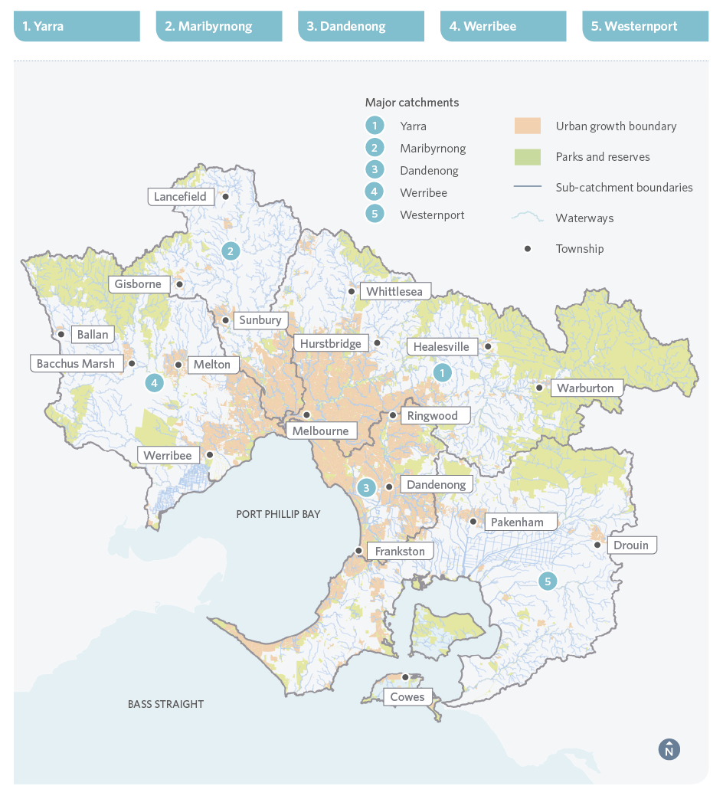
Figure 1. The five major catchments of the Port Phillip and Westernport region

Vision
The Healthy Waterways Strategy is driven by a single regional 50-year vision, which was adopted from the previous (2013) Healthy Waterways Strategy:
Healthy and valued waterways are integrated with the broader landscape, and enhance life and liveability. Waterways connect diverse and thriving communities of plants and animals; provide amenity to urban and rural areas, and engage communities with their environment; and are managed sustainably to enhance environmental, economic, social and cultural values.
Acknowledging the complexity and diversity of the region’s waterways, communities and pressures, collaborative partners have created their own shared vision and goals for each of the five catchments. The Healthy Waterways Strategy vision for the Yarra Catchment builds on the Yarra River 50-year Community Vision developed as part of the Yarra Strategic Plan in early 2018. Both Yarra visions are presented below.
Using scientific knowledge and lived experiences, collaborative partners then created a set of performance objectives that drive the 10-year Co-Designed Catchment Programs, which in turn contribute to the aims of the overarching Strategy over a 50-year horizon.
The catchment vision statements are as follows:
Werribee | The Werribee catchment community values, enjoys and actively participates in managing the health, connectivity and resilience of our rivers, estuaries and wetlands.
Maribyrnong | A Maribyrnong catchment whose ecological health has significantly improved since 2018. It is accessible, used and valued by the community. Its collaborative management reflects the contributions of Traditional Owners and the broader community.
Yarra | Yarra River 50-year Community Vision:  Our Yarra River, Birrarung, is recognised around the world as an iconic example of a nurturing relationship between a river and its community.  Flowing from source to sea, it is the resilient lifeblood of past, present and future generations of Victorians. It connects and enriches our flourishing city, suburbs, regions and beyond.  Our Yarra River, Birrarung, its essential role in our lives and its rich history are respected, understood and protected. It has cared for us for thousands of years and will for thousands to come.  The vital and continued role of Traditional Owners as custodians of the River, and its role in their culture, is recognised and celebrated.  Our Yarra River, Birrarung, and its diverse surrounding landscapes provide a place of refuge, recreation, learning and livelihood. It brings communities together and supports sustainable local economies.  Its clean waters and connected network of thriving green spaces nurture biodiversity, and deepen the relationship between people and nature.  Our Yarra River, Birrarung, is respected as a sacred natural living entity and everyone takes responsibility for its care. Its health and integrity are paramount and uncompromised. What is good for the Yarra is good for all.  This Healthy Waterways Strategy has interpreted the Yarra River 50-year Community Vision to mean:  Our Yarra catchment waterways are increasingly protected, respected and collaboratively cared for by Traditional Owners, government and community as living and highly valued entities. They are a linked network of thriving corridor and in stream spaces that nurture biodiversity, deepen the relationship between people and nature, build resilience as our population grows and the climate changes, and contribute to wellbeing and liveability. Their ecological health and value to the community continuously improve through rehabilitated waterways and balanced uses.
Dandenong | A vibrant, valued Dandenong catchment waterway and wetland network, whose ecological health and liveability attributes continue to improve through rehabilitated waterways and connected and secured biodiversity corridors.
Westernport | Waterways and our bays are highly valued and sustained by an informed and engaged community working together to protect and improve their value.

Navigating the Healthy Waterways Strategy
The Strategy Parts A to E are fixed for the life of the Strategy. The supporting Co-Designed Catchment Programs are open to updates over the 10-year life of the Strategy.
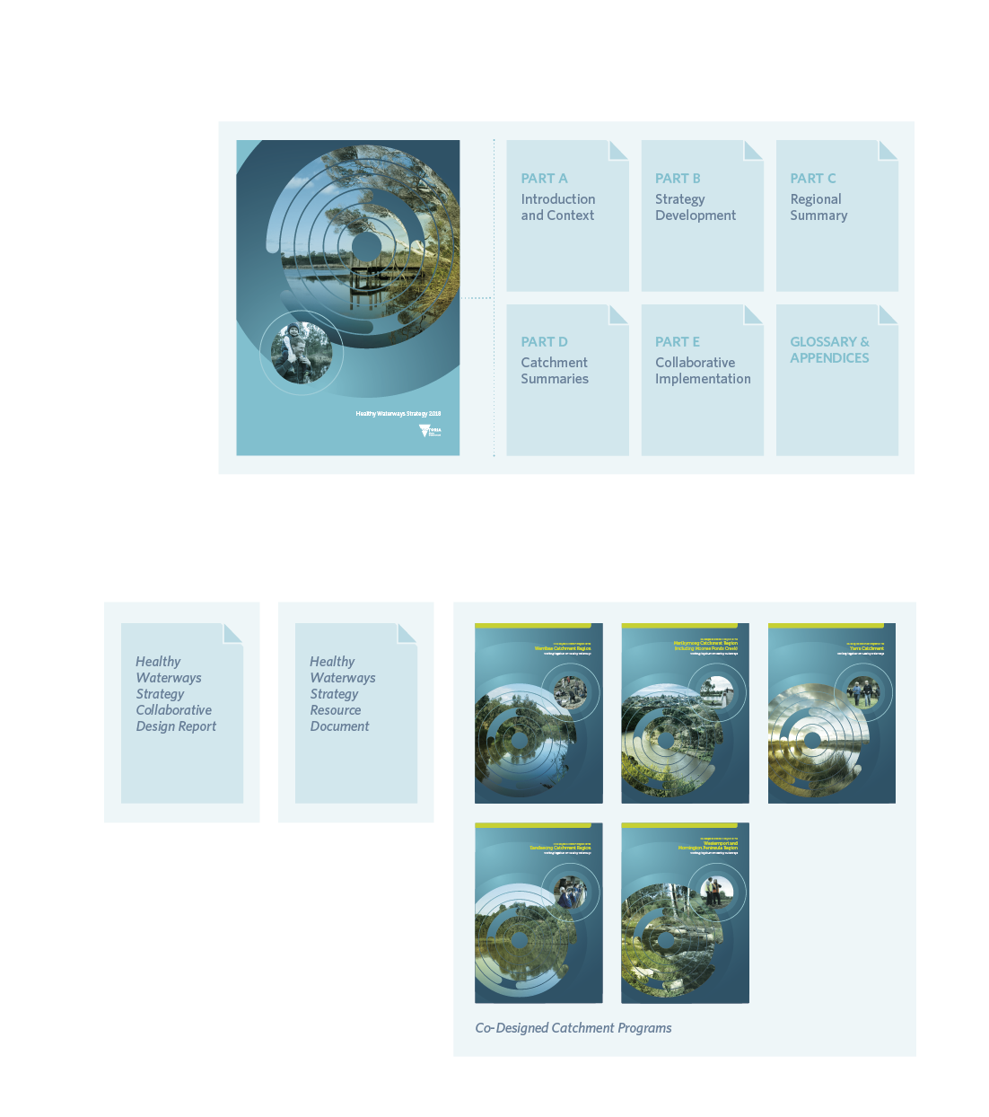
Figure 2. Document library

Healthy Waterways Strategy
This Strategy is the overarching planning document for the management of rivers, wetlands and estuaries in the Port Phillip and Westernport region aiming to ensure their value to the community is protected and improved, taking a 50-year outlook. This document provides the context for the Strategy, outlines the methodology for its development, and summarises the performance objectives for the five major catchments.

Co-Designed Catchment Programs
Adaptive programs have been collaboratively designed for each of the five major catchments. These programs will be reviewed and updated over the 10-year life of the Strategy to reflect changes in catchment condition, progress of works, and to respond flexibly to emerging opportunities or challenges.
These programs provide specific details of 10-year outcomes required in each of the local sub-catchments and are written in alignment with the overarching Strategy. Their delivery will enable successful implementation of the Strategy and therefore contribute to long-term, 50-year outcomes.

Engagement and Collaboration Summary
This summary contains a record of the engagement activities, collaborative efforts and feedback that have shaped this Healthy Waterways Strategy.

Resource Document
This technical reference documents the methods and approaches, assumptions and limitations relevant to the development of the Strategy.

Part A

Introduction & Context

Introduction to the Strategy
Our rivers, creeks, wetlands, floodplains, estuaries and bays are shared places of significance for Victoria’s economic prosperity, Traditional Owners, local communities and biodiversity. These places make up our complex and interconnected regional waterway system and collectively are of immense value. This Healthy Waterways Strategy recognises and embraces the complexity of regional waterway systems and waterway management.
This Healthy Waterways Strategy spans the Port Phillip and Westernport region, and considers conditions over the next 50 years. It provides strategic direction for the management of a diverse array of waterways, from powerful and iconic rivers such as the Bunyip, Yarra, Maribyrnong and Werribee, to wetlands such as the Ramsar-listed Edithvale-Seaford Wetlands, and valued local waterways such as the Plenty and Tarago rivers, and the Monbulk, Kororoit, Steele, Moonee Ponds, Merri, Darebin, Gardiners, Dandenong, Kananook, Balcombe and Cardinia creeks.
In 2013, Melbourne Water published separate five-year Healthy Waterways and Stormwater strategies. These 2013 strategies led to a wide range of waterway and stormwater initiatives, including improved planning controls, advocacy, enforcement, research and monitoring, knowledge-sharing, vegetation and habitat management, asset protection and renewal, integrated stormwater management, environmental water and diversions management. A measure of the strategies’ success is the very high level of average community satisfaction toward local waterways, which has recently been measured at 87 per cent (Waterways Perceptions survey, 2018).
This new Strategy builds on the successes and learnings of previous strategies and has used a process of collaborative design. It is anticipated that by bringing various stakeholders together to collaborate, share knowledge and align efforts, this Strategy will achieve real and lasting improvements to the health of waterways in the region.
Across all five major catchments, current waterway conditions have been assessed using the best available data, expertise and modelling. Knowing the current condition of each waterway has enabled collaborative partners to agree on the priorities and locations most likely to result in sustainable and long-term waterway improvements.
This approach has identified many viable waterways for effort and investment. It has also identified that some waterways cannot be maintained for one or all values without an unreasonable and inequitable investment, due predominantly to pressures from urban growth and climate change. Local priorities have been determined based on each waterway’s social and environmental values, including the presence of rare or endangered species, current condition, formal recognition of its biodiversity or cultural importance, naturalness or rarity, cost-effectiveness rankings, feasibility and scale of effort.
This Healthy Waterways Strategy relies on existing catchment planning processes and integrated catchment management initiatives across the region. It addresses the community expectations and obligations for waterway management as expressed in the Victorian Water Act 1989, Catchment and Land Protection Act 1994, the draft State Environment Protection Policy (Waters), other relevant State and national legislation and policies, and international agreements. It aligns with the requirements of the Yarra River Protection (Wilip-gin Birrarung Murron) Act 2017, and the Victorian Waterway Management Strategy (2013). More comprehensive details of relevant legislation and policy are provided in Section 6 and Appendix 1.
This Strategy is intended for use by a wide range of people and organisations directly involved in waterway management, or involved in land use planning or activities that can affect waterway condition. The users of this Strategy should include:
- State Government
- local government
- Melbourne Water
- Melbourne’s retail water companies, Southern Rural Water and regional urban water corporations
- Parks Victoria
- Environment Protection Authority Victoria (EPA)
- Port Phillip and Westernport Catchment Management Authority (PPWCMA)
- VicRoads and other transport and infrastructure agencies
- management partners, regional agencies and authorities
- Traditional Owners and Aboriginal Victorians
- developers, landholders and farmers
- environmental, recreational and other community groups.

1.1 Commitments to the Healthy Waterways Strategy
As waterway manager for the region, Melbourne Water is committed to implement its share of the Strategy, and recognises the importance of collective efforts across all segments of the community. Collaboration during the development of this Strategy acknowledged that State government, regulators, local government and other land managers need to be aligned and working together in order to minimise degenerative impacts and realise the full value of the region’s waterways. Importantly, the following commitments have been made by the key government agencies that oversaw the development process for the Strategy. Many other groups have contributed and demonstrated commitment through the development of this Strategy, and are acknowledged in the Co-Designed Catchment Programs.
Melbourne Water is the facilitator of the Healthy Waterways Strategy and commits to:
- Ongoing facilitation of collaborative waterway management toward the catchment visions, goals, targets and performance objectives across all waterway stakeholders including Traditional Owners
- Transparently develop, communicate and lead the collaborative implementation of Co-Designed Catchment Programs to:
  - maintain and improve waterway condition
  - support further recognition of cultural and social values of waterways
  - increase community engagement and knowledge of waterways
- Prioritise and facilitate environmental water delivery
- Collaborate on integrated water management projects
- Respond to pollution events.
The Department of Environment, Land, Water and Planning (DELWP) is a core partner of the Healthy Waterways Strategy and commits to:
- Providing general direction on the management of climate change, urban development and land use change that affect waterways including policy, standards and guidelines
- Delivery of regional services toward the implementation of the Healthy Waterways Strategy
- Management of public land including waterways, bays and coasts
- Supporting improvements to stormwater management in the planning system for identified priorities.
The Environment Protection Authority (EPA) Victoria is a core partner of the Healthy Waterways Strategy and commits to:
- Providing specific direction on the management of various activities that affect water quality, including guidelines and standards
- Using mandatory and regulatory processes, such as licensing and other discretionary tools, to assist in the achievement of water quality objectives
- Acting in partnership with government agencies and regional bodies to monitor water quality and waterway condition, enable problem-solving approaches and independent audits of impacts on the environment, and the protection of the community from human health and environmental risks.
The Port Phillip and Westernport Catchment Management Authority is a core partner of the Healthy Waterways Strategy and commits to:
- Ensuring alignment of the Healthy Waterways Strategy and the Regional Catchment Strategy
- Promoting cooperation in the management of land, biodiversity and water resources
- Advising on regional priorities and resource allocation, matters relating to catchment and land management, and on the condition of land and water resources
- Promoting community awareness and understanding of the importance of land, biodiversity and water resources, their sustainable use, conservation and rehabilitation.
Parks Victoria is a core partner of the Healthy Waterways Strategy and commits to:
- Managing parks and conservation reserves in which many waterways are located, including national, State, metropolitan and regional parks, marine national parks and sanctuaries, and conservation and natural features reserves
- Creating, managing and maintaining visitor sites and managing a range of assets, including visitor facilities and access points, piers and jetties, sporting facilities and navigation aids, many of which are associated with waterways
- Providing leadership in the Healthy Waterways Strategy of the social values of waterways.
The Municipal Association of Victoria (MAV) is a core partner of the Healthy Waterways Strategy and commits to:
- Representing and advocating for local government interests in the strategic management of waterways
- Encouraging councils to support the Healthy Waterways Strategy and achieve alignment between local government initiatives and broader waterway programs
- Taking a leadership role in promoting integrated water management solutions which deliver liveable places and resilient communities
- Facilitating effective networks between local government and Melbourne Water.

2. Important concepts and terminology

2.1 Waterways
Throughout this Strategy, the term ‘waterways’ refers collectively to rivers, wetlands and estuaries. These key waterway elements are briefly described in Figure 3, with a more detailed description provided in Section 2.2.
Adjoining waterbodies such as bays, oceans and groundwater are intimately connected to the waterway system. While this Strategy acknowledges and integrates these interrelationships, it focuses on the surface-water system and will not be addressing management of groundwater, bays and oceans.
Rivers – refers to rivers, creeks, and smaller tributaries, including the water, bed, banks, and adjacent land (known as riparian land).
Wetlands – areas, whether natural, modified or artificial, subject to permanent or temporary inundation, that hold static or very slow moving water and develop, or have the potential to develop, biota adapted to inundation and the aquatic environment. They may be fresh or saline. Examples of wetlands include swamps or billabongs.
Estuaries – where a river meets the sea, including the lower section of a river that experiences tidal flows where fresh water and saline (salty) water mix together. For this Strategy, the definition of an estuary is that it must be at least 1 kilometre in length or have a lagoon greater than 300 metres in length. The downstream extent of an estuary is where the banks of the river end and the waterway meets the bay or ocean.

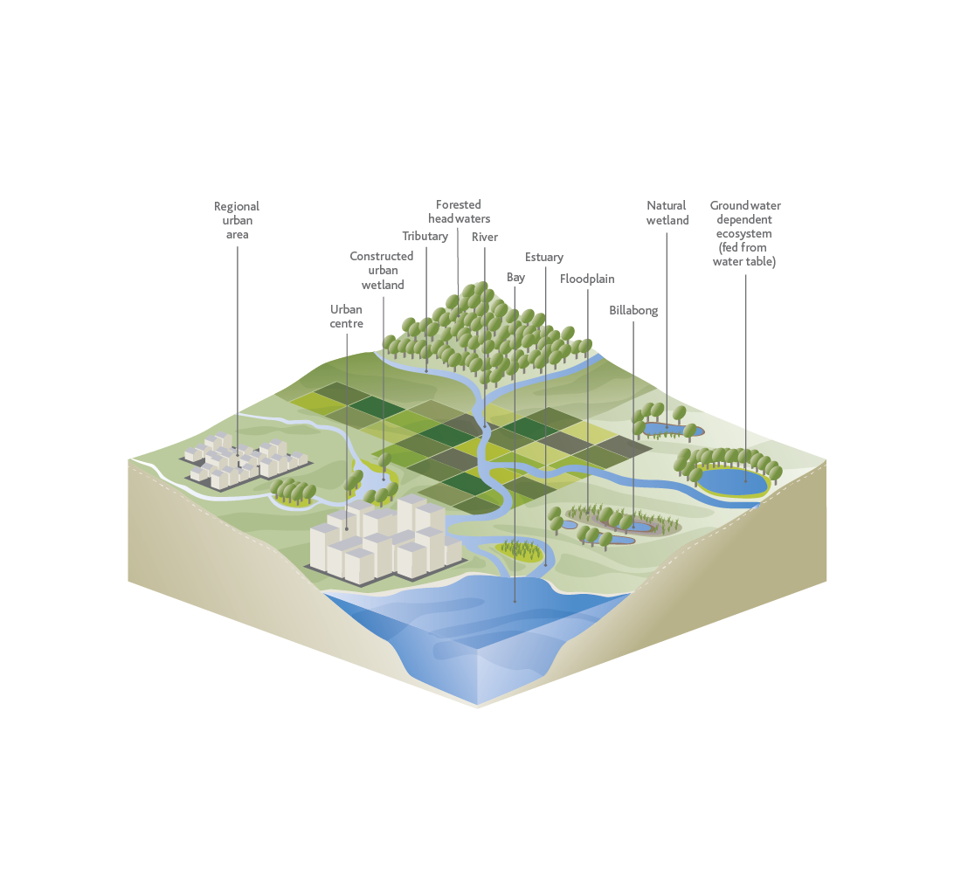
Figure 3. Elements of the waterway system
The health of waterways is assessed using the following framework of waterway conditions and waterway values.

2.1.1. Waterway values
Waterway values describe a range of benefits that waterways provide. There are four categories:
- environmental
- social
- cultural
- economic
Environmentally, waterways provide habitat for plants and animals, and are critically important in sustaining much of our region’s native biodiversity.
Socially, waterways are important for our wellbeing. They provide places to escape the busy urban landscape, to bird watch, to fish for food, to actively commute, to meet with friends and family, to exercise and connect with nature. They provide cool and shady spaces during hot weather, and water for swimming and boating.
Culturally, they are places of memories, spiritual connection and ancestral history.
Economically, waterways provide benefits, through provision of drinking water for towns and cities, water for livestock and irrigation for crops, and pleasant places for travel, tourism, hospitality purposes and convenient boat mooring.

2.1.2. Key values
Key values are a sub-set of nine waterway values that have been chosen in this Strategy as representative measures of waterway values. Not all features of waterways can be effectively assessed and tracked, so these nine were chosen by science and collaborative teams on the basis of:
- their importance to the community
- their ability to represent the range of environmental and social values.
The understanding is that improving key values will in turn improve the environmental, social, cultural and economic waterway values, thereby paving the way to achieving the overarching vision of the Strategy.
The nine key values used throughout this Strategy are:
- Amenity: the pleasantness of waterways and their ability to provide a restorative escape.
- Community connection: waterways connect the community with nature and each other.
- Recreation: waterways provide a setting for active and passive recreational activities.
- Birds: all types of bird species, including waterbirds, raptors and bush birds.
- Fish: freshwater and estuarine species.
- Frogs: native amphibians.
- Macroinvertebrates: small but visible animals without a skeleton (e.g. insects, crustaceans).
- Platypus: unique and iconic aquatic mammal.
- Vegetation: for example trees, shrubs, grasses, bulrushes.

Assumptions and limitations for key values:
- Although some animals such as turtles, lizards and freshwater crayfish, or small mammals such as bandicoots and water rats, are not among the key values, they are still an important part of waterway-associated biodiversity. It is assumed that when waterway management addresses these nine chosen ‘key values’, it will also be managing for other species and values. However, there may be cases where this does not hold true. Further research and understanding of the representativeness of these indicators is therefore still required.
- Cultural and economic values are only considered at a regional scale. Over the life of the Strategy, more research and development of cultural and economic value may be achieved, and key values will be reviewed to ensure they remain relevant.
- A metric to measure the macroinvertebrate value of wetlands and estuaries will be developed during the implementation period of the Strategy.

2.1.3. Waterway Conditions
Waterway condition refers to the overall state of the waterway and key processes that underpin well-functioning waterway ecosystems.
Waterway conditions support the waterway values (environmental, social, cultural and economic).
Improvements in waterway conditions in turn improve the waterway values and the benefits that can be derived from that waterway. Rivers, wetlands and estuaries have a different set of conditions that support their specific environmental values.

The conditions supporting environmental key values for rivers are:
- Stormwater condition: The impact of stormwater on waterways.
- Physical form: Physical attributes such as shape, size and sediment characteristics.
- Water for the environment: Water that is managed to support waterway values.
- Vegetation quality: The quality of vegetation relative to Ecological Vegetation Classes (EVCs) ‘benchmarks’.
- Vegetation extent: Extent of continuous indigenous vegetation cover within a defined width either side of the river.
- Instream connectivity: Ability of uninhibited fish passage.
- Water quality - environmental: Water quality indicators such as nutrients, water clarity, dissolved oxygen, salinity, pH and metals.
The conditions supporting social key values for rivers are:
- Access: Accessibility to and along waterways and corridors.
- Recreational water quality: The waterway water quality suitable for primary and secondary contact recreation.
- Vegetation extent: Extent of continuous indigenous vegetation cover within a defined width either side of the river.
- Litter absence: Litter detracts from people’s enjoyment of waterways and can be detrimental to wildlife.
- Participation: Amount of participation in waterway stewardship activities.
The conditions supporting environmental key values for wetlands are:
- Vegetation condition: Refers to the extent that the ‘natural’ wetland vegetation are intact or displaced and modified.
- Wetland buffer condition: Wetland buffer is native vegetation above the maximum inundation extent.
- Wetland water quality: Considers changed water properties within the wetland including nutrients, salinity regime and disturbance of acid sulphate soils.
- Water regime: Considers changes to the wetland water regime, including those that impact the flow regime of the wetland water source, interfere with the natural connectivity of flow to the wetland, involve disposal of water into the wetland or extraction of water from the wetland and changed wetland depth.
- Wetland habitat form: Considers the extent that the wetland area has been reduced through levees, diversions, etc., and the extent that the wetland bed has been altered through excavation and land-forming activities.
The conditions supporting environmental key values for estuaries are:
- Flow regime: Changes from ‘natural conditions’ to the flow regime.
- Tidal exchange: The ability of sea water and fresh water to mix in the estuarine environment.
- Longitudinal extent: Considers the proportion of estuary affected by constructed barriers that interfere with the movement of water (in a typical year).
- Water quality: Water quality indicators such as nutrients, water clarity (turbidity), dissolved oxygen, pH and metals.
- Estuarine vegetation: The extent to which estuarine vegetation extent and condition is modified.
- Estuarine wetland connectivity: The proportion of the estuary that is connected to its fringing wetlands.

Assumptions and limitations for waterway conditions:
- Waterway conditions are relatively well understood and can be assessed for their contribution to environmental values. Waterway conditions for social values are less well understood and are represented by only five measures for all waterways.
- The assessment of the current status and setting of targets for litter in the Strategy has been limited by a lack of survey data specific to waterways across the region.

2.2. Program logic
Program logic is an approach to planning (commonly used in natural resource management) that uses a diagram to demonstrate the rationale for a program and express how change is expected to occur. The program logic for the Strategy is shown in Figure 4.
It provides the rationale for how, over the 10-year implementation period, the shorter-term outcomes (performance objectives) collectively contribute to either maintaining or improving the waterway conditions, in turn maintaining or improving the status of the key waterway values, and ultimately contributing to the regional and catchment visions and goals for waterways.
In the long term, this will ensure that the waterways can continue to support environmental, social, cultural and economic values. The monitoring, evaluation and reporting (or ‘MER’) provides a mechanism to check and adjust implementation, performance objectives and targets to respond to changing conditions, successes or failures, and evolving challenges during the life of the Strategy.
The Victorian Auditor General report on Environment and Sustainability Sector: Performance Reporting (2013) supports the use of program logic as part of best practice in performance reporting for government.
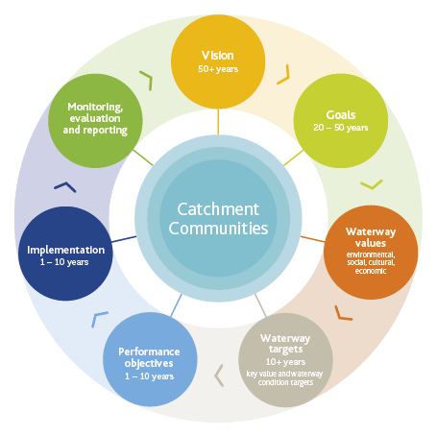
Figure 4. Healthy Waterways Strategy program logic
Vision – The Vision is established for the region and for each of the five catchments in the region. Each catchment vision is intended to:
- Be aspirational and inspiring
- Be credible but not easily or completely achievable
- Enable action and aid decision making
- Focus on assets rather than how the vision will be achieved
- Be written in the present tense and answer the question: What will the region’s waterways and waterway management be like in 50 years?
Goals – The community goals for each catchment were intended to apply to a time frame generally longer than 20 years and assist in priority setting.
Values – In this Strategy, there are two specific uses of the word ‘values’:
- Waterway values
- Key values
Waterway values – Environmental, social, economic and cultural values are described in section 2.1.1 above.
Waterway targets – These are the targets set collectively for waterway conditions and the key values. Waterway targets are the quantification of improvement that is required in order to achieve the desired waterway conditions and waterway values.

Performance Objectives
Performance objectives are measures that guide progress towards the waterway targets, and ultimately the goals and vision. They may define an area of land that must be revegetated, or a number of fish barriers that need to be removed from rivers. The terminology ‘performance objectives’ is aligned with the requirements of the Yarra River Protection (Wilip-gin Birrarung Murron) Act 2017.

Performance objectives:
- are outcome-based, and not actions
- enable a partnership approach
- are quantitative, measureable and achievable in 10 years
- inform short-term management aims through annual planning processes
- describe where they link to environmental conditions
- are underpinned by transparent and best available information and knowledge
- are able to be assessed without needing to measure waterway values and condition outcomes on every asset.
Performance objectives provide short-term, tangible outcomes, which indicate progress towards less tangible, long-term outcomes.

Implementation and actions
This Strategy does not include specific actions. Instead, the Co-Designed Catchment Programs aim to provide a flexible framework for meeting the outcomes described in the Performance Objectives, Waterway Targets, Goals and Vision. Through the process to develop this Strategy (see Part B), a significant number of actions were identified to meet the vision and goals in each catchment. A summarised sample of these is available in each of the Co-Designed Catchment Programs.

Monitoring, evaluating and reporting (MER)
The MER is a process of continual checking and adjustment to ensure that the Strategy is on track. It enables activities to be assessed for effectiveness and adjustments to be made where needed.
The key challenge with developing targets and performance objectives is to provide quantitative measures of progress towards qualitative goals and vision. This Strategy does not specify actions, rather it is designed allow flexibility to adapt to changing resources, policy and emerging opportunities. The management of rivers, estuaries and wetlands in the region is conducted within an adaptive management framework.

3. Regional overview
The region’s five major catchments extend from high up in the Yarra Ranges in the north-east across to Ballan in the west, from Mornington Peninsula and Phillip Island in the south-east to Lancefield in the north, and right across metropolitan Melbourne (Figure 5).
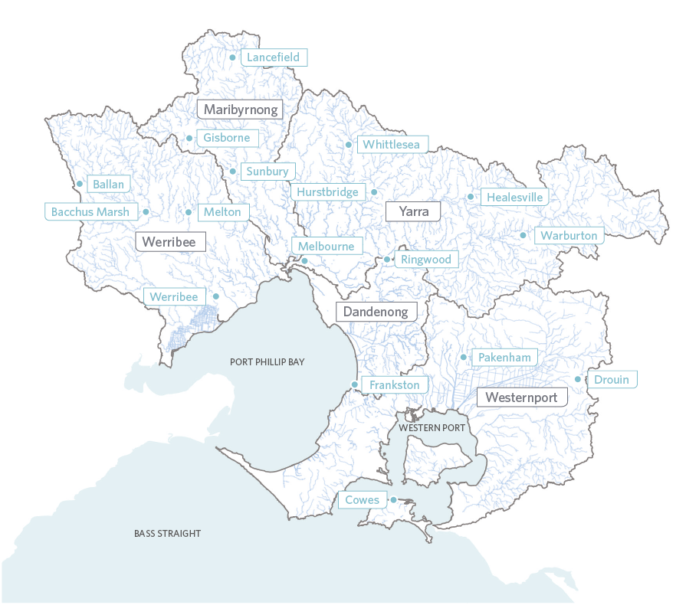
Figure 5. Five major catchments of the Port Phillip and Westernport region
Each of the major catchments differs in its characteristics, including size, shape, rainfall, vegetation and patterns of urban development. For management purposes, these five catchments are divided into 69 sub-catchments that reflect the drainage of smaller creeks and tributaries into the larger river systems. In the upper reaches of the catchments, several large reservoirs collect and store high-quality water for household, industrial and agricultural use.
The region boasts some of Victoria’s most productive farming land, spectacular parks and landscapes, and diverse natural ecosystems. Within the catchments, waterways form a complex and interconnected drainage network of rivers, wetlands and estuaries, which collectively gather water from the landscape and ultimately flow into Port Phillip Bay, Western Port or Bass Strait.

3.1 An interwoven history of people and waterways
Our landscape is ancient, and ever-changing. Thirty thousand years ago, megafauna, such as Diprotodon (a marsupial that was the size of a rhinoceros) and giant kangaroos roamed the landscape. Eighteen thousand years ago, ocean levels were much lower than they are now. In those times, there was a land bridge to Tasmania.
Up until about 8000-10,000 years ago, Aboriginal people lived and hunted on a broad vegetated plain now known as Port Phillip Bay. At that time, the climate would have been much colder and wetter, the river valleys far deeper, and trees and vegetation much more extensive than what they are now.
Aboriginal people have lived and prospered in south-eastern Victoria for thousands of years. The physical evidence of Aboriginal occupation across the Melbourne metropolitan area is present almost everywhere. Sub-surface archaeological deposits, shell middens, quarries, fish traps, artefact scatters, scarred trees and earth mounds bear silent witness to hundreds of generations of continuous land use prior to the arrival of Europeans.
Artefacts indicate that the region’s Traditional Owners travelled the region seasonally to cultivate and harvest shellfish, wattle gum, plants and animals, reptiles, birds and eggs, using efficient and lightweight tools. There is evidence of sustainable land management in the form of fire-stick farming, which Aboriginal people used to increase pasture for kangaroos and regenerate food plants. The region has long provided food, and spiritual, trade and family connections for Traditional Owners.
European settlers were attracted to ‘Port Phillip’ by its safe harbour, fresh water and rich biodiversity. They built a frontier town sustained by the fresh water of the Yarra River, which rapidly became altered by development of the port and the use of the river for waste disposal. Patterson Cut was formed in 1879 to drain parts of the then 5000-hectare Carrum Carrum Swamp, taking significant flows from Kananook Creek. Channelising creeks continued for the next century, first for farming, and then for industry and public housing as post-war migration saw enormous growth and development. Similar draining of the Koo Wee Rup Swamp in the Westernport catchment was undertaken to support agricultural development.
The gold rush, subsequent population and property booms, and the lack of city services in the 19th century led to Melbourne gaining an international reputation as ‘Marvellous Smellbourne’. But then, over several decades, visionary plans set aside an enormous sewerage farm at Werribee, protected the forested headwaters of the Yarra River for water supply, and reserved an arc of green open space around the growing city, much of it along the winding course of the Yarra River.
The Yarra River and its parklands soon became the focus of recreation and celebration. Together with profound social and cultural changes, in a relatively brief period, the frontier town transformed into ‘Marvellous Melbourne’ and was able to maintain the prosperity that was initially driven by the discovery and mining of gold.
Remarkably little investment in open space and green infrastructure occurred over the following decades due to wars and the Great Depression. Melbourne’s early prosperity was underpinned by consequential degradation of waterways.
The 1956 Summer Olympics in Melbourne signalled a time for optimism and vision. Melbourne’s population was again booming, this time driven by immigration from post-war Europe. Drainage and river improvement works were needed to allow the city and industry to grow, triggering investment in drainage infrastructure and reform in planning and institutions.
One new institution was the Dandenong Valley Authority, which was created in 1964 to oversee development in the rapidly growing flood-prone south-eastern suburbs. River improvement and drainage works allowed Melbourne to achieve lower levels of flood risk and flood damage costs than other Australian cities. However, communities began to react to the utilitarian ‘improvement’ works that were transforming waterways and wetlands into drains and freeways.
By the 1970s, sprawling development had virtually doubled the extent of the metropolitan area. The Yarra River, the waterways and the Bay were neglected and becoming grossly polluted. Community pressure to tackle pollution problems and protect waterways from development grew. EPA Victoria was created in 1971 to regulate industry, making it the second EPA in the world.
The State Government and Australian Government jointly channelled a huge investment towards sewers in the suburbs. Together, these initiatives began a dramatic improvement in water quality of waterways including the Yarra River and Port Phillip Bay. A new Metropolitan Plan, also established in 1971, identified open space corridors (green wedges) along waterways including the Yarra River, and land began to be acquired to build this network and the trail systems that connected it. Victoria became known as the ‘Garden State’ in 1974, principally because of Melbourne’s vision for an extensive network of green open spaces across the city.
Melbourne is fortunate to have incrementally established a unique institutional model for managing the region’s waterways. The past two decades have seen significant innovation in waterways, drainage and floodplain management that has helped maintain and enhance the productivity and competitiveness of the region, establishing Melbourne’s position as a recognised leader in water sensitive urban design (WSUD).
Partnerships between waterway authorities and research institutions have helped to transform waterway, stormwater and floodplain management practices, and enabled the city to avoid economic disruption and crisis-driven responses from flooding and environmental degradation. Although the advances made have been substantial, there is still work needed to make the transition to a ‘water sensitive city’ and build this into Melbourne’s development so that protecting waterways becomes business as usual.
The increasingly important role of waterway corridors as places for communities to gather, create and travel is also being recognised. Partnerships between waterway authorities, local and State governments are helping to support waterways as key networks of open space and active transport.

3.2. The region’s waterway network
The Port Phillip and Westernport region covers a total catchment area of almost 13,000 square kilometres, containing more than 25,000 kilometres of rivers and creeks, 33 estuaries and in excess of 14,000 natural wetlands. Three of these wetland complexes are listed as internationally significant under the Ramsar Convention.
Figure 3 illustrates the interconnectedness of the waterway system. This connectedness is central to the nature and health of the waterway system. Among other things, this connection enables the movement and dispersal of water, seeds, nutrients and animals through the landscape.
Waterways are central to the historic occupation and culture of the Traditional Owners. Cultural stories and physical evidence of thousands of years of Aboriginal peoples’ presence are often connected to the proximity of water and waterways.
As water flows downhill, it naturally follows that activities, pollution and land use changes in the upper reaches of the system can affect all sections further down the waterway. For example, excess fertiliser washing off farmland in the upper catchment can add to nutrient levels and cause algal blooms in a wetland near the coast. In some cases, a threat entering in the lower reaches of a waterway can also impact upstream, such as when an introduced freshwater fish species is released and travels upstream to breed.
Three key, interconnected elements of the waterway network are detailed in this Strategy: rivers, wetlands and estuaries.

3.2.1. Rivers
The Port Phillip and Westernport region contains a variety of rivers, which differ significantly in size, flow regime, origin, destination, patterns of adjacent land use, vegetation cover, cultural history, accessibility, species distribution, sediment types and level of human intervention.
Many of the region’s waterways are highly modified from their natural state. For example, the Yarra River originates in forested ranges, and meanders through countryside, farms, small towns, a major city and an operational port, to finally reach Port Phillip Bay. In the upper reaches, large volumes of water are extracted for drinking water supplies. In the middle reaches, much of the land has been cleared for agriculture, and water is diverted to domestic, stock and agricultural uses.
Through urban areas in the mid to lower reaches of the Yarra River, modifications such as retaining walls and port structures alter the natural state of the river and constrain it from overspilling its banks and replenishing historic wetlands. In one example of urban constraint, north of the city centre, a prominent section of the Moonee Ponds Creek has no natural banks, and water flows through constructed concrete channels. Nevertheless, these modified waterways still provide connections across the landscape, habitat for wildlife, and are highly valued and extensively used by local communities.

3.2.2. Wetlands
There are over 14,000 natural wetlands within the region. These include coastal wetlands, dominated by salt tolerant vegetation, ephemeral wetlands on the Victorian Volcanic Plain which may be dry for significant periods, and billabong wetlands on the floodplains which are filled intermittently when rivers spill their banks.
Wetlands filter out suspended sediments and store nutrients which contribute to natural food chains. They are important habitats, and provide feeding and breeding grounds for many aquatic animals that move between wetlands, rivers, estuaries and bays. They may also be places of refuge in times of drought. Many of our wetlands contain very significant and rare vegetation communities such as the Environment Protection and Biodiversity Conservation Act-listed Seasonal Herbaceous Wetlands, and saltmarshes.
Thousands of migratory birds travel annually to Port Phillip Bay and Western Port wetlands from as far away as Alaska, Siberia, China and Japan. The region includes three wetland complexes which are listed under the Ramsar Convention (a global, intergovernmental treaty for the conservation of wetlands): Western Port, Edithvale-Seaford Wetlands and Port Phillip (Western Shoreline), and Bellarine Peninsula.
Much like rivers, many of the region’s wetlands have been modified for urban settlement and agriculture. The draining of Koo Wee Rup Swamp from the late 1800s to the early 1900s converted around 40,000 hectares of paperbark and grassland swamp to agricultural land. It was drained through the construction of a large network of channels which feed into Western Port.
Other wetlands across the region have similarly been drained and modified to improve access, land availability, flooding control and amenity. Many inner Melbourne and coastal suburbs have been built on ‘reclaimed’ wetlands, and encroaching urban development continues to pose a threat to ephemeral wetlands.
Throughout the region, there are now also more than 370 constructed stormwater treatment wetlands that provide habitat for wildlife and areas of high amenity for residents.

3.2.3. Estuaries
Estuaries within the region include those that are permanently open to the sea, such as the Werribee, Maribyrnong and Yarra, and those which are naturally intermittently open and closed to the sea, such as the Balcombe and Merricks creeks estuaries.
Estuaries support a range of distinctive aquatic and terrestrial plants and animals. They provide core breeding and feeding areas for waterbirds, and spawning and nursery areas for many fish species.
Vegetation adjacent to estuaries (such as mangroves, seagrasses and saltmarshes) help to maintain water quality, assist with nutrient cycling, and provide a buffer to catchment-derived sediments, nutrients and other pollutants entering the marine environment.
Estuarine ecosystems are highly complex and dynamic. Since estuaries are at the end of waterways, their condition is affected by activities occurring upstream in the catchment. Where the condition of catchments, rivers or estuaries is poor, there are likely to be impacts on the marine receiving waters and coastal areas. Similarly, the condition of the marine environment can also impact the health of estuaries.
Humans have long valued estuarine areas. The region’s estuaries are important to Traditional Owners and many contain ancient sites of cultural significance. Sheltered estuarine waters across Victoria were also among the first areas to be settled by non-Indigenous people.
Many estuaries in the late 1800s and early 1900s were transport and fishing hubs, which supported prosperous industry and ports. These early settlements have since developed into some of the region’s most densely populated areas.
The Yarra estuary is a prime example of this commercial and urban growth. Estuaries are valued for recreational and commercial fishing, tourism, recreation, port trade and boating.

3.2.4. Waterway relationship with the bays
The region covered by this Healthy Waterways Strategy is characterised by two dominant bays, Port Phillip and Western Port. This Strategy does not directly provide management for the bays. However, it does consider the needs of Port Phillip Bay and Western Port, and responds to the policy and regulatory directions relating to stormwater and pollutant impacts on bay health.
The Strategy acknowledges that waterways and stormwater drains deliver fresh water, nutrients, sediments and other pollutants to the bays and directly impact their water quality, amenity, health and productivity.

4. Regional Vision and Waterway Values
The Healthy Waterways Strategy is driven by a single regional 50-year vision, which was adopted from the previous (2013) Healthy Waterways Strategy:
Healthy and valued waterways are integrated with the broader landscape, and enhance life and liveability. They connect diverse and thriving communities of plants and animals; provide amenity to urban and rural areas, and engage communities with their environment; and are managed sustainably to enhance environmental, social, cultural and economic values.
Waterway values are the things that people consider beneficial about waterways. They are important because they represent the reasons why people want to protect and improve waterway health. The waterways in the Port Phillip and Westernport region support an enormous range of environmental, social, cultural and economic values, some of which are illustrated in Figure 6 and Figure 7.
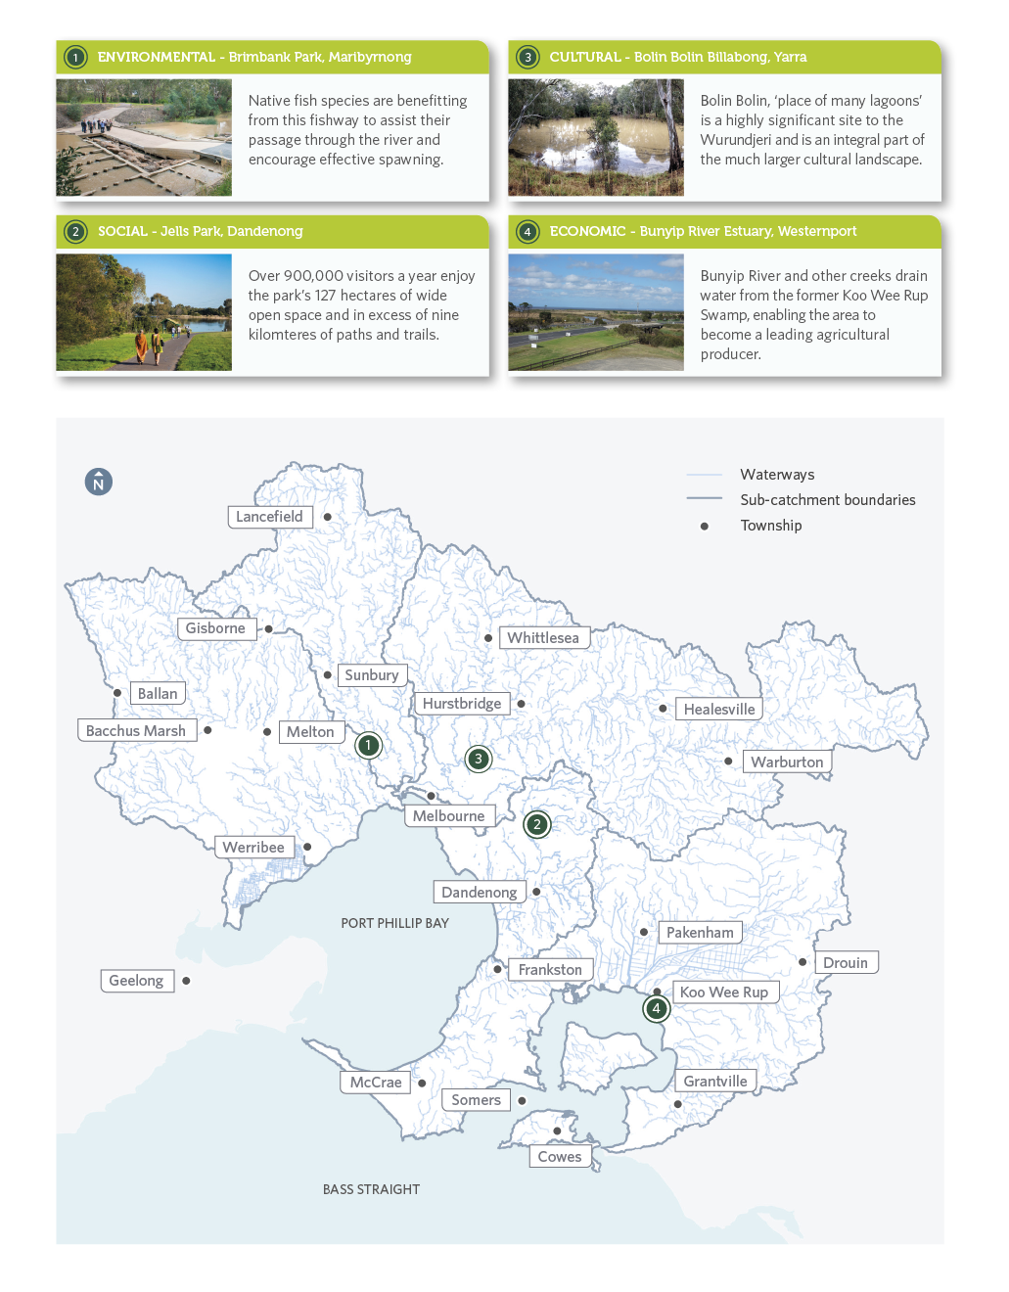Figure 6. Examples of waterway values across the region

Survey Shows How Much Communities Love Their Rivers
Melbourne Water formally surveys the community’s knowledge and perceptions of the region’s waterways every two years. The results offer an insight into community expectations, attitudes and behaviours regarding waterway management, and have helped understand the values of waterways for this Strategy.
Over 2100 residents from across the Port Phillip and Westernport region participated in the 2018 survey. Two thirds of respondents had visited waterways in the past year and over a quarter of respondents said they visited their local waterway at least fortnightly. Eighty-seven per cent of all respondents expressed satisfaction with their local waterways.
The top four roles of waterways were identified as providing:
- a natural habitat for plants and animals
- drainage and flood protection
- parkland/open space
- a place for recreation.
From data obtained through the 2018 Waterways Perceptions survey, Figure 7 illustrates the order of importance of activities undertaken by the survey respondents when they visit waterways.
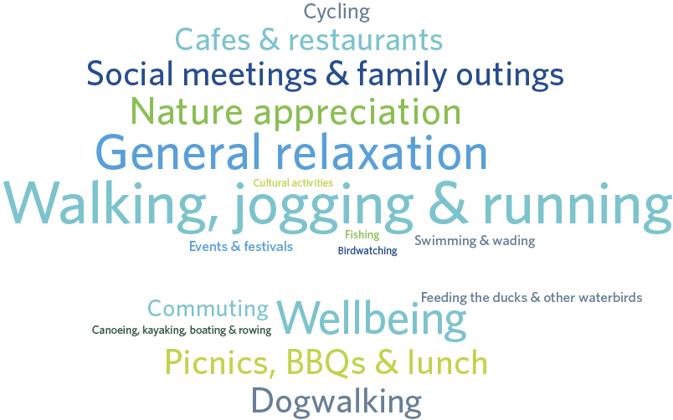
Figure 7. Reasons for visiting waterways (2018 Waterways Perception survey)

4.1. Environmental values
Environmental values underpin all other waterway values. If waterways are not healthy and productive, then there is a commensurate decline in the social, cultural and economic values of those waterways.
Biodiversity, clean water, natural flows and interconnected habitats are required for a productive and resilient natural system. All animals and plants in those systems contribute to a complex natural web of life, with many levels of interdependence.
Traditional Owners have long seen themselves as belonging to their Country, and as having responsibility as the custodians of lands and waters. This perspective is an important reflection that the natural environment has inherent value and has value for our long-term survival.
For this Strategy, the environmental values of waterways are represented by six key values: birds, fish, frogs, macroinvertebrates, platypus and vegetation. However, the intention is to manage for the whole environment, including other animals such as turtles, skinks, water rats and freshwater crayfish. This means that the key values should be considered representative of all other species.

4.2. Cultural values
Cultural values are based on the physical and spiritual connection of people to land and waters. Cultural values are both contemporary and ancient.
Aboriginal Traditional Owners have lived in this region for tens of thousands of years, and have connection with the landscape and waterways through significant places, artefacts, language, stories and traditions.
While European settlers and subsequent waves of migrants have a comparatively short history of a couple of hundred years, they too have forged cultural and spiritual connections which are important to them.
The Port Phillip and Westernport region is home to several Traditional Owner organisations from the Wada wurrung, Woi wurrung and Boon wurrung language groups.
Traditional Owners’ connection to this region has been damaged by the processes of colonisation and urbanisation. Traditional Owners have been excluded from waterway management since the first days of colonisation.
The sad outcome of this exclusion is twofold: contemporary waterway managers who lack the unique and proven perspective of Traditional Owners, and Traditional Owners who lack the opportunity, skills and resources to manage their Country in a contemporary context.
This Strategy commits to working with Traditional Owners and Aboriginal Victorians to protect and promote their cultural and historical connections with waterways. It also aims to protect the environmental values (land, water, vegetation and wildlife) which underpin these connections, and to share knowledge and understanding about waterways and their catchments.

Case Study: Watering Bolin Bolin Billabong – an example of successful partnerships
Bolin Bolin means ‘place of many lagoons’ in the Woi wurrung language of the Wurundjeri, the local Traditional Owners. Bolin Bolin Billabong in Bulleen is part of a highly significant cultural and ecological landscape of wetlands and floodplains that extend from the confluence of the Yarra River with the Plenty River, through to Kew Billabong.
Before the colonisation and urbanisation of Melbourne, the billabongs would fill with water in the cooler months when the Yarra, Birrarung, burst its banks and reconnected with the surrounding country. Eels (iuk) and other fish would come into the billabong with the flowing water. During the warmer months, the waters of the Birrarung would recede back to the river channel, with the eels left behind in the billabongs.
During eel harvest time at the end of the warmer season, the Woi wurrung people held important ceremonial meetings here, negotiating and trading with neighbouring tribes. The gatherings were large, comprising hundreds of people. Written history acknowledges that Bolin Bolin and nearby billabongs had such a plentiful eel population that they were able to sustain these large gatherings for 8 to 12 weeks at a time.

Collaborative planning, diverse strengths
Water extraction, channel erosion and modification, as well as drought and climate change have prevented the billabong from filling each year as it would have in the past.
Wurundjeri people identified the cultural significance of Bolin Bolin and the need to refill the billabong. Melbourne Water and the Victorian Environmental Water Holder (VEWH) also identified the need to water billabongs on the Yarra floodplain for ecological objectives. The Wurundjeri Tribe Land and Compensation Cultural Heritage Council Incorporated has been working with Manningham Council and Parks Victoria to better manage public lands.
All parties agreed that watering Bolin Bolin Billabong was a priority restoration project, and in October 2017, water was pumped from the Yarra River into Bolin Bolin Billabong for the first time in many years. The ecological effects of watering can now be tested, while a more permanent connection to the river is being developed.
Being involved in the ongoing monitoring of water quality in the billabong has helped Wurundjeri people to reconnect with an important cultural place. It has also helped them to understand the threats to its ecological and cultural health, and options for future management. This knowledge will be important in ensuring improvement in cultural and environmental health for this billabong, and for the Yarra floodplain more generally.
- End Case Study -

4.3 Economic values
Good waterway condition provides the essential building block for liveability, growth and prosperity. River catchments provide water for Victoria’s 6.5 million people and support agriculture, recreational fishing and commercial industries.
Recognising the economic values of waterways is essential to appreciating the wide scope of ecosystem services – the benefits that humans receive from nature. Economic benefits delivered by waterways include:
- urban water supply/storage
- recreation and commercial tourism
- natural water treatment and dilution/assimilation of waste
- production from extractive uses
- drainage and flood conveyance
- increase in property value.
Declining waterway condition can lead to direct economic costs for communities.
Poor land management can result in a deterioration of water quality and hence high costs for water treatment.
Poor water quality, in turn, can trigger algal blooms leading to costs associated with providing alternative water supplies, cessation of irrigation, illness in livestock, closure of recreational lakes and beaches, and loss of recreational and tourism revenue. Accelerated erosion of riverbeds and banks may cause loss of valuable land or public infrastructure, such as roads and bridges. Other costs will not be able to be measured in economic terms. For example, over-extraction of water affects the diversity and abundance of many native aquatic plants and animals.
Farmers, Landcare networks and other community action groups play a significant role in contributing to improvements in the environmental condition of waterways through better on-ground management practices, local planting days, and pest plant and animal control. Some of the gains in environmental condition from these restoration works can be measured in economic terms.

Case study: City transformations
The Yarra River (Birrarung) has been central to the establishment and development of the city of Melbourne. Development has expanded along its banks and significantly contributed to economic activity. The city’s history of development was based on its early versatility and safety as a sea and river port. The development of port and shipping facilities along its banks initially excluded large sections of the estuary from every day public use.
Around the turn of this century, the south side of the Yarra River became the focus of several major government development projects, with Crown Casino and the Melbourne Exhibition and Convention Centre being built. This has created a centre of hospitality, commerce, tourism, entertainment and recreation.
More recently, the Melbourne Docklands urban renewal project was realised, being perhaps one of the most significant urban renewal projects in the nation’s history. With upwards of $12 billion invested, the project transformed the Docklands from a largely disused docks area into a new residential and commercial precinct for 25,000 people.
Connectivity of the city along the Yarra River has further been enhanced by the development of an inner-city park on both banks, named Birrarung Marr, meaning ‘river of mists’ and ‘river bank’ in the native language of the Wurundjeri people.
Birrarung Marr connects the central business district to the city’s sports and entertainment precinct, three kilometres east of the city centre.
This Yarra River example demonstrates that commercial and economic opportunities presented by the region’s waterways are significant and ever-changing.
- End Case Study -

4.4. Social values
The region’s waterways are important community assets providing opportunities for recreation, to enjoy amenity, and for people to connect with nature and with each other. Activities on and alongside the region’s rivers include passive and active recreation, nature appreciation, active commuting, picnicking, music and entertainment, boating, swimming and fishing.
People appreciate the space, serenity, cooling effect and connection that waterways provide. A 2018 survey of over 2100 residents in the Port Phillip and Westernport region also demonstrated that many people appreciate the role waterways play in providing habitat for plants and animals (Figure 7).
Numerous new housing developments incorporate artificial wetlands that provide an essential stormwater management asset, and also act as a central social and amenity feature for the community.
The co-design process used in the development of this Strategy recognised the important role that waterways play in supporting community health and wellbeing.

Case Study: Partnership in improving river recreation – a practical application
Kayaking and canoeing are popular recreational activities and these river users are strong advocates for our rivers and the environment. Melbourne Water, Canoeing Victoria and other key paddling groups are working together to explore and prioritise options for providing additional boat launch facilities along major waterways like the Yarra River. This work recognises the need to be inclusive of all people and abilities in designing features that provide safe access for new and retrofitted boat launches.
A successful example is the partnership between Melbourne Water and Manningham City Council on the Yarra River in Templestowe. The ‘Finns Reserve Canoe Launch’ project was identified in Council’s Finns Reserve Management Plan. The Reserve contains three main river access points that offer panoramic views and access to the Yarra River. The management plan recommended for the three points to be upgraded by way of constructing paths, steps and a canoe launch, so as to provide easier and safer pedestrian access to the river while reducing environmental damage.
- End Case Study -

5. Threats and opportunities to waterway values
Current and future threats to waterway health are widely recognised across communities and in government policy. Over the past two years, extreme challenges such as climate change, increasing urbanisation, pollution and rapid population growth have been explored through the refresh of the Healthy Waterways Strategy. Measured, cooperative and targeted investment is both necessary and possible, and will prevent a widespread decline in waterway health in the face of these external challenges and allow the significant opportunities to be realised.

Aboriginal Cultural Values
As a society, we are only just starting to appreciate the wealth of cultural knowledge and meaning of waterways for the Traditional Owners.
Understanding, protecting and promoting this cultural knowledge and facilitating a greater involvement in waterway management will help to achieve better outcomes for the environment and our community.

Environmental Qualities
The condition of the environment supports the condition of life: clean water, clean air, clean soil. Efforts to improve the quality of the waterway environment will consequentially improve the functioning of ecosystems, and underpin cultural, economic and social values. Shared benefits can be achieved by aligning needs, for example, an environmental water release timed with summer can enable people to kayak in the waterways.

Stormwater as a Resource
Sustainable stormwater management will help to protect property from flooding and waterways from pollution. Harvesting of stormwater will provide an alternative water source that can contribute to the maintenance of cool, vegetated urban environments.

Pollutants and Sediment
More people in the catchment and more intense storms will increase the volume of nutrients, pathogens, pesticides, heavy metals and sediments in the waterways. They will reduce oxygen and light levels, may directly poison aquatic life, reduce amenity and prevent drinking or swimming.

Pest Plants and Animals
Feral species like foxes, rabbits and deer directly compete with, and eat, native species. Aquatic weeds and invasive animals alter the physical and chemical processes, they change the waterway conditions, and faeces of some species pollute the water and make it unfit for drinking.

Rapid Urbanisation
An additional 39,000 dwellings are being added in the Port Phillip and Westernport region every year. Drainage and transport infrastructure impact on waterways and urban encroachment, light and noise impact on habitat qualities, amenity and naturalness of waterways.

Climate change
A warmer and drier climate will alter the natural flows to waterways. There will be more intense storms and longer periods without rain, hotter maximum temperatures, rising sea levels and a greater risk of bushfires in the catchments.

Modifications and Diversions
Many urban waterways have been modified by humans, and restricted by artificial structures such as weirs and constructed channels. Natural waterway flows are also affected by extraction and diversion to drinking water supplies, irrigation and stock use. Together, these result in a reduction in natural habitat and less water reaching the waterways, even after good rainfall.

Intensity of Stormwater
As the region becomes more urban, vegetated surfaces are incrementally replaced with hard, impervious surfaces like pavements, roads and buildings. Water runs quickly off these surfaces, instead of soaking into the ground, and this increases stormwater volumes and intensity, which in turn reduces water quality and changes the pattern of water availability in waterways. The region is predicted to be 59 per cent more impervious within the next 50 years.

Co-Delivery
There are many individuals and organisations that contribute to the health of waterways and catchments across the Port Philip and Westernport region. The collaborative nature of this Strategy provides an opportunity to align efforts, share knowledge and maximise the benefits to waterways.

Litter
Ninety-five per cent of litter on the beaches on Port Phillip Bay comes from stormwater, much of it originating in suburbs well away from the coast. Litter includes microplastics, cigarette butts, food packaging and general waste. It affects water quality in the waterways and in the receiving bays and ocean, impacts on aquatic and marine life and reduces amenity. Litter and street cleaning costs local government across Victoria over $94 million per year.

Social Benefits
Waterways provide connectedness, naturalness, and a place to exercise, relax and socialise. Improvements to the accessibility and quality of waterways will improve the social values associated with them.

5.1. Threats to waterway values
Many waterways and waterway environments in urban areas are highly modified from their natural state. They also experience constant pressure from people, urban expansion, poor land management and land development practices, and wider environmental change.
The Port Phillip and Westernport region supports a population of five million, which is more than three-quarters of Victoria’s population. With a population of that size comes a substantial pressure on our waterways. As Melbourne now experiences its third great wave of population growth, with a predicted eight million or more people by 2050 and nearly a million new homes constructed by then, it will be a challenge to maintain and improve waterway health so that waterways can continue to support city prosperity, competitiveness, liveability and wellbeing.
At the same time, the world is experiencing notable warming of climate. The region is becoming hotter, drier and is experiencing more extreme weather (hotter days and more intense storms). On a global scale, climate change is not new, but the current rate of change is rapid, and with limited time to adjust, waterway systems will be highly impacted. Coastal inundation is a threat to communities, coast and estuaries, with storm surges advancing further up the coast and sea levels rising.
Seven key challenges to waterways have been identified, of which two are of a magnitude that cannot be ignored: climate change and urban stormwater.

5.1.1. Climate change
History reminds us that climate can be variable over short and long time frames. Research and cultural oral histories of local Traditional Owners suggest there have been regular droughts and floods across Australia for many thousands of years of human habitation. Contemporary research suggests that we are now living in a time of relatively rapid climate change and global warming. It is predicted that over the next 100 years, there will be a dramatic and long-term decline in rainfall and stream flows, increases in temperature, and increased peak storm events.
The Port Phillip and Westernport region is expecting a median increase in average daily air temperature of between 1.2 and 2.3°C by the middle of this century. At the same time, the region is predicted to experience a median decrease in average annual runoff from the catchments of between 11 and 20 per cent from current levels. We can expect higher maximum temperatures in summer, which will exacerbate urban heat impacts on communities, and result in a shift of plant species and generally drier vegetation in the catchments. This in turn will result in an increased risk of bushfire. There will be more unpredictable weather patterns, with higher intensity storms, resulting in rainfall and higher peak flows in the region’s drains and waterways.
For waterways, intense stormwater events are known to result in poorer water quality, increased sediment and nutrient loads, reduced dissolved oxygen, rapid alteration of habitats, and reduced amenity and access for communities. Over the longer term, warming and drying trends will affect the plants and animals that can survive along waterways and around wetlands. Sea level rise and storm surges will also affect soil and water salinity, water levels and the physical form of coastal areas that will in turn, influence coastal plant and animals communities.
The Victorian Coastal Strategy (2014) recommends to ‘plan for possible sea level rise of not less than 0.8 metres by 2100’, and incorporates the combined effects of tides, storm surges, coastal processes and local conditions (such as topography and geology) when assessing risks and impacts associated with climate change. Threats to estuarine environments and coastal wetlands are particularly significant.
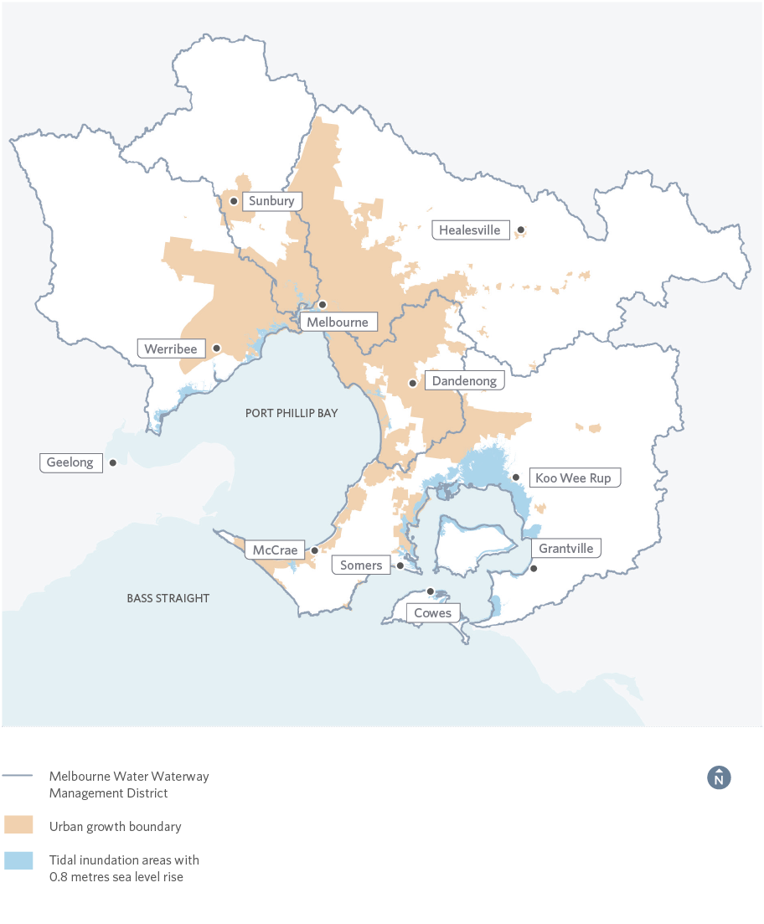
Figure 8. Predicted tidal inundation areas in the Port Phillip and Westernport region by 2100

5.1.2. Urban stormwater and pressures of urbanisation
As vegetated surfaces are replaced with hard, impervious surfaces (such as roofs, roads and paved areas) that drain directly into waterways via stormwater systems, infiltration to the soil and groundwater system is reduced. This affects the waterway system in two ways: rapid runoff in wet conditions, and lack of soil moisture during dry conditions.
Increased and rapid runoff to waterways during, and shortly after, rain events leads to scouring of aquatic habitats, and a heavier load of urban pollutants, including oils, dirt, nutrients, heavy metals, pesticides and litter. Changing flow regimes and water quality affect the habitats and health of platypus, fish, invertebrates and other aquatic animals, and naturally saline wetlands and waterways in the lower parts of catchments. These changes have major impacts on instream and riparian flora and fauna.
When less rainfall can soak into the ground, there is less moisture in the soil, and subsequently less water available for vegetation and seepage into rivers during dry conditions. This lack of moisture in the environment also leads to increased ambient temperatures which in turn impacts on community health and wellbeing.
Figure 9 illustrates the differences in stormwater flow in natural and urbanised environments.
Melbourne’s waterways are experiencing pressure from increased urbanisation, with over 39,000 dwellings added to the Port Phillip and Westernport region each year. Currently, the impervious footprint across the region is around 1100 Kilometres square, with a projected increase to 1750 Kilometres square (a 59 per cent increase) over the next 50 years. This will increase the impacts of urban stormwater on waterways, unless we urgently begin to change the way we develop new and existing urban areas.
Increased urban development presents challenges to waterways as catchment imperviousness and drainage infrastructure expand. A trend towards smaller back yard size also places growing importance on the role of waterways as green open space for a growing population, and, with waterway corridors increasingly required to provide for infrastructure, such as transport and utility routes, careful planning is critical to maximise the benefits of waterways for all users.

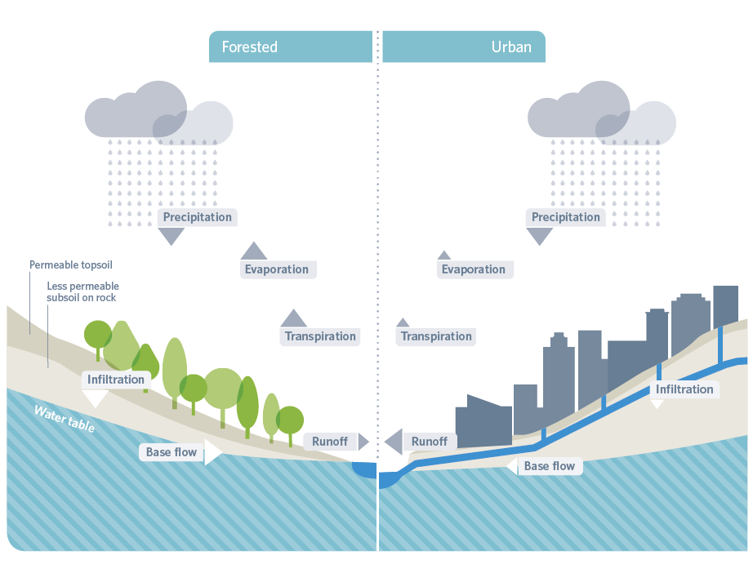
Figure 9. Stormwater flow in natural and urban environments
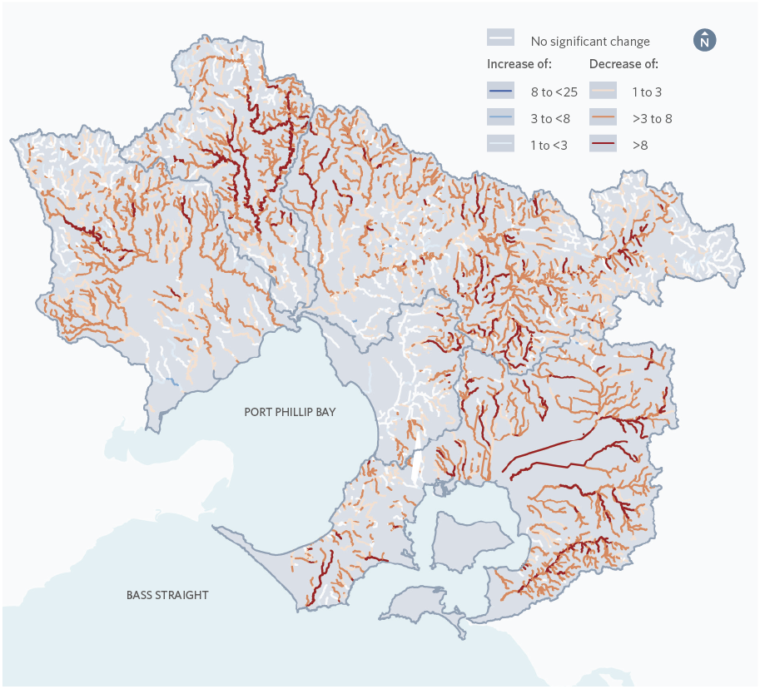
Figure 10. Predicted river health by 2070 (based on changes in the number of macroinvertebrate families compared to current)
As well as altering stream flows and water quality, ongoing greenfield and infill development has historically impacted waterways where small natural streams have been converted into underground pipes or enlarged, rock-lined channels.
These small, headwater streams play an important role in the protection of waterway health, for example: reducing flooding, filtering excess nutrients and sediment, processing organic matter, supporting unique species, and decreasing downstream erosion.
Urban encroachment and densification around urban waterways can also detract from waterway amenity if development results in overshadowing, loss of views and vistas, noise and light pollution, and loss of a sense of naturalness around waterways.

5.1.3. Combined effects of changing climate and urban stormwater
The Healthy Waterways Strategy has considered individual threats, as well as cumulative impacts to waterways, such as the combination of climate change and changing intensity of stormwater flows. These impacts can be extreme. For example, modelling suggests that under current management regimes, the length of the region’s rivers in ‘poor’ or ‘very poor’ condition will increase by around 850 kilometres over the next 50 years (Figure 10). At the same time, the length of waterways unable to support platypus will increase by around 1200 kilometres. This translates to a probable extinction of platypus across the entire Werribee, Maribyrnong and Dandenong catchments, with only the upper reaches of the Yarra and Bunyip rivers likely to sustain the species in the region.
There are five other major threats to waterway health, and these are described below.

5.1.4. Pollution
Pollutants such as chemicals, pathogens, nutrients, excess sediment, heavy metals and other toxicants can enter waterways through: inappropriate use of agricultural or domestic herbicides, pesticides and fungicides; sediment from erosion and soil disturbance; leaching of contaminants through soil and groundwater; illegal dumping into stormwater drains and waterways; licenced discharges from treated effluent; untreated dairy effluent; sewer spills and leaks; illegal sewerage connections to the stormwater system; septic tanks; and industrial discharges.
Pollution results in physical, chemical and biological impacts on the receiving environment. Impacts can be directly on the chemical balance of the waterway, or on amenity or ecosystems, and may cause fish kills, blue-green algal blooms, and health and odour issues that make it unsafe for swimming or boating. The impacts depend on the sensitivity of the receiving waterway and characteristics (frequency, duration, volume and concentration) of the discharge.
Occasional discharge of untreated or diluted sewage from the sewerage system is referred to as a sewerage overflow (or spill) and can occur in dry and wet weather. Overflows can occur due to pipe blockages, pump station failures, or when the capacity of the sewerage system is exceeded due to high rainfall.
In order to protect public health, sewerage systems are designed with designated overflow points to control the location of discharges and prevent sewage backing up and spilling in public areas or in homes. The controlled discharge points generally flow to waterways and can be timed to negate water quality impacts and improve ecological value.

5.1.5. Litter
Litter is any waste that is deposited inappropriately. Litter can be seen as harmful (non-biodegradable and/or hazardous) and less harmful (biodegradable). Harmful litter includes cigarette butts, plastics (including micro (small) plastics), broken glass and fast-food wrappers. Less harmful litter includes paper, cardboard and fruit scraps.
It has been estimated that around 95 per cent of litter found on Melbourne’s beaches has been transported from suburban streets through the stormwater system.
Litter is the result of poor commercial or industrial waste management practices, irresponsible behaviour, carelessness and illegal dumping. Litter makes waterways look unattractive and dirty, reduces water quality and can kill or harm aquatic animals such as platypus.

5.1.6. Vegetation clearing and grazing
Vegetation removal for development and grazing by livestock can significantly impact the physical form and ecological health of waterways. These stressors decrease bed and bank stability, reduce the quality of instream and streamside habitat, alter levels of organic matter in the waterway (vegetation adds organic matter beneficial to stream biota, and livestock add faeces), and alter temperature and light regimes. Under native vegetation regulations, vegetation clearing in wetlands includes active vegetation removal as well as any activity that results in changes to the vegetation present in the wetland. For example, changes to the water or salinity regime of a wetland may result in the loss of native vegetation, even if the resultant vegetation is made up of native species. These combined impacts not only affect aquatic biodiversity, but also the sense of naturalness that contributes to amenity. Removal of habitat such as vegetation along waterways also has a significant impact on the connectivity of plants and animals across the landscape. The clearing of native vegetation is regulated through native vegetation clearing regulations.

5.1.7. Interference to natural water flows
River flows are impacted by surface water and groundwater harvesting for domestic, stock and agricultural uses, and for urban drinking supply. The impacts of these extractions are acutely noticed during low flow periods, although all components of the flow or inundation regime of waterways are significant for their ecology. (For instance, they provide triggers for breeding or migration of fish and they affect the connectivity of floodplain habitats to rivers.)
Ongoing extraction across the landscape has potentially long-term effects on water flows and waterway health, particularly if extraction rates are not carefully managed.

5.1.8. Pest plants and animals
Pest animals affect social, environmental and safe drinking water values. Foxes, feral dogs and cats directly affect biodiversity by preying on or competing with birds, reptiles and mammals, including platypus. Increases in exotic weeds impact on the healthy functioning of waterways, such as changing stream bank structure and water flow, changing habitats of native animals, outcompeting native vegetation, and altering the chemical composition of the water or soil. Grazing and browsing animals such as rabbits and deer reduce groundcover. In addition, wild deer and pigs can pollute drinking water supplies through carrying human-infectious organisms.
With higher water temperature caused by climate change, increased nutrients from stormwater and higher boat traffic from a growing population, the risk of aquatic and marine pest introductions and spread in estuaries is increasing.
Aquatic and marine pests can compete with native species, alter habitats, reduce important fish stocks, and potentially disrupt nitrogen cycling processes.

5.2 Future opportunities for waterway management
The Healthy Waterways Strategy responds to a range of waterway challenges and opportunities identified by the community and stakeholders.

5.2.1. Recognising Aboriginal waterway values
Traditional Owners and Aboriginal Victorians place enormous cultural significance on waterways. This Strategy will increase the involvement of Traditional Owners and Aboriginal Victorians in recognising, promoting and protecting cultural waterway values.

5.2.2. Understanding and promoting the social value of waterways
Waterways are an important part of people’s lifestyles and connection with nature. We continue to learn more about how and why the community values the waterways they visit, interact with and care for. This Healthy Waterways Strategy is an opportunity to incorporate this knowledge into waterway management and collaborate across organisations to achieve improved amenity, recreation and community connection associated with waterways.

5.2.3. Shared benefits to environmental, social, cultural and economic values
There is often more than one potential benefit from an action on waterways. An action aimed at improving environmental values may ultimately create a shared benefit for social, economic or cultural values, and these opportunities can be maximised. For example, timing the release of environmental flows to meet ecological objectives, but to also provide opportunities for kayaking.

5.2.4. Co-delivering the Strategy
Waterway management pursues many needs and values. This Strategy is an opportunity to coordinate the work of many willing partners sharing roles and costs according to their means, needs and interests. The collaborative nature of this Strategy enables coordinated and aligned effort and investment that can maximise the benefit of everyone’s actions in advancing waterway health.

5.2.5. Improving stormwater management
Sustainable stormwater management is expected to protect people, property and receiving waters, enhance liveability, and supply fit-for-purpose water in a cost-effective manner. This Strategy presents an opportunity to identify and set priorities to harvest and use significant volumes of stormwater for multiple benefits including diversifying water sources, improving wellbeing and improving public safety.
The response to these threats and opportunities is outlined in Parts C, D and E.

5.2.6. Waterways of the West
A new Ministerial Advisory Committee (MAC) for Waterways of the West will work with communities and Traditional Owners to develop a set of recommendations for government consideration. These may further support the achievement of this strategy’s vision. These recommendations may draw on the lessons from the Stony Creek investigation following the 2018 fire in Footscray.

6. Policy environment
The Healthy Waterways Strategy has been developed in close collaboration with government regulators and agencies. This has helped to ensure that the Strategy advances national, state wide and regional legislation, policy, regulation and programs.

6.1 Legislation and policy
This Strategy provides a single framework for addressing the community expectations and obligations for waterway management outlined in relevant State, national and international legislation, policy and agreements. These include:

6.1.1. State legislation and policies
Legislation that guided this Strategy include: Water Act 1989; Environment Protection Act 1970/2018; Climate Change Act 2017; Flora and Fauna Guarantee Act 1988; Marine and Coastal Act 2018; Heritage Rivers Act 1992; Safe Drinking Water Act 2003; Planning and Environment Act 1987; Catchment and Land Protection Act 1994; Aboriginal Heritage Act 2006; and Yarra River Protection (Wilip-gin Birrarung Murron) Act 2017. The draft State Environment Protection Policy (Waters) (draft SEPP (Waters)) prescribes the environmental quality indicators and objectives needed to protect beneficial uses of waters in Victoria.
Key plans and strategies that have guided this Strategy include: Victorian Waterway Management Strategy (2013); Water for Victoria; Plan Melbourne (2017-50); the Central Region Sustainable Water Strategy (2006); the Port Phillip and Western Port Regional Catchment Strategy; and the Port Phillip Bay Environmental Management Plan (2017).
The Victoria Planning Provisions are a set of standard provisions for planning schemes, which provide for the protection of waterway values and stormwater management and are designed to support draft SEPP (Waters), as part of setting standards for residential subdivision. The coverage of requirements under planning schemes is currently limited and is under review (Clause 56.07-4).
Across Victoria, water sensitive urban design (WSUD) is encouraged as an approach to planning and designing urban areas that reduces both flooding of urban areas and harm to waterways. The EPA has issued the Urban Stormwater – Best Practice Environmental Management Guidelines (BPEM) to help owners of water management assets, including local government, ensure that stormwater is managed to avoid or minimise risks to waterways, bays and ocean.
An outline of key State legislation and policies is provided in Appendix 1.

6.1.2. National legislation, policies and international agreements
National legislation on which this Strategy is based includes: Water Act 2007 (Cwlth); Environment Protection and Biodiversity Conservation Act 1999 (Cwlth); and Native Title Act 1993 (Cwlth). The key national policy that has guided the Strategy is the National Water Initiative.
The national legislation and policies are summarised in Appendix 1.
Relevant international agreements that Australia has entered into include: the United Nations Sustainable Development Goals; the United Nations Declaration of Rights of Indigenous Peoples, the Convention on Biological Diversity; and the Convention on Wetlands of International Importance (the Ramsar Convention). Relevant international agreements are summarised in Appendix 1.

6.2. Roles and responsibilities
In a growing region with five million people, the foundation of successful program delivery is the ongoing commitment and input from State and regional agencies, local governments, the community, non-government organisations, industry and research institutions.
Institutional arrangements for waterway management in Victoria exist at both the State and regional levels. These arrangements, often supported by legislation, help define the roles and responsibilities for key agencies involved in waterway management. The roles and responsibilities for waterway management in implementing this Strategy are outlined in Appendix 2.
The Water Act 1989 outlines the duties of Melbourne Water as the manager for waterways in the Port Phillip and Westernport region. The role involves coordination and integration with agencies who hold complementary responsibilities that impact waterways and stormwater. These agencies include local government, Parks Victoria, other water corporations, the EPA, the Port Phillip and Westernport Catchment Management Authority, DELWP, and the Department of Health and Human Services (DHHS).

Part B

Strategy Development
Developing this Healthy Waterways Strategy has brought together the lived experience of waterway managers, planners, developers and community groups, with ecologists and social scientists.
It has involved a process of information gathering, reflection, research, analyses and shared decision making. The Strategy development process has recognised that in such a large and complex, rapidly changing environment, no one organisation can mandate what needs to happen for waterway protection and resource all actions.
Development of this Strategy has required a complex array of inputs and outputs at multiple scales, and a variety of processes for information gathering, collaboration, data analyses, and determination of management actions and responsibility. The Strategy development has aimed to collaboratively, transparently and in a technically rigorous manner identify:
- what the community and government want regional waterways to be like in 10-50 years
- the current status of the region’s waterways
- the current and projected threats and risks to the region’s waterways
- an agreed future state for these waterways
- cost effective and feasible outcomes that can be collaboratively achieved within the 10-year implementation period of the Strategy that will contribute to the agreed long-term vision and goals.
This section outlines the key principles, logic, tools and methods that have been applied in the development of this Strategy. The process of strategy development is illustrated in Figure 11.

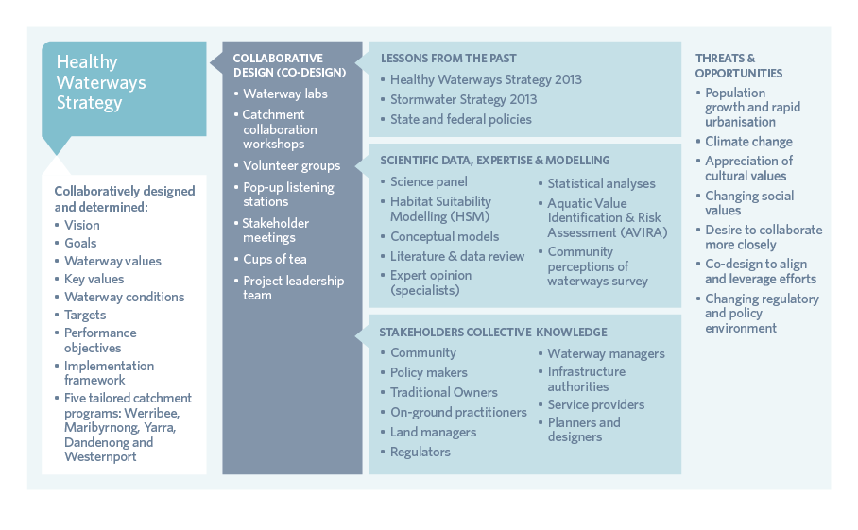
Figure 11. Developing this Strategy
This section of the Strategy summarises a multi-layered process of development. More detail about this process is provided in the Healthy Waterways Strategy Reference Document (2018). Key elements of the process are outlined in the following sections:
- Collaborative design (co-design) – section 7
- Lessons from the past – section 8
- Scientific data, expertise and modelling – section 9
- Stakeholder collective knowledge – incorporated into co-design, section 7
- Development of trajectories (scenarios) and targets – section 9.

7. Collaborative Design (co-design)
Collaborative design is a key strength of this Strategy, which has gone beyond traditional consultation approaches and has empowered the community and stakeholders to genuinely be involved in its creation and design.
Over 630 individuals representing over 220 organisations via 23 workshops have partnered to shape this Strategy, from project inception in September 2016 to formal consultation on the draft in July 2018.
The process has encouraged partners to contribute in their areas of interest, knowledge and/or responsibility. It has enabled a synthesis of scientific data, modelling and on-ground experience, and built on this shared expertise. The power of this collaboration lies in the shared sense of ownership, purpose and alignment.
Figure 12 illustrates how the process helped to identify the ‘sweet spot’ – where science and local knowledge overlapped. We have found that the overlap was generally strong. For example, in the Maribyrnong catchment, there was 60-80 per cent overlap of stormwater and revegetation priorities coming from both local knowledge and the science tools.
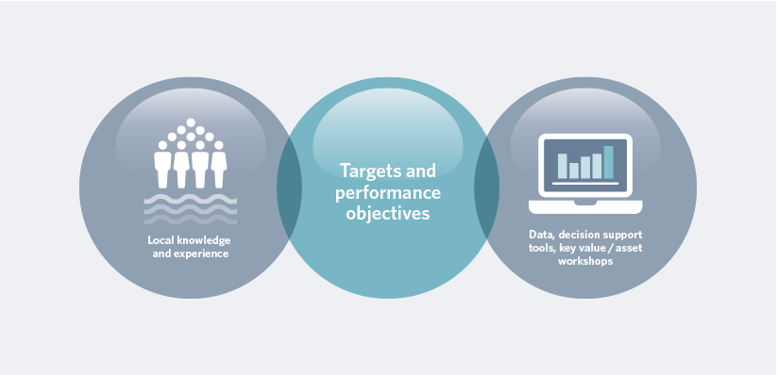
Figure 12. Alignment of collective knowledge and science produced the targets and performance objectives

The co-design process comprised five key elements:
Local knowledge and experience
- Participation in four Co-design Labs (three to inform the co-design process, and one to discuss co-implementation). The Labs brought together people with a strong interest and experience in waterway management to consider the topics on hand.
- Guidance on the Strategy development process from an independently-chaired Project Leadership Team, with representation from the Port Phillip and Westport CMA, EPA Victoria, DELWP, Parks Victoria, the Municipal Association Victoria and Melbourne Water.
- Trial of a co-design process in the Maribyrnong catchment, where participants jointly designed the development process for the Strategy.
- A sequence of workshops for the remaining four catchments, each with a set of issues for discussion and decisions, and based on the Maribyrnong trial. Each catchment was invited to confirm or improve the Strategy development process along the way.
- Invitations to participants to give feedback throughout the process on the impact of the workshops, their ideas and connections to waterways, and what they were doing differently. An analysis and summary of findings were provided to participants following each workshop and provided vital information for developing subsequent workshops.

Other elements of the co-design process were:
- Five volunteer working groups developed the catchments’ vision and goals. Three additional groups gathered in the Maribyrnong catchment to discuss social and environmental values, education and strategy implementation.
- Tailored engagement with the three Registered Aboriginal Parties (RAPs) across the region: Wurundjeri Land Council, Bunurong Land Council and Wathaurong Aboriginal Corporation.
- Three rounds of formal consultation provided additional feedback on the draft catchment vision and goals (September- November 2017), preliminary targets and performance objectives (March-April 2018) and the draft Strategy and Co-Designed Catchment Programs (June-July 2018).
- Nine community listening posts (at regional locations) to hear what the general public values about its waterways.
- A digital engagement website (YourSay) that received over 16,000 visits and regular communication with nearly 900 mailing list subscribers.
- The outcomes of consultation undertaken by Melbourne Water on related projects (for example the Yarra Strategic Plan) have also been considered.

Evaluating the Collaborative Process
This Strategy aimed to shift people’s thinking and their relationships, and to build willingness to take action and collaborate. Ongoing evaluation and feedback informed the project team whether they were on the right track.
It also showed participants that the time and energy going into the collaboration was paying off.

Building on and Evaluating the Collaborative Process
“The collaborative process ensures all voices are heard equally.” Maribyrnong (June 2018)
“Great passion and spirit of collaboration. People felt comfortable to ask the hard questions and challenge the status quo.” Regional Lab (May 2018)
“I enjoyed the continual focus on how this is a collective strategy, not just Melbourne Water.” Dandenong (March 2018)
“I enjoyed hearing about the alignment between the science and community opinions.” Yarra (March 2018)
“Getting so many diverse individuals and organisations involved in waterway management in the one room.” Westernport (October 2017)
“It was a good opportunity to scope out the project for this catchment.” Werribee (August 2017)

A participant’s experience
Tony Smith, an active member of Friends of Moonee Ponds Creek and Friends of Maribyrnong Valley, participated in the Healthy Waterways Strategy Catchment Collaborations workshops.
“You have to work with people effectively and have good relationships to get things done. I’ve been opinionated and encouraged and thrilled by the collaborative process.”
“A critical thing was Melbourne Water put community into the process at the same level as everyone else. Whether it was local government, state instrumentalities, academics or community, we were all in together. There were no pecking orders; it was a democratic process.”
“Waterways are incredibly complicated; every place is different. Community involvement will help get the details right because most of the people who are interested have intense knowledge of a relatively small geographic area or a specific interest that they know more about than anyone else in the world.”
“When people feel listened to it makes an enormous difference.”
“I’ve been to so many community engagements over the last 10 years and this was by far the top of the pile with the level of engagement and the results. There was an enthusiasm to participate and it is infectious.”

8. Lessons from the past
Melbourne Water led the implementation of both the Healthy Waterways Strategy (2013) and the Stormwater Strategy (2013) between 2013 and 2018.
The Healthy Waterways Strategy (2013) outlined the role Melbourne Water would play, in partnership with the community, customers and stakeholders, in managing waterways to ensure their value to the community was protected and improved. Table 1 summarises the achievements of the previous five-year Healthy Waterways Strategy.
Table 1. Region-wide achievements against the 2013 Healthy Waterways Strategy
Works | Target | Achievement
Vegetation established (kilometres) | 802 | 850
Vegetation managed (kilometres) | 7579 | 8937
Stock exclusion fencing constructed (kilometres) | 545 | 489
Number of fish barriers removed | 16 | 19
Aquatic habitat improved (hectares) | 193 | 291

The Stormwater Strategy (2013) articulated a shift in the way stormwater was managed to a more integrated, multi-benefit approach. Key achievements are provided in Table 2.
Table 2. Region-wide achievements against the 2013 Stormwater Strategy
Activity | Target | Achievement
Delivered structural and strategic stormwater projects to achieve multiple community outcomes through the Living Rivers program | 125 | 290
Delivered capacity building initiatives under the Clearwater program | 100 | 120
Delivered industry workshops aiming to reduce key industry gaps in stormwater management by Clearwater | 10 | 22
Nitrogen loads will be reduced by a further 10 tonnes towards the Port Phillip Bay water quality target | 10 tonnes | Exceeded

The key insights from the implementation and review of the previous strategies are:
- Targets were exceeded, apart from the construction of stock inclusion fencing target which relies on engagement with private landowners
- Continue with the waterway values and condition approach of the Healthy Waterways Strategy (2013) because it has been effective
- Combine the 2013 Healthy Waterways Strategy and Stormwater Strategy to ensure alignment and reinforcement
- Increase focus on the region’s estuaries and wetlands
- Improve the adaptive management program and extend the implementation period of the Strategy to 10 years because adaptive management will be a key strength in light of changing climate and land use conditions
- Continue Melbourne Water’s commitment to resourcing waterway management and bolster the collaborative arrangements around waterway management to minimise duplication and increase effectiveness.
This Strategy strongly builds on these insights and achievements, including performance objectives for continued capacity building, establishing continuous streamside vegetated buffers, removing fish barrier to ensure instream connectivity and preventing decline in stormwater condition by maintaining low directly connected imperviousness.

9. Scientific data, expertise and modelling
A complex array of data, modelling and specialist expertise has been integrated into this Healthy Waterways Strategy. Habitat Suitability Modelling (HSM) is an example of leading Australian science, which represents a major step forward for regional waterway management.
Community perceptions of waterways surveys are also beginning to identify what the community values about waterways, but more remains to be done in future years to better comprehend the social values of waterways.
Several scientific modelling tools have been used to gain insight into potential futures and to assess the cost-benefit of management interventions. The selection of these tools has been driven by data availability, confidence in data and knowledge, timelines and resourcing. The ‘science’ informing the Strategy has been overseen by a panel of waterway scientists.
Scientific methods and tools used in the development of this Strategy are briefly outlined in the following sections. Their application (where they are highly complex or technical in nature) is more comprehensively documented in the Healthy Waterways Resource Document (2018). Table 3 provides a summary of how different tools have been used.

Table 3. Evaluation and target setting for key ecological and social values
Steps | Key values for estuaries and wetlands | Key values for rivers
 |  | Fish, platypus, macroinverte- brates | Vegetation | Frogs and birds | Amenity, community connection and recreation
Key value status | Aquatic Value Identification Risk Assessment (AVIRA) | Habitat Suitability Models (HSM) | Spatial data and expert opinion | Spatial data | Community perceptions of waterways
Threat analysis | AVIRA and expert opinion | HSM models and data | Data and expert opinion | Expert opinion | Data and conceptual models
Current trajectory for waterway conditions and key values | AVIRA and expert opinion | HSM models and expert opinion | Data and expert opinion | Expert opinion | Data, conceptual models and collaboration
Long-term targets for conditions and values | AVIRA and expert opinion | HSM Zonation and expert opinion | Existing targets and Zonation | Expert opinion and data analysis | Conceptual models and collaboration
10-year performance objectives | Risk-based AVIRA | Zonation and internal experts | Risk-based | Cross checking with Zonation and review of existing Healthy Waterways Strategy priority areas | Conceptual models and collaboration

9.1. Aquatic Value Identification and Risk Assessment (AVIRA)
AVIRA has been applied to key environmental values for estuaries and wetlands, and to key social values for estuaries.
The AVIRA framework is a statewide tool that provides a consistent approach to describing the environmental, social, cultural and economic values of waterways, and the assessment of threats to these values. The framework comprises a standardised list and scoring system (metrics) of values and threats to waterway assets. Metrics include presence of rare or threatened species, formally recognised significance such as a Ramsar listing, and significance of a waterway for recreational fishing. Threats are similarly described and include metrics such as reduced wetland area, degraded vegetation or poor water quality, or presence of weeds or pest animals.
AVIRA value and threat metric data was collected for 29 estuaries and a sub-set of 81 wetlands for this Strategy. Sources of data included monitoring programs, statewide data sets, aerial photography, site management plans or Index of Estuary Condition (IEC) data, where available.
AVIRA indicated that for many regional wetlands and estuaries, threats were already at the highest level possible, but that in many, significant key values still exist.
For more information on AVIRA, the key underpinning science and limitations, refer to the Healthy Waterways Strategy Resource Document (2018).

9.2. Habitat Suitability Modelling
Developed by Melbourne Water and the University of Melbourne, quantitative Habitat Suitability Models (HSMs) are a significant advancement since the development of the 2013 Healthy Waterways Strategy.
Based on over two decades of survey data and analysis of habitat conditions where animals are present or not present, the HSMs predict the quality of habitat for particular species and the potential for that species to occur in a certain section of river. The HSMs include the ability to predict the likelihood of finding animals where survey data is lacking, and can identify and compare the expected benefit of undertaking different types of waterway management actions, including streamside revegetation, stormwater management and removal of fish barriers. The reliability of HSMs’ predictions were quantitatively and qualitatively assessed, including comparison with the known distribution of animals and whether the predictions make ecological sense.
HSMs were used in this Strategy to predict where habitat is suitable for three of the environmental ‘key values’: macroinvertebrates (52 families), native fish (13 species) and platypus.
The development of HSMs is summarised in Figure 13. For more information on HSMs, the key underpinning science and limitations, refer to the Healthy Waterways Strategy Resource Document (2018).
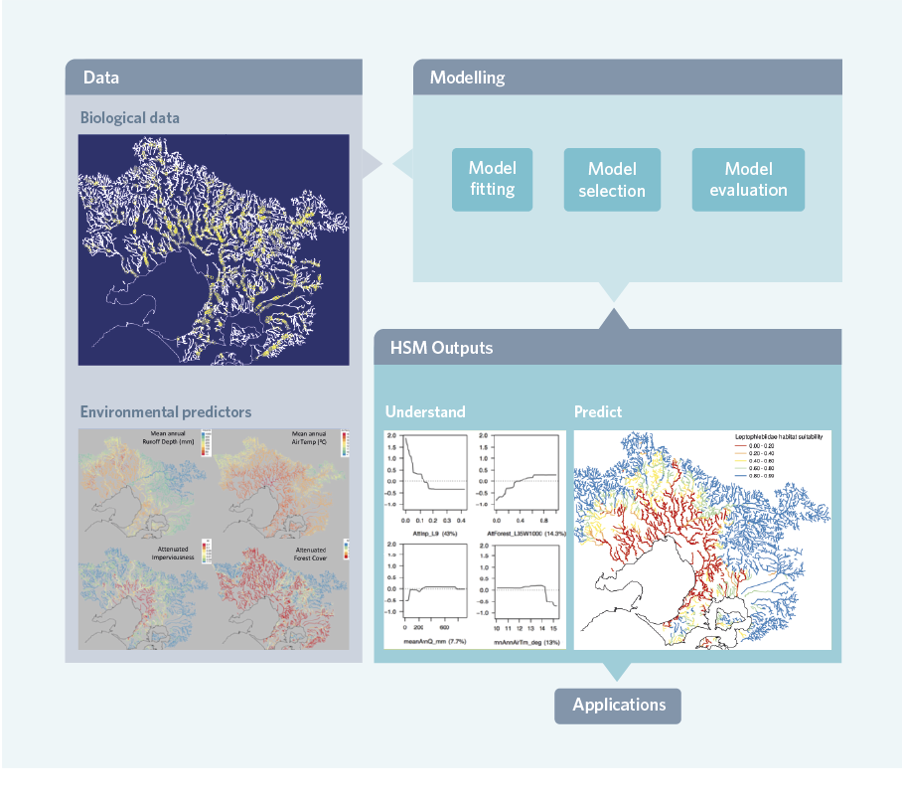
Figure 13. Habitat Suitability modelling process

9.3. Zonation
Another software tool called Zonation was used to combine habitat suitability and cost of management, to identify the most cost-effective management actions.
In combination with local expertise and knowledge captured during the collaborative workshops, the predicted benefits of these actions were used to develop the 10-year (performance objectives) and 50-year targets for instream values within each of the Co-Designed Catchment Programs. Figure 17 outlines the process for developing actions and targets for the macroinvertebrates, fish and platypus key values.
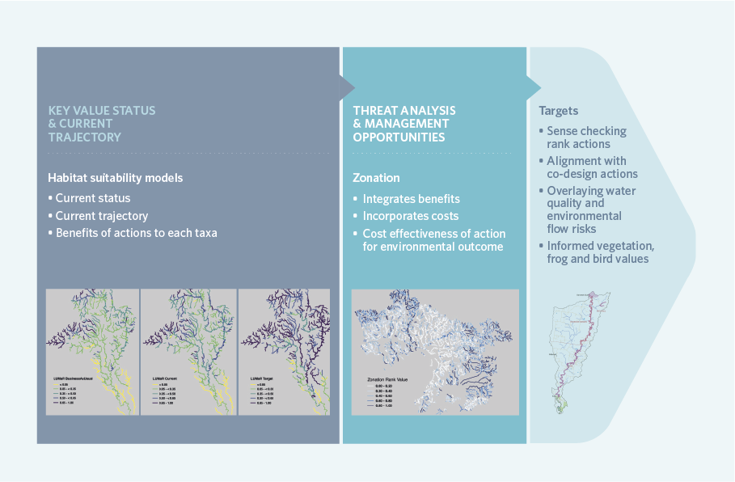
Figure 14. Process for developing actions and targets for key values – macroinvertebrates, fish and platypus

9.4. Conceptual models
Conceptual models are used to describe how certain management actions are known (or assumed) to produce a particular environmental or social value response. For example, they can help us to understand how the provision of streamside vegetation affects water temperatures, and how this then affects fish populations. A conceptual model can be a simple table or a complex diagram.
In this Strategy, many conceptual models have been used to help identify which waterway conditions are most (or least) important, and what management actions might be applicable to protect and enhance these conditions. The social values conceptual model is illustrated in Figure 15.
For more information on the development of conceptual models, the key underpinning science, and limitations, refer to the Healthy Waterways Strategy Resource Document (2018).
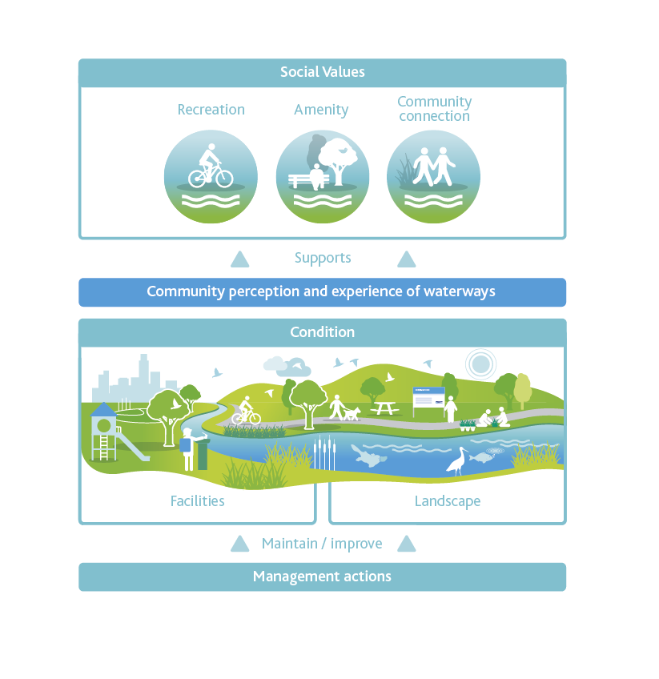
Figure 15. Conceptual model - social values

9.5. Data and expert input
A range of experts were engaged during the development of the Healthy Waterways Strategy to provide knowledge, conduct reviews, compare results, analyse, and add depth and richness to our understanding of technical and scientific matters.

Using expert opinion and monitoring data to inform the status of riparian birds
The bird value ‘metric’ (or measure) adopted for this Strategy for riparian birds is well developed. It has been tested against expert opinion and used in numerous applications over several years.
The metric is informed by a comprehensive list of expected native riparian species and builds on:
- a dataset held by Birdlife Australia (which holds over 400,000 bird records) based on 20,370 appropriate bird surveys within 250 metres of streams and wetlands, all collected by community volunteers between 2012 and 2017
- analysis of this data
- discussion with ornithologists (bird experts).
Statistical analysis showed the need for at least 40 robust surveys to determine the full suite of bird species present. Most Birdlife Australia surveys do not record actual counts of birds present, so the reporting rate has been used, or the proportion of surveys in which a species is recorded as a surrogate for species’ abundance and frequency of habitat use.
The reporting rates of all expected riparian species recorded are summed and then normalised (to account for differing numbers of expected species in different catchments) to generate a single metric capturing appropriate species richness and frequency of habitat use.

Likely future
In order to estimate the likely future trajectory of riparian communities a survey was sent to 85 bird or habitat management experts in the region. The expert feedback was that, under current management practices and investment, the condition of riparian bird communities would generally decline over the foreseeable future due to new urban growth, land use intensification and climate change effects. Declines were not forecast to be universal, and there are some sub-catchments where the majority of experts believed improvements to riparian bird communities were possible.

9.6. Planning scenarios (trajectories) and waterway targets
In order to understand how improving waterway values might contribute to long-term targets, two planning scenarios (or trajectories) were prepared and tested for each waterway. The scenarios estimate the likely waterway outcomes with two different levels of management effort, policy and climate variables. These trajectories demonstrate that a step-change in waterway management is required over the next 10 years, to prevent broad scale loss of waterway values.
Many assumptions have been built into the scenario planning, including that climate change predictions will affect our waterways (in line with the principles outlined in the Climate Change Act 2017) and that the current urban growth boundary will reach ‘ultimate’ development within the next 50 years.

Current Trajectory
This scenario represents the expected change in waterway health if current programs and approaches continue, otherwise referred to as the ‘business as usual’ approach.
This scenario indicates a worsening of key values across the majority of the region’s waterways’ key values.
A key learning from this scenario is that even with the extensive existing effort and resources contributed by waterway managers, agencies and community, it will be extremely difficult to maintain all the waterway values everywhere. This knowledge provides a definitive call to action, and confirms that aligned, increased and collaborative efforts will be required over the next 10 years.

Target Trajectory
This scenario represents what can be achieved with an increase in coordinated, collaborative and prioritised effort. It is the scenario that the Strategy partners have agreed is required. Maintaining, and where possible improving, waterway health is what the Healthy Waterways Strategy proposes to achieve. This ‘target trajectory’ includes assumptions on policy allowing increased standards for stormwater management, increased resources for waterway management, willingness to take collaborative actions, and that it is feasible to establish continuous vegetation buffers along the majority of waterways.
Figure 16 compares the current and target trajectory of a sample river.

9.7. Setting performance objectives and targets
Performance objectives are short-term (one to ten-year) quantitative steps to achieve the Strategy’s waterway targets (refer to the program logic, Figure 6). Examples include maintaining recreational water quality at a specific location or increasing participation rates. Performance objectives will be the result of actions that have yet to be defined through collaborative implementation (further described in Part E). Examples of actions include fencing along waterways or engaging schools with citizen science projects.
Performance objectives occur at three scales and are outlined in the following sections of the Strategy:
- Part C: Region-wide performance objectives (includes performance objectives for cultural and economic waterway values)
- Part D: Catchment-specific performance objectives (includes performance objectives for environmental and social waterway values)
- Part E: Implementation (administrative) performance objectives.
The Strategy’s multi-scale performance objectives serve two purposes:
- They ensure that local and regional opportunities are achieved and aligned.
- They enable different organisations to contribute at a scale and magnitude that matches their size, resources and level of authority.
Waterway condition targets are also measurable, but are likely to be achieved in a period beyond the 10-year Strategy implementation horizon, although some progress will be measured for some conditions in some locations in a shorter time frame. These may include measurable improvement in water quality in a certain river, or the extension of the native vegetation buffer for a specific wetland.
Waterway key value targets are long-term targets, developed with a 50-year outlook. Examples of such targets include having most of the expected frog species present in a selected waterway or establishing habitat that has very high likelihood of supporting platypus populations.
Environmental and social waterway targets are calculated at the asset level (river reach, estuary or wetland) and then amalgamated at the sub-catchment, catchment and/or regional scale. Cultural and economic values do not have targets at this stage, but they do have performance objectives set at a regional scale.
Performance objectives and targets have been determined to keep the waterway investment at a level that will maintain each waterway on its target trajectory, and to ultimately achieve the Strategy’s goals and visions.

9.7.1. Social and environmental values
Environmental values are the most understood waterway values. Table 3 and sections 9.1-9.6 illustrate the depth of scientific knowledge and analytical capability that has informed the setting of targets for the six environmental key values, associated conditions and performance objectives. The targets and performance objectives provide quantitative measures of progress towards qualitative goals and vision, within the program logic approach. This approach is described in section 2.2.
The program logic approach has also been used to develop the targets for the three social key values, associated conditions and performance objectives. The social values of waterways are becoming better understood; however, it is recognised that the methodologies and knowledge collective are still developing.
Figure 16 outlines the data and decision support tools that were used to set the targets and performance objectives for the three social key values.
In developing these targets and performance objectives, several factors became apparent:
- Community perception of waterways is influenced by various external elements (for example, social media) as well as individuals’ preferences and background.
- While some preferences apply community-wide (for example, natural waterways are preferred to concrete channels), there is a continuum of preferences which makes identifying definitive relationships between value and perception difficult. For example, one sector of the community may be satisfied with a grassed park-like waterway, while another sector may prefer a wild forested waterway.
- Factors that support positive perceptions and satisfaction with waterways include opportunities for people to engage in a diverse range of experiences on or near waterways and improvement in the environmental condition of waterways.
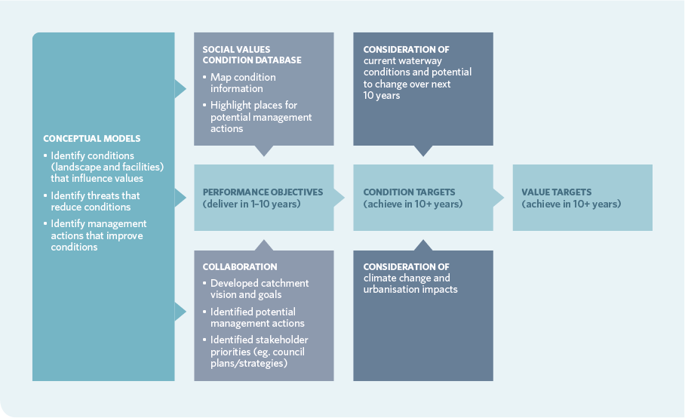
Figure 16. Data and decision support tools for the three social key values

Investment to maintain and improve waterway conditions that support social values is prioritised according to the following principles:
- direct investment to provide the most efficient and effective long-term improvements in waterways condition and the greatest community gain
- focus on regional priorities – this Healthy Waterways Strategy is a means to collaborate and focus on regional priorities and outcomes that may lose focus in individual agency or community organisation planning
- prioritise management activities that provide outcomes which meet the community’s greater needs over those of individuals or special interest groups
- consider social equity
- take advantage of opportunities presented by other investment (for example, a road widening project can incorporate shared user paths)
- align investment with relevant existing plans and strategies (for example, Urban Forest strategies, Recreational Paddling Investigations).

9.7.2. Cultural values
Cultural values are currently not well understood or documented, certainly not as well as social and environmental values. They are, at this stage, only addressed in this Strategy as performance objectives at a regional level. Data, methodologies and the knowledge collective to better understand these values needs to be further developed so that catchment-specific targets and performance objectives can be developed for both Aboriginal and other cultural values in the future.
Aboriginal cultural values need to be identified by Traditional Owners.
In enabling effective Aboriginal participation in natural resource management, this Healthy Waterways Strategy seeks to:
- support the Australian Government’s commitment as a signatory to the United Nations Declaration on the Rights of Indigenous Peoples
- meet the responsibilities set out in Australian and Victorian legislation and policy, including Traditional Owner agreements, Native Title, Aboriginal Heritage, the National Water Initiative, the Environment Protection and Biodiversity Conservation Act as well as the Catchment and Land Protection Act
- support existing and future Traditional Owner settlement arrangements
- support commitments set out in documents such as the Victorian Government Aboriginal Affairs Framework, Victorian Aboriginal Economic Strategy, and the Community Engagement and Partnerships Framework for Victoria’s Catchment Management Authorities
- support the intentions and agreements set out in the Regional Catchment Strategy, Water for Victoria and in other current plans and strategies.
Traditional Owners have been engaged in developing this Strategy.
The Aboriginal Participation Guidelines for Victorian Catchment Management Authorities has underpinned this engagement. The Guidelines:
- commit the Healthy Waterways Strategy and its implementation partners to engage and work with Traditional Owners and Aboriginal communities to manage and improve the health of land and waters
- commit the Healthy Waterways Strategy to be transparent in supporting Traditional Owner and Aboriginal community aspirations for recognition of rights, reconciliation, participation, employment and economic development through natural resource management
- act on the commitment of all Healthy Waterways Strategy implementation partners to strengthen their cultural competency
- build upon existing experiences, procedures and work practices
- complement the existing Community Engagement and Partnerships Frameworks of Healthy Waterways Strategy implementation partners.
The performance objectives in this Strategy were developed in partnership with the Wurundjeri Land and Compensation Cultural Heritage Council and approved by the Bunurong Land Council Aboriginal Corporation and the Wathaurung Aboriginal Corporation (Wadawurrung).

9.7.3. Economic values
Economic values are currently not well understood or comprehensively analysed, and at this stage only addressed in this Strategy at the regional level. Data and the knowledge collective to better understand these values needs to be further developed so that catchment-specific targets and performance objectives can be developed for economic values in the future.
The System of Environmental-Economic Accounting (SEEA) is an internationally accepted standard, with a set of accounting principles that can help recognise the interdependence of societies, economies and the environment.
Victoria is developing accounting applications based on the SEEA framework to provide better, integrated and more consistent information and analysis on our environmental assets.
This will incorporate information about which assets have been depleted or lost, which are declining in condition and how the health of these assets affects our wellbeing as a society.
This framework is intended to support government policy, planning and investment decisions affecting the environment. It will also strengthen the ability of local government, business, not-for-profit and community stakeholders to recognise the benefits of protecting and investing in the environment.
In order to develop the goals, targets and performance objectives needed for economic values, this Healthy Waterways Strategy has commenced the exploration and development of environmental-economic accounts to meet the following aims:
- increased engagement and understanding across government, private sector and communities about needs to sustain the region’s waterways
- increased understanding of the role of healthy waterways in the region’s progress and growth
- stronger capability to assess benefits from healthier waterways and hence better balance trade-offs between competing uses of waterways and water resources across the community when making policy, planning (resource allocation) and investment decisions
- support for government, businesses and communities to identify synergies where more sustainable practices improve waterway health, while supporting economic activity and social outcomes
- improvement in transparency and accountability to the government and the public in measuring the outcomes and effectiveness of government investments in the region’s waterways
- ability to undertake consistent analysis to improve programs and policy design over time.

10. Setting priorities
While we would ideally like to unlock the hidden value of waterways and rehabilitate all waterways in the region, there are too many with too much complexity to undertake such an enormous task. With limited resources and a 10-year implementation period, it is important to direct investment at the regional priority management activities that provide the most efficient and effective long-term improvements in waterway condition and greatest community gain.
The development of new science and tools has enabled this Healthy Waterways Strategy to prioritise management across the region based on the waterways’ environmental, social, cultural and economic values (and the threats to those values).
In setting this Strategy’s priorities, it was recognised that some values are of greater priority or significance, including:
- particularly important social, cultural or economic values (for example, recreation, Aboriginal cultural heritage, urban or rural drinking water sources)
- formally recognised significance (for example, recognition in the Convention on Wetlands of International Importance (the Ramsar Convention) or the Heritage Rivers Act 1992)
- the presence of highly threatened or rare species and communities such as species listed in the Environment Protection and Biodiversity Conservation Act 1999 (Cwlth)
- high naturalness values (for example, aquatic invertebrate communities or riparian vegetation) or special waterway features (that is, drought refuges or important bird habitat).
Priority for the development of the five Co-Designed Catchment Programs was also given to:
- waterways with significant value and where the management of the threats or opportunities was considered feasible
- waterways with significant value and minimal threats that just require protection.
In some cases, it was agreed that investment can be undertaken outside the nominated priorities. Principles for investing outside priorities include:
- the investment manages a source of threats to other priorities (for example, waterways with downstream priorities)
- there is a serious risk to public infrastructure from waterway processes or an opportunity to reduce risks associated with extreme events (such as floods)
- there is a new strong community commitment to improving the condition of their local waterway
- work is required to meet statutory or regulatory obligations
- pilot projects/research projects that aim to test and create new learning to improve management
- evolving evidence base or best practice changes investment priorities.

Part C

Regional Summary
A holistic approach to waterway management means actively managing waterways for all the waterway values (environmental, social, cultural and economic) they support. The Regional Summary section outlines the region-wide performance objectives (RPOs). This includes all performance objectives for cultural and economic values, along with social and environmental performance objectives applicable at the region-wide scale.
Alongside region-wide performance objectives, five Co-Designed Catchment Programs have been developed which identify specific 10-year performance objectives for sub-catchments, estuaries and wetlands. These Co-Designed Catchment Programs are summarised in Part D.

11. Cultural values
This section was developed with the Wurundjeri Land and Compensation Cultural Heritage Council Aboriginal Corporation and approved by the Bunurong Land Council and Wathaurung Aboriginal Corporation (Wadawurrung).
The overarching goal for recognising Aboriginal waterway values is:

Traditional Owners have a recognised role as custodians of waterways and their cultural values. Their unique perspective and knowledge allows them to influence the agenda for waterway management and actively participate in caring for their Country.
This goal is supported by a series of agreed principles on how we will achieve this goal and seven performance objectives.

How will we achieve our goal?
- Traditional Owners are involved at all levels of waterway management – planning, prioritisation and delivery.
- Traditional Owner groups have the resources and expertise to support a self-sustaining ‘waterway business’.
- Traditional Owners are included in planning and prioritisation processes as early as possible.
- Where possible, waterway management programs are designed to match the existing capability of Traditional Owner groups and participation increases their capability for involvement in future programs.
- The internal collaborative processes of Traditional Owner groups are supported with time and/or resources by waterway management partners.
- Waterway management is a job that an individual Traditional Owner can aspire to.

What we agree on:
- Partnership projects must develop intellectual property or expertise that can be applied by Traditional Owner groups to new situations.
- Participation in waterway management is an expression of culture. It is a cultural value in its own right.
- Contemporary Aboriginal culture is always developing and, as a result, things that have not been tried before need to be mutually supported.
- Partnership projects need to proceed at a pace that respects Traditional Owners’ other obligations and allow upskilling and inclusion of diverse individuals and communities. They must also facilitate intergenerational knowledge transfer.
The water industry is accountable to the general community via Traditional Owners. To judge progress, we rely more on conversations with Traditional Owners than performance measures.

Performance Objectives
RPO-1 | Traditional Owners and Aboriginal Victorians have an increased expertise in contemporary land and waterway management, waterway science and lore.
RPO-2 | Partnership projects build on what is working. Expertise developed in one project is applied in others.
RPO-3 | Traditional Owner groups and Aboriginal Victorians are supported by industry partners to influence the agenda for waterway management by proactively developing communications, resolutions or project scopes and seeking industry partners.
RPO-4 | Aboriginal and Traditional Owner cultural awareness training is available to all industry professionals and is actively pursued.
RPO-5 | Cultural competency is valued as a career skill and leads to ongoing relationships.
RPO-6 | Partnerships are fostered between Traditional Owner groups and research groups, and Traditional Owner groups and community groups.
RPO-7 | Public events led and/or organised by Traditional Owners are regular and frequent.

12. Economic values
Waterways are recognised as important natural capital providing regionally-significant ecosystem services, which are the benefits that humans receive from nature, as well as contributing to the health and wellbeing of the communities who visit, use and care for them.
Many values that waterways support, including economic values, are rarely reflected in organisational or national decision-making frameworks. The System of National Accounts (SNA) is an internationally agreed standard on how to compile measures of economic activity. The SNA specifically excludes environmental features such as the atmosphere and ecosystems. Environmental-economic accounts work alongside conventional accounts with the aim of tracking the health of ecosystems and their ability to produce goods and services that benefit populations. This Healthy Waterways Strategy has commenced the exploration and development of environmental-economic accounts. Section 9.7.3 outlines a number of aims associated with developing environmental-economic accounts to support recognition of economic values. The following performance objectives will measure progress towards these.

Performance Objectives
RPO-8 | Environmental-economic accounts are developed for the region’s waterways using contemporary international standards, and are used to demonstrate the returns on catchment and waterway investment.
RPO-9 | Environmental-economic accounting is incorporated into Healthy Waterways Strategy monitoring, evaluation and reporting (MER) by 2023.

The use of environmental-economic accounting may also support the understanding of the multiple benefits associated with investment in waterways. For example, the timing of environmental flows release to meet ecological objectives can also provide opportunities for kayaking. Likewise investment in waterways management can improve community health and wellbeing.

13. Approaches and responses to region-wide threats to waterway values

13.1 Responding to climate change
Further consideration is needed to understand the predicted impacts of climate change on the resilience of environmental values into the future and determine possible courses of action. Adaptive pathways planning is an approach that shows how with future uncertainty, options can be implemented over time. Strategies (or pathways) are developed that are robust and flexible against multiple plausible futures or scenarios.
Ongoing research and monitoring, adaptive management and adaptive pathways planning will enable good decisions now and preparedness for future conditions.
Preparing for the impacts of climate change will be done in alignment with the requirements of the Climate Change Act 2017 and help shape and inform the development of the Climate Change Strategy and Adaptation Action Plans required under the Act. By managing risks to waterway assets and services, working closely with local governments and supporting adaptation action for the natural and built environment, this Strategy will contribute to the Government’s adaptation priorities outlined in Victoria’s Climate Change Adaptation Plan 2017-2020.
Three key responses to the impacts of climate change are outlined below.

13.1.1. Environmental water reserve
The environmental water reserve was established by the Victorian Government to ensure that water is available to protect the environmental values of waterways. Future stream flows are now predicted to be lower than previously modelled, and it is clear that additional water will be needed to meet environmental objectives for the region’s waterways. It is also acknowledged that there will be additional and ongoing demand for rural and urban water supply from the catchments, including water for domestic, stock and agricultural uses.
Over the long term, the shortfall due to climate change is estimated at between 36–70 billion litres (36 GL–70 GL) per year. This Strategy targets an increase of the environmental water reserve by 23 billion litres (23 GL) per year by 2028, with any water recovery for the environment considered through the Victorian Sustainable Water Strategies (SWSs), markets and use of alternative water. Contribution from each catchment to this total is identified as performance objectives in the Co-Designed Catchment Programs and outlined in the table below.

River System | 10 Year Performance Objective | Long-Term Shortfall
Werribee River | 7 GL per year | 10-20 GL per year
Maribyrnong River | 5 GL per year | 10-20 GL per year
Yarra River | 10 GL per year | 15-25 GL per year
Tarago and Bunyip River | 1 GL per year | 1-5 GL per year

Note: Any water recovery for the environment will be considered through the Victorian Sustainable Water Strategies, markets and use of alternative water.

13.1.2. Groundwater-dependent ecosystems
Water flow management across the catchments must also consider the dependency of some high value and high risk ecosystems on not only the streamflows, but on infiltration and groundwater. These ecosystems are known as ‘groundwater dependent ecosystems’. It is important to increase the health of these ecosystems when times are good, so that they have greater resilience to withstand drier periods. Assessments of climate change impacts on recharge rates of groundwater and interactions with surface water are needed to improve understanding of the resilience of groundwater dependent ecosystems and their water sources.

13.1.3. Alternative water sources
Using alternative sources of water that are ‘fit for purpose’ (that is, of an appropriate quality for its intended use) can help reduce reliance on water from our waterways and groundwater systems. Urban stormwater will represent a large alternative water source for many parts of Melbourne. Another alternative water source is recycled water produced from sewage treatment plants. Recycled water is released to waterways for a range of reasons. In some cases this may provide environmental or social benefits. However, negative effects can also result where recycled water is released to waterways and may counteract or outweigh any benefits provided.
Proposals for using recycled water for environmental purposes must be carefully assessed on a ‘case by case’ basis and only supported where they provide overall net benefits to the community and the environment and no detriment to human health. The waterway manager for the proposed system must also be satisfied that any flow benefit is consistent with environmental flow requirements. Melbourne Water will work with DELWP, EPA and other relevant water corporations to communicate approval pathways and cost sharing principles.
For example, increasing flows by discharging recycled water to a flow-stressed waterway could provide benefits if at the right time, duration and quality. However, recycled water treatment plant discharges can contain water quality that may not support net environmental benefits, such as elevated nutrients or micro-pollutants (for example, pharmaceuticals) that are not easily removed by the treatment process. Consequently, the benefits of an increased flow will not be realised if the discharge is not of an appropriate quality or timing for that waterway resulting in a small net environmental benefit or negative impact.
The following performance objectives are designed to monitor progress towards managing the impact of climate change.

Performance Objectives
RPO-10 | An adaptive pathways approach is adopted to understand and manage the risks of climate change on waterways.
RPO-11 | Understanding of groundwater dependent ecosystems is improved and opportunities to maintain or improve these continue to be investigated.
RPO-12 | Water for the Environment continues to be managed and delivered to the region’s rivers and wetlands and recovery options continue to be investigated.

13.2. Responding to urban stormwater and pressures of urbanisation
Urban stormwater is a unique threat in that it is also an opportunity – a threat if current management practices are continued and an opportunity if urban stormwater is used as a resource.
Through the collaborative development of the Healthy Waterways Strategy, community knowledge and understanding of the vast scale and impact of the stormwater threat to waterways has become better understood. While urban waterways can and are being irreversibly impacted by stormwater, we know that some of our urban waterways still have high ecological values that can be protected and/or rehabilitated if urban stormwater is appropriately managed. This understanding has enabled the setting of ambitious stormwater targets that are essential to meet community waterway and bay health expectations. Failing to meet these targets is forecast to lead to significant declines in the health of most urban waterways across the region.
A first for the region, the Strategy identifies priority areas for enhanced stormwater management. In these areas, stormwater management will seek to maintain the natural water cycle that is necessary to protect the good ecological health of those waterways. Performance objectives in the Co-Designed Catchment Programs outline that a combined stormwater volume in excess of 80 GL/a needs to be captured and 20 GL/a needs to be allowed to soak into the ground, to protect and/or restore waterways. The priority areas are identified in Figure 17.
Although managing the excess volumes generated by urbanisation presents practical challenges, it also presents a significant opportunity for better waterway and bay outcomes that would diversify the region’s mix of available water resources as well as improve wellbeing and public safety.
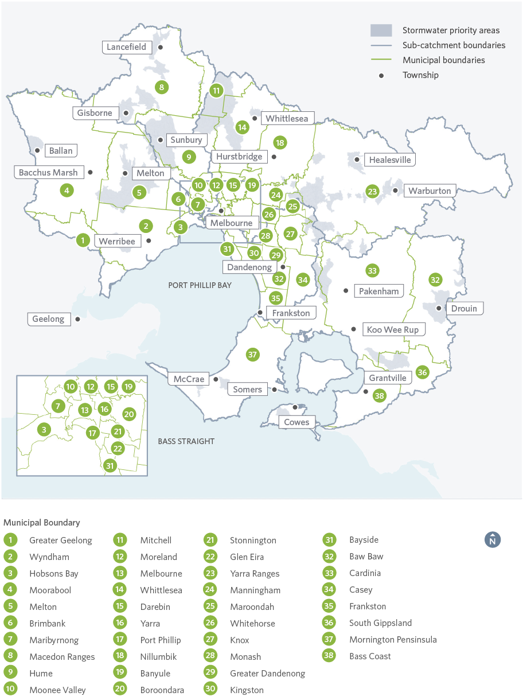
Figure 17. Priority areas for enhanced stormwater management

The benefits of improved urban stormwater management include:
- healthier waterways and bays
- a viable, fit-for-purpose alternative water supply
- increased community wellbeing and amenity through access to cooler, greener urban spaces and recreation areas
- improved public safety by reducing the risk of flooding and providing safer water recreation.
Delivering the Strategy’s stormwater targets will require extensive stormwater solutions that can manage flows as well as water quality. These may include large-scale stormwater harvesting schemes (that involve the collection, treatment and re-use of stormwater for different purposes such as watering of sporting fields), distributed on-lot systems (for example, rainwater tanks, raingardens, green roofs, living walls), street and end of pipe systems (for example, street trees, biofilters, stormwater treatment wetlands, new innovative products) or a combination of these approaches, as place-based responses to specific local constraints and opportunities. As well as protecting flows and water quality in waterways for environmental values, these solutions keep water in the landscape and soils providing cooler, greener urban places, supporting public health and wellbeing. This will be increasingly important with increased and prolonged periods of heat expected from climate change.
Tackling urban stormwater and pressures of urbanisation is both challenging and urgent due to the pace and scale of growth, the complexity of the technical solutions involved and the significant planning already underway (including waterway corridor planning, precinct structure plans and development services schemes). Some of the key approaches for this are outlined below.

13.2.1. Integrated water management and capacity building
Integrated water management (IWM) is a body of practice that considers the movement of water across and through the landscape, its uses and disposal, its sources and its destinations. This is referred to as a ‘whole of water cycle’ approach. IWM acknowledges that all parts of the water cycle and land use practices are intrinsically connected. IWM requires a collaborative approach to planning, bringing together organisations that influence all elements of the water cycle, from wastewater management, alternative and potable water supply, stormwater management and water treatment.
IWM supports preparedness to extreme events, and challenges from climate change and population growth. It aligns water and land use planning, and investment decisions that take into account beneficial outcomes, including those articulated in the Strategy. IWM will be key to meeting challenges associated with urban stormwater.

Integrated Water Management Forums
In 2018, the water industry, supported by the Victorian Government, established Integrated Water Management Forums to identify and prioritise areas that would most benefit from collaborative place-based planning. Forums have been established in the five major catchments. Agencies including water corporations, catchment management authorities, local government, Traditional Owner groups, the Victorian Planning Authority and others are participating in these forums.
These forums consider the waterways outcomes that are set out in this Strategy together with other key elements of the water cycle such as water supply.
Capacity building that strengthens collaborations is essential to support adoption and implementation of the stormwater management practices (including planning and policy responses) needed to achieve the outcomes set in this Strategy.

Clearwater – integrated water management capacity building
Clearwater is a capacity building program working together with the water industry to transform the way water is managed, using IWM approaches.
Clearwater is hosted by Melbourne Water, and supports a diverse collection of professionals and organisations to improve their skills, knowledge and capability to promote and implement ‘whole of water cycle’ practices. Clearwater delivers industry capacity building initiatives through network building, specialised training workshops, guided technical tours and other knowledge sharing activities to ensure the latest technical and scientific information is put into practice.

13.2.2. Water harvesting
Water harvesting is a key element to achieve the ambitious stormwater targets set in this Strategy. Solutions may include:
- large scale stormwater harvesting schemes (collection, treatment and re-use of stormwater for a range of purposes, such as watering of sporting fields)
- distributed on-lot systems (for example, rainwater tanks, raingardens, green roofs, living walls)
- street and end of pipe systems (for example, street trees, biofilter, stormwater treatment wetlands, new innovative products)
- a combination of these approaches, in response to place-specific constraints and opportunities.
As well as protecting flows and water quality in waterways for environmental values, these solutions keep water in the landscape and soils providing cooler, greener urban places, supporting public health and wellbeing.

13.2.3. Planning and policy responses
Planning and policy responses are a key mechanism for protecting and managing the impacts of stormwater on waterways. Several planning approaches will be necessary to meet this Strategy’s objectives for widespread implementation of stormwater management and appropriate urban development including:
- Develop place based approaches to integrating urban development with waterway management to more closely match local characteristics and waterway health objectives. This includes updated best practice performance objectives for stormwater quality appropriate to each region or catchment.
- Upgrade and develop tools to support future urban development that minimises impacts on waterway health and enhances amenity values.
- In the long-term, beyond the next 10 years, it has been assumed that higher stormwater standards will be applied across the region to achieve significant improvements in the character of urban waterways across the greater Melbourne area within a 50-year horizon.
- The State Government is responsible for the Victoria Planning Provisions (such as Clause 56.07-4), which incorporate stormwater management objectives and associated requirements for development to reduce their impact on waterways, bays and the ocean. It has been acknowledged that these requirements are currently limited and need to be updated. The Victorian Government has initiated a review to examine options to revise existing planning scheme provisions and an update of the Urban Stormwater – Best Practice Environmental Management Guidelines. Improving these standards and regulations will assist the implementation of this Healthy Waterways Strategy.
Some waterway managers and local councils have applied additional local stormwater and development standards to address existing gaps.

Case study: Western Water’s ‘Development IWM Plans’
Western Water’s region is in the midst of a rapid growth in population and increased imperviousness due to increased housing and suburban infrastructure. Western Water has a long-term commitment to waterway health and is implementing an Integrated Water Management (IWM) Strategy across the rapidly urbanising region. The business has recognised that regional IWM Forums will assist in driving Western Water’s Urban Water Strategy and deliver on catchment and regional IWM objectives. Western Water has also recognised that planning at the development scale is a very powerful mechanism for managing the urban water cycle including improving water efficiency and managing sewerage, as well as improving stormwater and waterway health outcomes.
Since 2017, Western Water requires developers to provide a Development IWM Plan, as a condition of planning permits. The Plan must outline how the water cycle as a whole will be managed across the development. This process brings together the water cycle management requirements of Western Water, Melbourne Water and local councils into a single plan.
Guidance for the preparation of a Development IWM Plan was developed collaboratively by several agencies and finalised in August 2018. A Development IWM Plan is now required for all planning schemes.
It is intended that Development IWM plans will reference catchment scale and regional scale IWM planning, and address performance objectives outlined in the Healthy Waterways Strategy.
Initiatives pursued by developers through their Development IWM plans to date have included:
- stormwater harvesting for public open space irrigation
- passive irrigation of street trees
- residential rainwater tanks
- class A and B reticulated recycled water supply
- digital metering of water supply systems.
- End Case Study -

13.2.4. Stormwater retention and constructed wetlands
Stormwater retention systems include constructed wetlands and other smaller stormwater retention systems such as raingardens, bio-retention and stand-alone sediment ponds.
Constructed urban stormwater treatment wetlands remove harmful pollutants from stormwater before it reaches waterways and bays. They also slow flows and store water (lessening the impact of wet weather flows on downstream waterways), reduce flooding, provide local cooling and space for recreational activities like bushwalking and birdwatching, and can be designed to provide a water source for irrigation. Many constructed wetlands are valued by their local community for their amenity.
There are many managers for the hundreds of constructed wetlands across the region, including local government and water corporations. Melbourne Water alone owns and maintains more than 370 stormwater quality treatment systems, typically wetlands, including their upstream treatments such as sediment ponds and litter traps.
There is significant opportunity to retrofit existing wetlands to meet this Strategy’s infiltration and harvesting targets, through modifying designs and promoting stormwater harvesting. It is acknowledged that a comprehensive program to manage and maintain these diverse stormwater assets, using a risk-based approach, is required. This will ensure assets continue to perform their designed functions, including the management of flows, treatment of nutrients, and the detention of sediment and other pollutants.

How constructed fresh water wetlands work
- Water from rivers or creeks is directed into the wetland and slowly travels through several small ponds. This lets litter, sediment and other pollutants in stormwater sink to the bottom.
- Water is also filtered by microorganisms and algae that grow in the water, on the bottom of the wetland or on wetland plants, further removing pollutants such as nutrients.
- After one to three days in the wetland, cleaner water drains back into the river or creek and water levels return to normal.
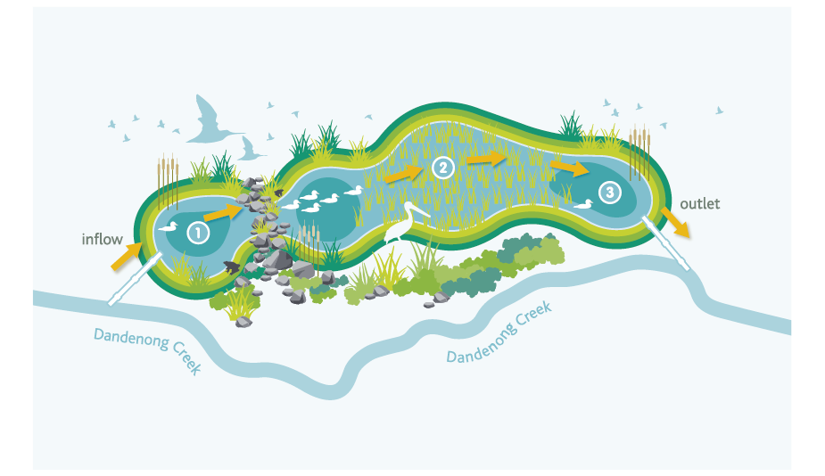
Figure 18. Schematic of a fresh water constructed wetland

The following performance objectives are designed to enable improved stormwater management and respond to the significant impacts of urbanisation on waterway health.

Performance Objectives
RPO-13 | Industry capacity for whole of water cycle and stormwater management is increased to enable collaboration, improved access to information and knowledge, and a skilful and capable industry with strong established networks.
RPO-14 | Standards, tools and guidelines are in place and implemented to enable re-use and infiltration of excess stormwater, and protect and/or restore urban waterways.
RPO-15 | Victoria’s planning system is used effectively to protect and enhance waterway values.
RPO-16 | Protection mechanisms are in place for headwaters to ensure that they are retained as features in the landscape for environmental, social, cultural and economic benefits.
RPO-17 | Water quality in waterways and bays is improved by reducing inputs of sediment and other pollutants from urban construction and development.
RPO-18 | Critical waterway health assets including stormwater treatment systems, fishways and erosion control structures, are maintained for their designed purpose or the same outcomes are delivered by alternative means.

These performance objectives will make an important contribution to:
- Targets in the Port Phillip Bay Environmental Management Plan (2017) of maintaining loads of total nitrogen (TN) and total suspended solids (TSS) at their current levels. These targets are within the Port Phillip Bay Environmental Management Plan (2017) and draft State Environment Protection Policy (Waters).
- The Western Port sediment load target of the draft SEPP (Waters).

13.3. Responding to climate change and urbanisation through community place-making
The combined effects of a warming, drying climate with increased urbanisation will result in hotter urban environments and a reduction of natural space for an increasing population. In response, opportunities must be found to protect and enhance the social values of waterways for communities across the region. Using a place-based approach to reinvigorate waterways and the land around them provides the opportunity to design places to enhance the health and wellbeing of local communities and flora and fauna. A place-based approach considers how the amenity of water and the natural environment can integrate seamlessly into a local urban context to benefit residents. The Reimagining Your Creek program is one example of how this might be done. This program is aimed at empowering communities to identify and participate in the improvement of waterway values in highly modified environments, to create more natural, community loved spaces.

Case study: Reimagining Your Creek program
The Reimagining Your Creek program has a 2021 target to transform five kilometres of modified waterways across the region into places which enhance community wellbeing, and at the same time improve the quality of habitat for native flora and fauna.
An example project is Arnolds Creek in Melton West, where Melbourne Water and project partners are working to replace more than one kilometre of concrete channel with vegetated, accessible waterway. The design team is using a place-based approach that provides connectivity and access, tree canopy cover to cool the area, respite areas to encourage the local community to stay longer, and links to support active and passive recreation.
This approach considers how the amenity provided by a waterway and the natural environment can integrate seamlessly into a local urban context to benefit residents.
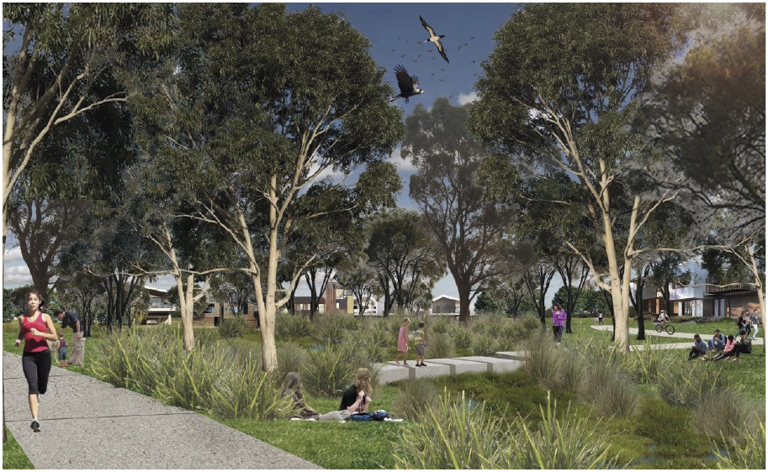
Figure 19. Artist’s impression of the Arnolds Creek Project in Melton West, provided by REALM Studios
- End Case Study –

Performance Objectives
RPO-19 | Options to transform modified waterways by creating more natural, community-loved spaces are identified and implemented.
RPO-20 | The amenity, community connection and recreation values of wetlands are better understood. Performance objectives are developed to enhance these values.
RPO-21 | The multiple benefits of waterways investment are tracked and understood.
RPO-22 | Cooler, greener and more liveable urban environments are created through revegetation and as part of managing excess stormwater.

13.4. Managing pollution
Identifying sources of pollution through monitoring and tracking is an important step in preventing harm to waterways.
For over 40 years, water has been routinely sampled at over 100 regional waterways monitoring sites to assess how water quality is changing over time. Water samples are tested for the following range of indicators:
- water temperature
- dissolved oxygen
- water clarity – suspended solids and turbidity
- salinity – salt levels
- pH level – acidity or alkalinity
- nutrients – forms of nitrogen and phosphorus
- faecal contamination – E. coli
- metals – arsenic, cadmium, chromium, copper, lead, nickel and zinc.
EPA Victoria has a set of policies and objectives for improving waterway health. It reviews water quality monitoring results and conduct audits of any changes to the monitoring network. The Environment Protection Amendment Act 2018 provides a framework for risk-based environment protection, focusing on preventing waste and pollution impacts, rather than managing those impacts after they have occurred. There are many sources of licensed and unlicensed discharges to waterways. Impacts from sewerage discharges will be reduced through a greater emphasis on risk-based discharge licensing, and through improved sewer system resilience (as outlined in the Melbourne Sewerage Strategy 2018).

13.4.1. Pathogens and contaminants of emerging concern
In addition, key recreational sites are tested for pathogens, such as E. coli and blue-green algae on a weekly basis during summer. Excessive amounts of these pathogens can cause skin irritation or illnesses for people and pets that come into contact with water.
In future, as well as monitoring for known pollutants and long-term trends, it is acknowledged that research into emerging contaminants of concern (including PFaS and pharmaceuticals) will be required.

Case study: Enhancing Our Dandenong Creek program
The Enhancing Our Dandenong Creek program was a five-year pilot of an alternative approach to sewerage management, developed in partnership between the community, local businesses, councils, EPA Victoria and Melbourne Water. The project has taken a risk-based, outcomes-focused approach to the management of wet weather sewerage overflows from the Ringwood South Branch Sewer to Dandenong Creek. Melbourne Water has been progressively investing in larger sewers to meet sewage containment requirements since 1992.
Ecological research showed that wet weather sewer spills were not the dominant threat to ecological values in Dandenong Creek. Pollutants such as heavy metals and pesticides (that enter the creek in dry weather) were discovered to present a bigger threat to the waterway ecosystem. This knowledge identified that, in terms of waterway health, general pollution management was an alternative investment to conventional sewer augmentation.
Together with the community, local businesses, local councils and EPA, a pilot project was implemented for the Ringwood Branch Sewer, seeking the best waterway and community outcomes.
Works delivered under the program included: 20 habitat sites for threatened fish species, complemented by a breeding program; stormwater pollution detection and education to improve water quality from industrial areas; the enhancement and creation of billabong features along the floodplain; the provision of interpretative signage and amenities; and the removal of 850 metres of piped waterway and reinstatement of an open, naturalised creek. The works focused on improving amenity, biodiversity and tackling stormwater quality, while at the same time continuing to monitor infrequent sewer overflows to ensure they are having no adverse impact on the waterway.
- End Case Study -

Performance Objectives
RPO-23 | The potential impacts of emerging contaminants of concern such as microplastics, pesticides and pharmaceuticals, and toxic chemicals are better understood and mechanisms to respond collaboratively developed.
RPO-24 | Risk-based programs are in place to mitigate sources of urban pollution (licenced and unlicensed discharges) to protect bays and waterways.

13.5. Rural and agricultural activity
Improvements to rural land management reduces the incidence of fertilisers, pesticides or animal waste entering waterways, and also reduces erosion and sedimentation. Improving the management of rural land adjacent to waterways, particularly headwater streams, drains, dams, wetlands, gullies, seeps, soaks springs and seasonally wet areas, is essential to local waterway and catchment health.
Across the region, efforts are being made to achieve a greater level of stock exclusion, revegetation and nutrient management. These activities have been shown to enhance productivity for the property owner and improve waterway health.

Case study: Environmental best practice meets large-scale farming in the West
Farmers David and Ben Blackmore run an internationally renowned business called Blackmore Wagyu Beef. They have a long-term lease on a 1400 hectare property known as ‘Fairfield’ in Darraweit Guim, north of Melbourne. In 2017, David and Ben joined Melbourne Water’s Rural Land and Stream Frontage incentives programs for a project that will see both parties contribute to:
- protect 7.4 kilometres of frontage to Boyd Creek and associated tributaries (sub-catchment of Deep Creek) from stock access
- establish a robust off-stream stock watering system.
The partnership between David and Ben and Melbourne Water will help minimise sediment and nutrient loss, and improve the water quality and drainage functions of the system by allowing vegetation cover to establish and thicken. A small section of the fencing will also contribute towards excluding stock from a high value area of approximately 180 hectares of remnant bushland in the headwaters of many of the gullies on the property.
- End Case Study -

Performance Objectives
RPO-25 | Programs, standards, tools and guidelines are in place to manage nutrients, sediments and other pollutants from rural land in priority areas.

This performance objective is designed to monitor and progress the management of pollutants and sediments entering waterways, and in doing so, will also make a significant contribution towards protecting the health of Port Phillip Bay and Western Port.

13.6 Managing litter
Currently, regional litter management is a combination of prevention and clean-up activities. Councils, Melbourne Water and Parks Victoria are the main agencies with responsibility for removing litter from waterways and beaches. There is also a significant contribution from local community groups with environmental and amenity interests. Litter clean-up costs are significant: in 2012–2013, litter and street cleaning maintenance were estimated to cost Victorian local councils more thanv$94 million.
Historically the focus has been on capturing litter (for example, through gross pollutant traps, street sweeping, bins in public places, beach sweeping). Emphasis is shifting, and government agencies and councils, with the support of some non-government agencies, are developing and implementing litter prevention and education strategies to reduce the incidence of littering and illegal dumping. Tools such as the Victorian Litter Action Alliance Local Litter Measurement Toolkit and the Clean Communities Assessment Tool have been developed and could form the basis of a new waterway litter monitoring program across the region.
This Healthy Waterways Strategy considers the reduction of litter and illegal dumping to be a key objective for improving waterway values.

Performance Objectives
RPO-26 | Methods are in place to assess volume and source of litter to inform and promote litter reduction programs.
RPO-27 | Incidence of littering and illegal dumping is reduced through raised community awareness and knowledge, infrastructure and enforcement.

13.7 Vegetation management
Vegetation management plays a key role in waterway health and can be achieved through a wide variety of approaches, including revegetation, weed control, fire management, pest animal management and grass cutting. Additional benefits associated with revegetation include cooler urban environments, better resilience and reduced impacts of climate change.
This Strategy has set significant vegetation targets for both public and private land that is managed by a diverse array of stakeholders. Collaboration will be critical to achieve the outcomes identified for maintaining and extending streamside vegetation in the Co-Designed Catchment Programs. A particular challenge is accessing, establishing or protecting vegetation on private land in areas marked for urban growth. Ephemeral wetlands are particularly at risk in these areas, despite their vegetation communities being protected through native vegetation planning controls.
The following performance objectives are designed to support maintaining and extending vegetation in priority areas for all assets – rivers, wetlands and estuaries and the performance objectives set out in the Co-Designed Catchment Programs.

Performance Objectives
RPO-28 | Seasonal Herbaceous Wetland vegetation communities are identified and a management program is in place to protect them on public and private land.
RPO-29 | Programs, standards, tools and guidelines are in place to protect wetland vegetation communities from urban and rural threats, including adequate planning controls.
RPO-30 | Climate change resilient revegetation management practices are understood and implemented by selecting plant species, provenances and vegetation communities that are suited to projected future climatic conditions.

13.8. Controlling pest plants and animals
A risk-based approach to the prevention, eradication, containment and value protection is proposed for the management of pest plants and animals in waterways and across catchments. The risk-based approach considers both current and known potential future risks to waterway conditions that are posed by pest plants and animals (including noxious weeds, deer, rabbits, carp and eastern gambusia).
Government intervention is warranted to address high-risk species that threaten significant environmental, social, cultural and economic values of waterways, where benefit is expected to exceed cost. Priority will be given to programs that prevent introduction or eradicate newly establishing pest plants and animals over containment and programs to reduce the impact of established invasive species.

Case study: Getting to know how deer behave
Forested catchments in the Port Phillip and Westernport region now support relatively large numbers of deer, which are damaging vegetation and impacting water quality. As these populations move closer to settlements they also impact agricultural productivity and create road hazards.
In Victoria, there are four species of deer, of which two are of regional concern: the Sambar (Cervus unicolor) and the Fallow Deer (Dama dama). Deer were initially released in the mid-1800s for aesthetic and recreational hunting purposes. More recently, large numbers were released or escaped into the wild following the collapse of commercial deer farms in the 1990s.
Melbourne Water and Parks Victoria are working with researchers on a three-year monitoring program to better understand the intensity and ecological impact of deer on regional waterways.
Fifteen study sites have been established across the Upper Yarra River catchment in three different vegetation types – wet, damp and streamside forest. Initial results indicate that deer browsing intensity varies across sites, with higher impact in damp forests compared to wet and streamside forests. Deer are preferentially browsing fresh growth of key understorey plants and damaging others through rubbing with antlers. As a result of deer behaviours, a reduction in understorey trees and ferns is likely, which will increase light at the ground layer, drying of the understorey, and an increased susceptibility to and impact from fire.
The potential ecological effects of increasing deer impacts are significant to waterway health, and a better understanding of their behaviour will encourage development of improved management and control methods.
- End Case Study -

Performance Objectives
RPO-31 | A risk-based approach is adopted to prevent, eradicate and contain pest plants and animals (including deer) and protect waterway assets.
RPO-32 | Programs are in place to protect and enhance sites of biodiversity significance associated with the region’s waterways, such as through Melbourne Water’s Sites of Biodiversity Significance Strategy.

Part D

Catchment Summaries
Each of the five major catchments has a tailored program, outlining its specific waterway assets, their current status and likely trajectories, and the performance objectives and targets that have been set in order to achieve the catchment vision and goals and the overarching vision of this Strategy. These programs are detailed in the Co-Designed Catchment Programs, and are summarised below for each of the catchments.
It is intended that the Co-Designed Catchment Programs will provide the on-ground management guideline for each of the catchments, and that they will be reviewed and adapted to changing conditions, progress and opportunities, within the life of this Healthy Waterways Strategy. It is not anticipated that the summary version presented in this document will be updated within the 10-year life of this Strategy, so readers should ensure they review the most recent and relevant catchment program. Appendix 3 contains the metrics for targets set out in this section.

Summaries of the five major Co-Designed Catchment Programs are presented in this order:
- Werribee Catchment Region
- Maribyrnong Catchment Region (including Moonee Ponds Creek)
- Yarra Catchment
- Dandenong Catchment Region
- Westernport and Mornington Peninsula Region

14. Werribee Catchment region

14.1. Catchment Overview
The Werribee catchment region incorporates rivers and creeks such as Little River, Werribee River, Lerderderg River, Toolern Creek, Skeleton Creek and Kororoit Creek, which all drain into the northwest area of Port Phillip Bay.
The catchment occupies an area of 2695 square kilometres. About 20 per cent of the area retains its natural vegetation, 65 per cent is used for agriculture and 10 per cent is urban (confined to greater Melbourne and larger townships within the catchment).
People of the Wada wurrung and Woi wurrung language groups were the original occupants of this land and their descendants place enormous cultural and spiritual significance on the region’s land and waters.
Basalt plains dominate the region’s geology and the landscape varies from steep-sided hills and gorges to flat plains. These plains form part of Victoria’s western volcanic plains grassland ecosystem (now highly fragmented), which lie in the rain shadow of the Otway Ranges and are the driest area south of the Great Dividing Range in Victoria.
Agriculture is the predominant land use, with forestry occurring in the upper parts of the catchment. The market gardens located around Bacchus Marsh and Werribee are key suppliers of vegetables for local, national and international markets.
Water storages, including the Melton, Pykes Creek, Djerriwarrh, Colbrook and Merrimu reservoirs, provide water supply for the Bacchus Marsh and Werribee irrigation districts, and drinking water for local townships. Since the 1980s there has been an increase in the volume of recycled water used to supplement water supplies for irrigated agriculture. And in some of the newer urban areas, recycled water is provided to houses for non-drinking water uses.
The waterways in this catchment are diverse, ranging from large rivers to small ephemeral creeks, wetlands and estuaries. Adjacent to the coast there are significant wetlands and estuaries that provide important habitat for animals such as migratory shorebirds, the threatened Altona skipper butterfly, and the Growling Grass Frog. In 1982, the Port Phillip Bay (Western Shoreline) and Bellarine Peninsula Ramsar Site was listed as a wetland of international importance. It included the Western Treatment Plant and wetlands in the former Cheetham saltworks which is now the Point Cook Coastal Park. Western Port and Port Phillip Bay (Western Shoreline) and Bellarine Peninsula is also recognised as a shorebird sites under the East Asian-Australasian Flyway Network.
The health of the catchment’s waterways is strongly linked to land use, with the upper reaches in a more natural condition than those in the rural and urban areas.
Despite significant impacts from agriculture and urban development across the catchment, waterways continue to support multiple and varied uses and values, including water supply, flood mitigation, and significant plant and animal species.
Population modelling shows that the Werribee Catchment Region will increase from some 660,000 people to over one million in the next 20 years, which will require an additional 8000 dwellings per year. Much of this will be in the new urban development area that stretches out from Melbourne to Melton and Bacchus Marsh to the north-west, and west towards Werribee and Little River. The City of Wyndham and the City of Melton are two of the fastest growing municipalities in Australia.

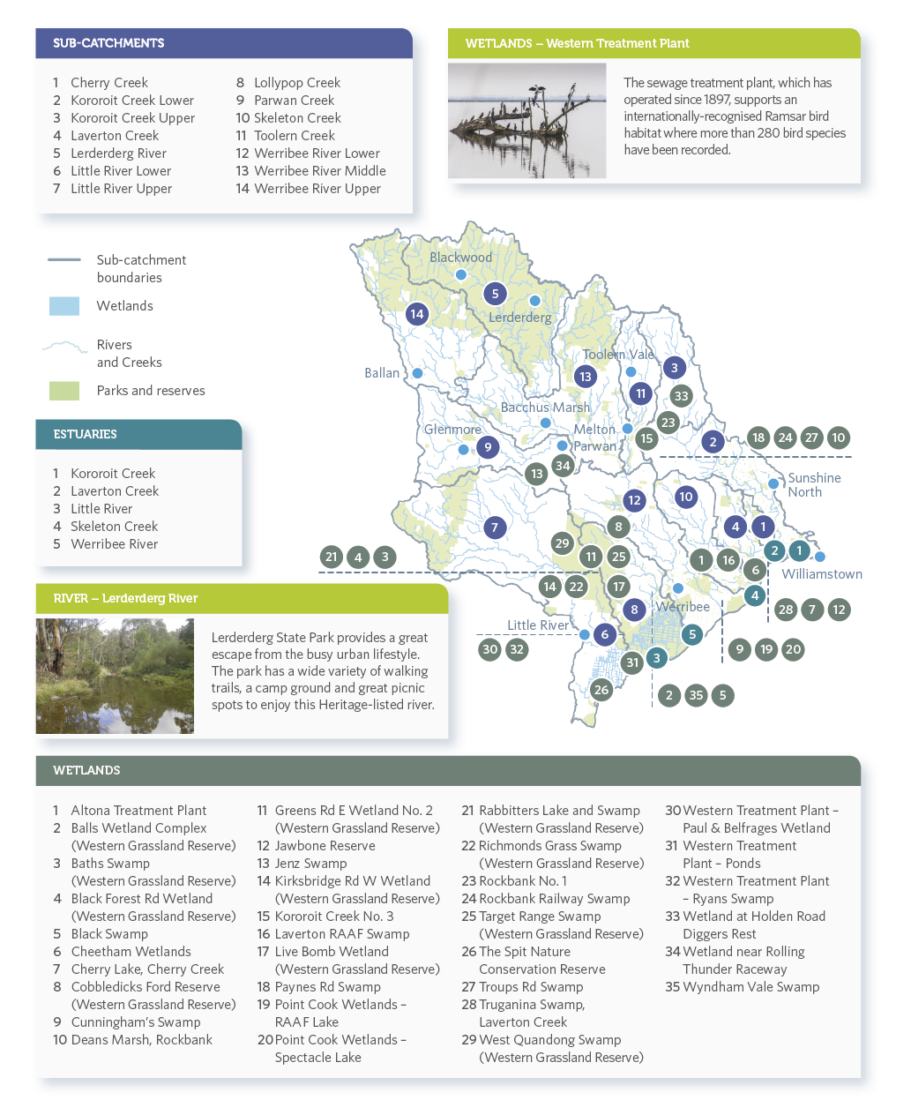
Figure 20. Sub-catchments and waterway assets including a sub-set of wetlands in the Werribee catchment region

14.2. Vision
The Werribee catchment community values, enjoys and actively participates in managing the health, connectivity and resilience of our rivers, estuaries and wetlands.

14.3. Goals
- Waterways and water resources of the Werribee catchment support and are supported by balanced and sustainable practices within industry, agriculture and the growing population.
- Innovation and knowledge guides appropriate use of our waterways.
- Viable, healthy, resilient and connected ecosystems across the catchment.
- Special places (rivers, creeks, wetlands and estuaries) within the catchment are recognised and managed for their significant values.
- Our community appreciates the values of our waterways very highly and is engaged to positively and actively contribute to waterway outcomes.

14.4. Waterway Values – Werribee

Environmental
There are 134 expected riparian bird species. There have been recent records of nationally-significant fish including the Australian grayling in the lower Werribee River. Frog species include threatened species such as the growling grass frog, Bibron’s toadlet and the southern toadlet; although neither of the two toadlet species have been recorded in the catchment since the Millennium Drought.
The upper forested areas of the Werribee River and Lerderderg River within Lerderderg State Park contain areas of very high vegetation value. The value of vegetation across other parts of the catchment is of low to moderate value as a result of the modified nature of the catchment. Macroinvertebrate scores are also highest in the forested headwaters with degradation increasing towards the lower reaches, which are increasingly impacted by urban runoff.
Platypus are distributed in those parts of the Werribee River system (includes Lerderderg River) that have reliable summer flow regimes. However, they are considered to be locally threatened due to low numbers and continuing long-term decline.

Social
In the Werribee catchment region social values for streams are currently high. There is currently no data for social values of wetlands in the Werribee catchment. Social values are based on the surveyed level of community satisfaction and are threatened by inappropriate urban development, poor environmental condition, poor access to waterways, and pollution.

Cultural
The land and waters of this region hold deep spiritual and cultural significance for Aboriginal peoples. The people of the Wada wurrung and Woi wurrung language groups were the original occupants of this land, as evidenced by the thousands of cultural sites and places recorded. Most of these occurring within 200 metres of a watercourse.

Economic
Economic values vary across the catchment. They include domestic, stock and agricultural uses in the upper and middle parts of the catchment. On the floodplains, wetlands are being restrained to increase the value of urban properties.

14.5. Targets and Performance Objectives
This section provides summaries of the long-term targets and performance objectives to be delivered through the implementation of the Strategy, in the 14 sub-catchments, sub-set of 35 wetlands and five estuaries of the Werribee catchment region. The full suite of targets and performance objectives are available in the Co-Designed Catchment Program for the Werribee catchment region.

14.5.1. Rivers – Key values and waterway conditions (Werribee)
The following target summaries represent an average across the Werribee catchment region for rivers.

Key Values | Current State | Current Trajectory | Target
Birds | Moderate | Low | Moderate
Fish | Low | Low | Moderate
Frogs | Moderate | Low | Moderate
Macroinvertebrates | Moderate | Moderate | Very high
Platypus | Low | Very low | Low
Vegetation | Moderate | Low | Moderate
Amenity | High | Moderate | High
Community connection | High | Moderate | Very high
Recreation | High | High | High

Waterway Conditions | Current State | Current Trajectory | Target
Stormwater condition | High | High | High
Water for the environment | High | Moderate | High
Vegetation extent | Moderate | Moderate | High
Vegetation quality | Low | Low | Moderate
Water quality – environment | Moderate | Low | Moderate
Instream connectivity | Low | Low | High
Physical form | Moderate | Moderate | High
Access | Very low | Very low | Low
Water quality - recreational | High | High | High
Litter absence | High | Moderate | High
Participation | Moderate | Moderate | Very high

14.5.2. Rivers – Summary of performance objectives (Werribee)
The following presents a summary of the 10-year performance objectives for rivers in the Co-Designed Catchment Program for the Werribee catchment region.
- Progressively implement stormwater harvesting in the lower and middle reaches of the Werribee River and Toolern and Lollypop Creeks. Once this catchment has reached its anticipated long term urban footprint (2050), this will require around 16.9 GL/year of stormwater harvested and 3.0 GL/ year infiltrated. Ensure directly connected impervious (DCI) levels in these priority catchments do not increase beyond current levels and headwater streams are retained as features in the landscape for environmental and social benefits.
- Investigate options to increase the environmental water reserve by 7 GL/year by 2028 to meet ecological watering objectives and cover projected shortfalls. Any water recovery for the environment will be considered through the Victorian SWSs, markets and use of alternative water.
- Identify opportunities to maintain or improve the flow regime in refuge reaches to support instream values, including platypus.
- Investigate and mitigate the threat of erosion in Kororoit Creek Lower, Lollypop Creek, Skeleton Creek, Toolern Creek, Werribee River Lower and Werribee River Middle waterways using a risk-based approach.
- Maintain 196 kilometres of high and very high quality vegetation (vegetation quality levels 4 and 5) through effective monitoring and management of threats.
- Establish 439 kilometres and maintain 671 kilometres of continuous vegetated buffers (using ecological vegetation class (EVC) benchmarks benchmarks and to at least a level 3 vegetation quality) along at least 80 per cent of priority reaches (including sections of Werribee River (including tributaries), Little River, Lollypop Creek, Skeleton Creek, Laverton Creek, Cherry Creek and Kororoit Creek). In addition, increase vegetation cover in existing and planned urban areas by 3 kilometres to support social values.
- Increase access to and along waterways by 34 kilometres by improving connections with existing path networks and extending paths into new urban area. Investigate opportunities to improve access for on-water activities.
- Reduce nutrient and sediment runoff from rural land through improved management of 320 hectares of land including works to protect and increase vegetation along headwater streams.
- Provide connectivity for fish along major waterways through the removal of 18 barriers by 2028. This will improve fish passage in Werribee River between the estuary and Melton Reservoir, in Little River between the estuary and Little River township and in Toolern Creek through Melton.
- Conserve all currently listed water dependent species and communities (20 fauna species, 104 flora species and 39 EVCs) through habitat protection, research and monitoring.

14.5.3. Rivers – Summary of long-term key value outcomes (Werribee)
The following target summaries represent an average across the Werribee catchment region for rivers.
Birds score for rivers is currently moderate overall and likely to decline over the long term under current trajectory. The target is to maintain as moderate.
Fish score is currently low overall but can be improved to moderate through improved instream connectivity, stormwater management, provision of adequate stream flows and streamside revegetation.
Frogs score is currently moderate overall. However, in the long term scores are likely to decline because of increased urbanisation, land use intensification, introduced predators and deteriorating water quality. The target is to maintain the frog score as moderate.
Locations where a decline or very low score is expected: Little River Lower, Lollypop Creek
Macroinvertebrates score is moderate overall. Scores are higher in the forested headwaters, but the catchment has been impacted by land use intensification and urbanisation that has resulted in changes to stream flows, water quality and instream habitat. The target is to improve to very high.
Locations where a decline or very low score is expected: Cherry Creek
Platypus are distributed in those parts of the Middle and Lower Werribee River system (includes Lerderderg River) that have reliable summer flow regimes. The Werribee population is considered threatened due to low numbers, continuing long-term decline and the severe impacts drought has had on populations. With projected reduced flows they are likely to decline without intervention. The target is to maintain current populations.
Platypus are not expected to be present in Cherry Creek, Kororoit Creek Lower, Kororoit Creek Upper, Laverton Creek, Skeleton Creek, Lollypop Creek.
Vegetation score is currently moderate, which is mainly due to the modified nature of the catchment. The current trajectory is low. However, with increased effort the potential trajectory is to maintain moderate scores.
Forested areas of the upper catchments have higher values for riparian vegetation; however, where land clearing has been extensive, streamside vegetation is in very low to moderate condition. Revegetation projects are helping to improve riparian vegetation.
Amenity score, which is based on level of satisfaction, is currently high but likely to decline with increased urbanisation and population growth. The target is to maintain as high.
Community connection score, which is based on level of satisfaction, is currently high but likely to decline with increased urbanisation. The target is to improve to very high. Thirty-three per cent of people in the Werribee catchment visit waterways at least fortnightly and 80 per cent are satisfied with waterways.
Recreation score, which is based on level of satisfaction, is currently high but likely to decline with increased urbanisation. The target is to maintain at high.

14.5.4. Wetlands – Key values and waterway conditions (Werribee)
The following target summaries represent an average across the Werribee catchment region for wetlands.
Key Values | Current State | Current Trajectory | Target
Birds | Low | Very low | Low
Fish | Insufficient Data | Insufficient Data | Insufficient Data
Frogs | High | Very low | Moderate
Vegetation | Low | Very low | Moderate

Waterway Conditions | Current State | Current Trajectory | Target
Water regime | Moderate | Very low | Low
Wetland habitat form | Very low | Very low | Moderate
Wetland buffer condition | Very low | Very low | Very high
Vegetation condition | Low | Very low | Moderate
Wetland water quality | Moderate | Very low | Low

14.5.5. Wetlands – Summary of performance objectives (Werribee)
The following presents a summary of the 10-year performance objectives for wetlands in the Co-Designed Catchment Program for the Werribee catchment region.

Wetlands
- Protect refuge habitats through providing an appropriate wetland water regime and vegetation buffer.
- Implement the Port Phillip Bay (Western Shoreline) and Bellarine Peninsula Ramsar Site Management Plan for wetlands in the catchment.
- Implement key actions to plan for climate change adaptation and resilience.
- Reduce the threat of invasive animals such as dogs, cats and foxes to protect key wetland bird habitats.
- Increase the buffer of native vegetation around key wetlands.
- Investigate opportunities to improve the water regime of key wetlands to meet ecological watering objectives, improve ecosystem services, and cultural and social value.
- Implement the outcomes of the Melbourne Strategic Assessment on the Western Grassland Reserves, and associated management.
- Reduce threat of invasive plant species, including the impact of salt tolerant species in significant coastal wetlands.
- Develop understanding of the amenity, community connection and recreation values of wetlands and develop performance objectives to enhance the values.

14.5.6. Wetlands – Summary of long-term key value outcomes (Werribee)
The following target summaries represent an average across the Werribee catchment region for wetlands.
Wetlands bird score is currently low. However, there are many wetlands in the Werribee catchment that are recognised for their significance as bird habitat. These include Cheetham Wetlands, The Spit Nature Conservation Reserve, Western Treatment Plant and Point Cook Wetlands (RAAF and Spectacle Lakes). Bird habitat at coastal wetlands may be severely impacted by the predicted impacts of climate change which may affect wetland watering regimes, salinity regimes and vegetation communities.
Locations where a decline or very low score is expected: Cherry Lake, Jawbone Reserve, Kororoit Creek No. 3, Rockbank No. 1, Rockbank Railway Swamp, Troups Rd Swamp, Wetland at Holden Road Diggers Rest, Altona Treatment Plant, Black Forest Rd Wetland (Western Grassland Reserve), Kirksbridge Rd W Wetland (Western Grassland Reserve), Richmonds Grass Swamp (Western Grassland Reserve), Greens Rd E Wetland No. 2 (Western Grassland Reserve), Black Swamp, Live Bomb Wetland (Western Grassland Reserve), Target Range Swamp (Western Grassland Reserve), Wyndham Vale Swamp, Jenz Swamp, Wetland near Rolling Thunder Raceway, Laverton RAAF Swamp, Cunningham’s Swamp
Very little data exists for wetland fish and a metric for wetland fish in this region will be developed through the Strategy implementation.
Frogs score is currently high, with a current trajectory of very low. Significant decline to wetland water regimes and water quality as a result of urbanisation and climate change impacts will affect frogs. Actions to reduce these threats may somewhat mitigate these impacts and retain the frog score at moderate.
Locations where a decline or very low score is expected: Little River Lower, Lollipop Creek, Cherry Lake, Cheetham Wetlands, The Spit Nature Conservation Reserve, Western Treatment Plant – Ryans Swamp, Black Swamp, Cobbledicks Ford Reserve (Western Grassland Reserve), Live Bomb Wetland (Western Grassland Reserve), Target Range Swamp (Western Grassland Reserve), Western Treatment Plant – Paul & Belfrages Wetland
Vegetation score is currently low. Implementing programs to improve wetland buffers, vegetation condition and habitat form is predicted to improve this score to moderate. Forward planning for adaption and migration of coastal wetland and estuarine vegetation is essential in light of predicted climate change impacts.
Locations where a decline or very low score is expected: Cherry Lake, Truganina Swamp, Western Treatment Plant – Ponds

14.5.7. Estuaries – Key values and waterway conditions (Werribee)
The following target summaries represent an average across the Werribee catchment region for estuaries.
Key Values | Current State | Current Trajectory | Target
Birds | Moderate | Low | Moderate
Fish | High | Moderate | High
Vegetation | Low | Very low | Moderate
Amenity | Moderate | Moderate | Very high
Community connection | Very high | Very high | Very high
Recreation | Moderate | Moderate | High

Waterway Conditions | Current State | Current Trajectory | Target
Flow regime | Very low | Very low | Moderate
Tidal exchange | High | Moderate | High
Longitudinal extent | Moderate | High | High
Water quality | Moderate | Very low | Low
Estuarine vegetation | Low | Very low | Moderate
Estuarine wetland connectivity | Low | Low | Moderate

14.5.8. Estuaries – Summary of performance objectives (Werribee)
The following presents a summary of the 10-year performance objectives for estuaries in the Co-Designed Catchment Program for the Werribee catchment region.

10-year performance objectives
- Enhance estuarine vegetation condition and reduce threat of invasive plant species to significant estuarine vegetation communities.
- Protect refuge habitats through maintaining critical stream flow components.
- Improve longitudinal connectivity in estuaries.
- Plan to enable lateral and longitudinal migration of estuarine vegetation communities on the floodplain to allow adaption to climate change risks.
- Reduce flow stress to the Little River and Werribee estuaries.
- Investigate opportunities to improve access for on-water activities, and improve connections with existing path networks.
- Enhance site appropriate opportunities for recreation (boating, fishing, walking/cycling).

14.5.9. Estuaries – Summary of long-term key value outcomes (Werribee)
The following target summaries represent an average across the Werribee catchment region for estuaries.
Birds are a significant waterway value across the catchment, with 350 bird species being recorded including 134 species of waterway specialists.
Estuaries bird score is currently moderate, with a current trajectory of low. Improvement to estuarine wetlands connectivity, vegetation and flow regime will maintain the bird score at moderate. The Little River and Werribee estuaries provide significant habitat.
Locations where a decline or very low score is expected: Laverton Creek Estuary
Fish score for estuaries is high with a current trajectory of moderate. Changes to the estuarine water regime as a result of urbanisation and climate change may impact fish communities. A good diversity of estuarine dependent species inhabit the estuaries and are likely to remain. The target is to maintain at high.
Vegetation score is currently low with a current trajectory of very low. Forward planning for adaption and migration of coastal wetland and estuarine vegetation is essential in light of predicted climate change impacts. The target is to improve to moderate.
Locations where a decline or very low score is expected: Laverton Creek Estuary
Amenity score is moderate with a current trajectory of moderate. Increased tracks, pathways and other facilities, along with improvements to estuarine vegetation are predicted to improve the amenity value to high.
Community connection score is very high and will remain very high. Community groups are active for estuaries in this catchment.
Recreation score is moderate with a target to increase to high.
Locations where a decline or very low score is expected: Laverton Creek Estuary

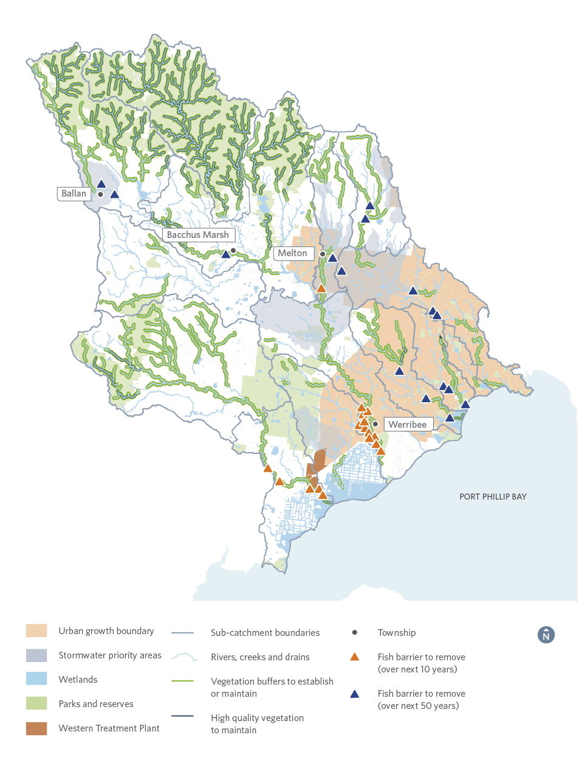
Figure 21. Summary of priorities in the Werribee catchment region
Note: This map does not show headwater streams, some minor tributaries, waterbodies on private land or wetlands less than one hectare.

15. Maribyrnong Catchment region (including Moonee Ponds Creek)

15.1 Catchment Overview
The Maribyrnong catchment region covers an area of around 1408 square kilometres. About 10 per cent of the catchment retains its natural vegetation, 80 per cent is used for agriculture and 10 per cent is urban (confined to greater Melbourne and larger townships).
People of the Woi wurrung language group were the original occupants of this land and their descendants place enormous cultural and spiritual significance on the region’s land and waters.
The catchment includes the 41-kilometre-long Maribyrnong River – the second major river in the Port Phillip and Westernport region – which begins on the southern slopes of the Great Dividing Range, in the Cobaw Ranges. The Moonee Ponds Creek sub-catchment (which flows into the Yarra River) has also been included in this section, as it was part of the pilot sub-catchments for the development of this Strategy together with all sub-catchments in the Maribyrnong.
Population modelling shows that the Maribyrnong catchment will increase from some 600,000 people to over 800,000 in the next 20 years, which will require an additional 5000 dwellings per year.
Many wetlands are encroached by urban development reducing the wetland area and losing the protection of a buffer of native vegetation. Groundwater-fed wetlands in this catchment are predicted to be most likely impacted by climate change.
Predicted sea level rise will impact the future condition of the region’s estuaries and the values that they can support. Without planning for landward migration of estuarine vegetation, existing ecological values may be lost due to an increasingly saline environment.

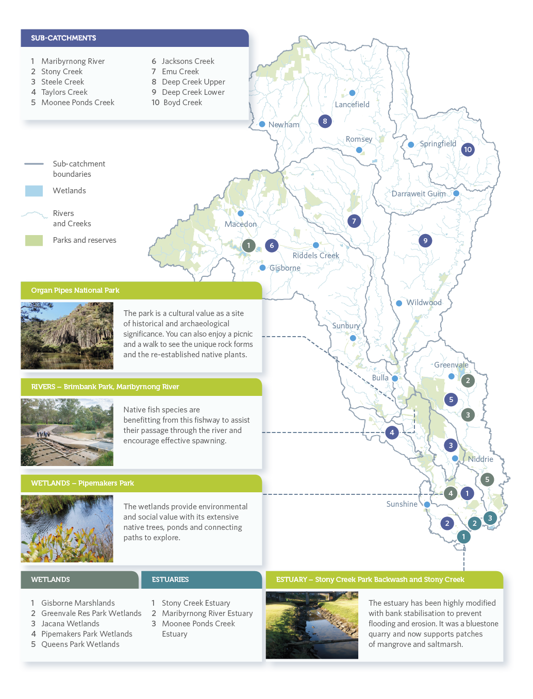
Figure 22. Sub-catchments and waterway assets including a sub-set of wetlands in the Maribyrnong catchment region (including Moonee Ponds Creek)

15.2. Vision
A Maribyrnong catchment whose ecological health has significantly improved since 2018. It is accessible, used and valued by the community. Its collaborative management reflects the contributions of Traditional Owners and the broader community.

15.3. Goals
- Environmental: Management is helping create a preferred future for the Maribyrnong’s environments by assisting species and habitats to change, adapt, move or be replaced as the catchment and climate change. The Maribyrnong River and its tributaries are important bio-links – corridors of secure, high quality habitats that allow plants and animals to move and adapt to changes in catchment conditions and climate. Water quality and flows provide for healthy and diverse populations of plants and animals. Stormwater is managed to enhance rather than destroy waterway health.
- Social: Waterways across the Maribyrnong are places that provide continuous, connected and accessible open spaces for public enjoyment and recreation.
- Education: Public authorities, community groups and hundreds of individuals across the catchment share their knowledge of the Maribyrnong and take regular action to help pursue this strategy’s goals. Education programs are resourced and coordinated across many organisations that are working or involved within the catchment.
- Decision-making and action: Long-term monitoring supports adaptive management by tracking progress towards this strategy’s goals. Urban planning decisions make explicit reference to their potential impacts on waterway environments. Victorian Planning Schemes include overlays to protect the river, its tributaries, floodplains and escarpments. Effects of planning decisions are monitored to support evaluation and learning. Melbourne Water is seen by all parties to the Strategy as a successful facilitator, enabler, coordinator and leader.

15.4. Waterway Values – Maribyrnong

Environmental
Over 350 bird species are recorded of which 95 species are riparian specialists. The overall score for fish is low with threatened freshwater species including the Australian grayling, Yarra pygmy perch and Australian mudfish. Threatened frog species include the growling grass frog, Bibron’s toadlet and southern toadlet.
Much of the higher vegetation and macroinvertebrate value areas are in the forested upper catchment with degradation increasing towards the lower reaches.
Platypus have been observed in the lower reaches of Jacksons Creek near Sunbury, Deep Creek Upper and Lower, and in the Maribyrnong River near the junctions with these creeks with likely presences in other streams.

Social
Social values for rivers are currently high. Social values for estuaries range from moderate to very high. Social values are based on the surveyed level of community satisfaction and are threatened by inappropriate urban development, poor environmental condition, poor access to waterways, and pollution.

Cultural
The land and waters of this region hold deep spiritual and cultural significance for Aboriginal peoples. The people of the Woi wurrung language group were the original occupants of this land, as evidenced by the thousands of cultural sites and places recorded, most near watercourses. Ancient and very rare sites with earthen rings can be found in the hills near Sunbury.

Economic
Streams and reservoirs in the upper and middle parts of the catchment provide water supply for a range of agricultural enterprises.

15.5 Targets and Performance Objectives
This section provides summaries of the long-term targets and performance objectives to be delivered through the implementation of the Strategy, in the 10 sub-catchments, sub-set of five wetlands and three estuaries of the Maribyrnong catchment region (including Moonee Ponds Creek). The full suite of targets and performance objectives are available in the Co-Designed Catchment Program for the Maribyrnong catchment region (including Moonee Ponds Creek).

15.5.1. Rivers – Key values and waterway conditions (Maribyrnong)
The following target summaries represent an average across the catchment region for rivers.

Key value target summaries for rivers in the Maribyrnong catchment region
Key Values | Current State | Current Trajectory | Target
Birds | Moderate | Moderate | Moderate
Fish | Low | Low | Moderate
Frogs | Moderate | Low | Moderate
Macroinvertebrates | Moderate | Low | High
Platypus | Moderate | Very low | Moderate
Vegetation | Low | Very low | Moderate
Amenity | High | Moderate | High
Community connection | High | Moderate | Very high
Recreation | High | Moderate | Very high

Waterway Conditions | Current State | Current Trajectory | Target
Stormwater condition | Moderate | Moderate | High
Water for the environment | Moderate | Low | High
Vegetation extent | Low | Low | High
Vegetation quality | Moderate | Low | Moderate
Water quality – environment | Moderate | Low | Moderate
Instream connectivity | Low | Low | Moderate
Physical form | Moderate | Low | Moderate
Access | Low | Low | Moderate
Water quality - recreational | High | Moderate | High
Litter absence | High | Moderate | High
Participation | Moderate | Low | Very high

15.5.2. Rivers – Summary of performance objectives (Maribyrnong)
The following presents a summary of 10-year performance objectives for rivers in the Co-Designed Catchment Program for the Maribyrnong catchment region (including Moonee Ponds Creek).
- Progressively implement stormwater harvesting, focusing on rural townships such as Lancefield, Romsey, Macedon and Mt Macedon and new urban areas such as Sunbury. Once this catchment has reached its anticipated long-term urban footprint (2050), this will require around 15 GL/year of stormwater harvested and 3.9 GL/year infiltrated. Ensure directly connected imperviousness (DCI) levels in these priority catchments do not increase beyond current levels and headwater streams are retained as features in the landscape for environmental and social benefits.
- Investigate options to increase the environmental water reserve by 5 GL/year by 2028 to meet ecological watering objectives and cover projected shortfalls. This will benefit Jacksons Creek and the lower Maribyrnong River. Any water recovery for the environment will be considered through the Victorian SWSs, markets and use of alternative water.
- Protect refuge reaches and key flow components to support instream values including platypus.
- Reduce the key threat of flow stress on waterways by addressing factors such as domestic, stock and agricultural uses, climate change, diversions or urbanisation.
- Establish 407 kilometres and maintain 297 kilometres of continuous vegetated buffers (using EVC benchmarks and to at least a level 3 vegetation quality) along at least 80 per cent of priority reaches.
- Maintain 74 kilometres of high and very high quality vegetation (vegetation quality levels 4 and 5) through effective monitoring and management of threats.
- Investigate and mitigate threats to physical form (for example, erosion) and other high values in the Boyd Creek, Deep Creek Lower, Deep Creek Upper, Emu Creek, Jacksons Creek and Moonee Ponds Creek sub-catchments.
- Increase access to and along waterways by 36 kilometres by improving connections with existing path networks and extending paths into new urban area. Investigate opportunities to improve access for on-water activities.
- Reduce nutrient and sediment runoff from rural land through improved management of 530 hectares of land including works to protect and increase vegetation along headwater streams.
- Provide connectivity for fish along major waterways through the removal of two more barriers by 2028. This will improve fish passage from the estuary to the mid-catchment and along Deep Creek.
- Conserve all currently listed water dependent species and communities (10 fauna species, 41 flora species and 25 EVCs) through habitat protection, research and monitoring.

15.5.3. Rivers – Summary of long-term key value outcomes (Maribyrnong)
The following target summaries represent an average across the Maribyrnong catchment region (including Moonee Ponds Creek).
Birds score for rivers is moderate overall. There are over 350 bird species recorded, of which 95 species are considered riparian specialists and two are considered threatened: Latham’s snipe and the eastern great egret. Today, bird values are high in Deep Creek Upper and Boyd Creek, but low in Emu Creek and Steele Creek. Birds scores are considered likely to decline over time. The target is to maintain to moderate.
Fish score is low overall, with 13 native and nine exotic freshwater species recorded. These include the threatened freshwater species Australian grayling, Yarra pygmy perch and Australian mudfish. Fish score is considered likely to improve over time. The target is to improve from low to moderate.
Frogs score is moderate overall, which means not many of the expected species are to be found today. Threatened species recorded in the catchment include growling grass frog, Bibron’s toadlet and southern toadlet. Frogs score is considered likely to decline with time unless the performance objectives outlined in this Strategy are achieved. The target is to maintain at moderate.
Locations where a decline or very low score is expected: Stony Creek, Maribyrnong River, Steele Creek
Macroinvertebrates score is moderate, with values higher in forested headwaters and decreasing towards the lower reaches, which are increasingly impacted by urban runoff. Macroinvertebrates score is considered unlikely to improve with time unless the performance objectives outlined in this Strategy are achieved. The target is to improve from moderate to high.
Locations where a decline or very low score is expected: Stony Creek, Steele Creek
Platypus have been observed in the lower reaches of Jacksons Creek near Sunbury, Emu Creek Lower, Deep Creek Upper and Lower, and in the Maribyrnong River near the junctions with these creeks. Platypus score is considered likely to decline from moderate to very low unless the performance objectives outlined in this Strategy are achieved. Target is to maintain current score and populations.
Platypus are not expected to be present in: Moonee Ponds Creek, Stony Creek, Taylors Creek, Steele Creek
Vegetation score varies, with upper forested areas very high due to extensive high quality vegetation, and other parts of the catchment low to very low due to land clearing and urban development. Overall score is low and likely to decline under the current trajectory. The target is to improve from low to moderate.
Amenity score, which is based on level of satisfaction, is currently high but likely to decline in the long term. The target is to maintain as high.
Community connection score, which is based on level of satisfaction, is currently high but likely to decline in the long term. The target is to improve to very high.
Recreation score, which is based on level of satisfaction, is currently high but likely to decline in the long term. The target is to improve to very high.

15.5.4. Wetlands – Key values and waterway conditions (Maribyrnong)
The following target summaries represent an average across the Maribyrnong catchment region (including Moonee Ponds Creek) for wetlands.
Key Values | Current State | Current Trajectory | Target
Birds | Very low | Very low | Low
Fish | Insufficient data | Insufficient data | Insufficient data
Frogs | Low | Low | Moderate
Vegetation | Very low | Very low | Low

Waterway Conditions | Current State | Current Trajectory | Target
Water regime | Very low | Very low | Low
Wetland habitat form | Low | Low | Low
Wetland buffer condition | Very low | Very low | Low
Vegetation condition | Very low | Very low | Moderate
Wetland water quality | Very low | Very low | Low

15.5.5. Wetlands – Summary of performance objectives (Maribyrnong)
The following presents a summary of the 10-year performance objectives for wetlands in the Co-Designed Catchment Program for the Maribyrnong catchment region (including Moonee Ponds Creek).

Wetlands
- Investigate opportunities to improve wetland water regime to meet ecological watering objectives, improve ecosystem services, and cultural and social values.
- Reduce the threat of invasive plants on wetland vegetation communities.
- Improve the buffer of native vegetation surrounding key wetlands.
- Develop understanding of the amenity, community connection and recreation values.

15.5.6. Wetlands – Summary of long-term key value outcomes (Maribyrnong)
The following target summaries represent an average across the Maribyrnong catchment region (including Moonee Ponds Creek) for wetlands.
Wetland bird score is currently very low across the catchment. Some improvements to wetland water regime, habitat form and vegetation condition may improve the score in some areas. However, the impacts of climate change and reduced periods of wetlands inundation, and the extensive urban growth in the catchment will continue to provide risk to birds. The overall target is to improve from very low to low.
Locations where a decline or very low score is expected: Pipemakers Park, Greenvale Reservoir Park, Queens Park
Fish Very little data exists for wetland fish and a metric for wetland fish in this region will be developed through the Strategy implementation.
Frogs score for wetlands is currently low and is predicted to remain low, as decreased frequency and duration of wetlands inundation will affect the frog community. However, improvements to wetland water regime, habitat form and vegetation condition will enable the frog score to increase to moderate.
Locations where a decline or very low score is expected: Pipemakers Park, Greenvale Reservoir Park
Wetland vegetation score is currently very low overall. Decreased frequency and duration of wetland inundation will impact the vegetation condition. However, improvements to wetland water regime, habitat form and vegetation condition will somewhat mitigate the predicted impacts of climate change and urban growth and enable the vegetation score to increase to low for wetlands.
Locations where a decline or very low score is expected: Pipemakers Park, Greenvale Reservoir Park, Queens Park

15.5.7. Estuaries – Key values and waterway conditions (Maribyrnong)
The following target summaries represent an average across the Maribyrnong catchment region (including Moonee Ponds Creek) for estuaries.
Key Values | Current State | Current Trajectory | Target
Birds | Very low | Very low | Very low
Fish | High | High | High
Vegetation | Very low | Very low | Low
Amenity | Moderate | Moderate | High
Community connection | Very high | Very high | Very high
Recreation | Moderate | Moderate | High

Waterway Conditions | Current State | Current Trajectory | Target
Flow regime | Very low | Very low | Low
Tidal exchange | Very high | Very high | Very high
Longitudinal extent | Moderate | High | High
Water quality | Very low | Very low | Moderate
Estuarine vegetation | Very low | Very low | Low
Estuarine wetland connectivity | Very low | Very low | Low

15.5.8. Estuaries – Summary of performance objectives (Maribyrnong)
The following presents a summary of the 10-year performance objectives for estuaries in the Co-Designed Catchment Program for the Maribyrnong catchment region (including Moonee Ponds Creek).

10-year performance objectives
- Protect remnant estuarine vegetation communities, particularly coastal saltmarsh, through targeting key invasive plant species.
- Enhance estuarine emergent vegetation condition that provides instream habitat.
- Reduce threat of invasive plant species to significant estuarine vegetation communities.
- Investigate opportunities to improve access for on-water activities, and improve connections with existing path networks.
- Maintain recreational water quality within the Maribyrnong estuary so that it suitable for secondary contact (boating and fishing).
- Enhance site appropriate opportunities for recreation (boating, fishing, walking/cycling).
- Enhance site appropriate facilities that support passive enjoyment and recreation.

15.5.9. Estuaries – Summary of long-term key value outcomes (Maribyrnong)
The following target summaries represent an average across the Maribyrnong catchment region (including Moonee Ponds Creek) for estuaries.
Estuary birds score for estuaries is currently very low. The estuaries are fringed by highly urban environments and the predicted climate change impacts will further erode suitable wetland bird habitat.
Locations where a decline or very low score is expected: Stony Creek (PPB) Estuary, Maribyrnong River Estuary, Moonee Ponds Creek Estuary
Fish score for estuaries is high and is predicted to remain high in the long term. A good diversity of estuarine dependent species inhabits the estuaries and are likely to remain. There are also several estuarine species, including black bream, yellow-eye mullet and mulloway.
Estuarine vegetation score is currently very low and likely to continue to decline.
Adopting some climate change adaption strategies may mitigate some of the risk to estuarine vegetation and improve the vegetation value score to low. The estuaries are fringed by highly urbanised environments allowing little potential for estuarine vegetation communities to migrate into more favourable less saline conditions.
Amenity score is moderate with a current trajectory of moderate. Increased tracks, pathways and other facilities, along with improvements to estuarine vegetation are predicted to improve the amenity score to high.
Community connection score is very high and will remain very high. Community groups are active for estuaries in this catchment.
Recreation score is moderate with a current trajectory to maintain at moderate. The target is to increase to high.

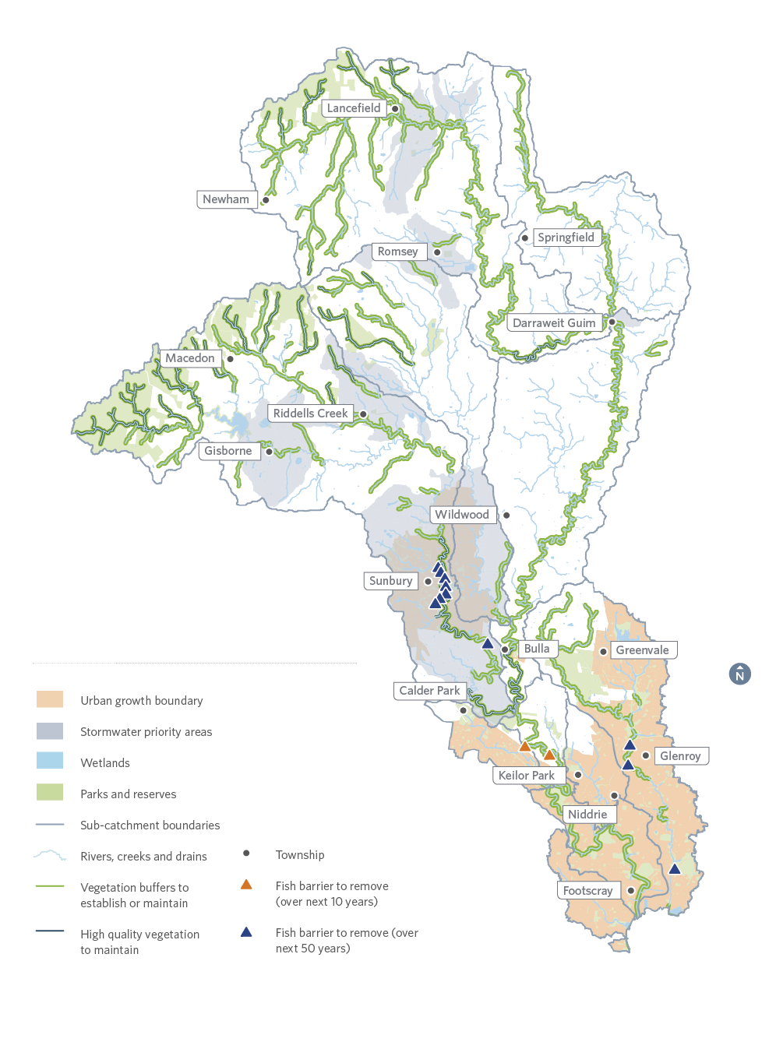
Figure 23. Summary of priorities in the Maribyrnong catchment region
Note: This map does not show headwater streams, some minor tributaries, waterbodies on private land and some wetlands less than one hectare.

16. Yarra Catchment

16.1. Catchment Overview
The Yarra catchment covers an area of 4046 square kilometres. About 55 per cent of the area retains its natural vegetation, 30 per cent is used for agriculture and 15 per cent is urban.
People of the Woi wurrung language group were the original occupants of this land and their descendants place enormous cultural and spiritual significance on the region’s land and waters.
The catchment includes the Yarra (Birrarung) River, which is the largest river in the Port Phillip and Westernport region. The river rises in the Great Dividing Range to the east of Warburton and flows 245 kilometres until entering Port Phillip at Newport. The Lerderderg River and Yarra River, between Warburton and Warrandyte, have been identified as a Victorian Heritage River, meaning that it has significant recreation, nature conservation, scenic and cultural heritage attributes.
There are over 21,000 wetlands in the Yarra catchment, including approximately 16,000 constructed wetlands and nearly 5100 natural wetlands that support significant environmental and social values. More than one third of Victoria’s native plant and animal species can be found in the Yarra catchment.
Population modelling shows that the Yarra catchment will increase from some 1.8 million people to over 2.4 million in the next 20 years, resulting in an additional 14,000 dwellings per year. The north growth corridor from Wallan to Broadmeadows, Mernda and Epping is the main growth area in the Yarra catchment. The Yarra catchment also encompasses part of the Fisherman’s Bend urban renewal area, which is planned to become home to approximately 80,000 residents and provide employment for up to 80,000 people by 2050.
Poor quality stormwater inputs, drainage and clearing of vegetation have already impacted many wetlands of the Yarra catchment. Additionally the construction of levees and harvesting of water means that river-fed wetlands, including billabongs, are less frequently inundated and less able to act as nursery and breeding areas.
Increased discharges of stormwater, toxicants and litter can threaten the use of waterways and beaches for swimming and boating activities. Inappropriate development along the waterways can limit public access, overshadow the waterways, destroy floodplain habitat and change the character of waterways for the worse forever.

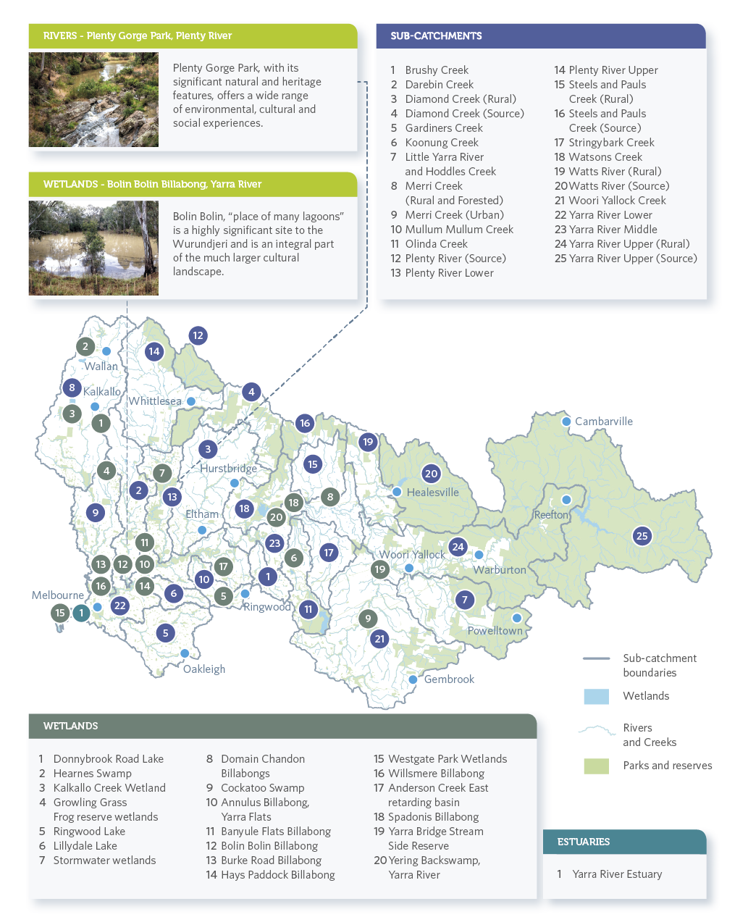
Figure 24. Sub-catchments and waterway assets including a sub-set of wetlands in the Yarra catchment

16.2. Vision
The Healthy Waterways Strategy vision for the Yarra Catchment builds on the Yarra River 50 year Community Vision developed for the Yarra Strategic Plan in early 2018:

Yarra River 50-year Community Vision
Our Yarra River, Birrarung, is recognised around the world as an iconic example of a nurturing relationship between a river and its community.
Flowing from source to sea, it is the resilient lifeblood of past, present and future generations of Victorians. It connects and enriches our flourishing city, suburbs, regions and beyond.
Our Yarra River, Birrarung, its essential role in our lives and its rich history, are respected, understood and protected. It has cared for us for thousands of years and will for thousands to come.
The vital and continued role of Traditional Owners as custodians of the River, and its role in their culture, is recognised and celebrated.
Our Yarra River, Birrarung and its diverse surrounding landscapes provide a place of refuge, recreation, learning and livelihood. It brings communities together and supports sustainable local economies.
Its clean waters and connected network of thriving green spaces nurture biodiversity, and deepen the relationship between people and nature.
Our Yarra River, Birrarung is respected as a sacred natural living entity and everyone takes responsibility for its care. Its health and integrity are paramount and uncompromised.
What is good for the Yarra is good for all.

This Community Vision will be given effect through both this Strategy and a separate document called the Yarra Strategic Plan. The Plan focuses on a more specific geographical area to the Healthy Waterways Strategy, concentrating on the Yarra River Corridor (rather than the whole of the Yarra catchment) and will consider public open space along the river, statutory planning, and the management of public land and infrastructure.
Achieving the Community Vision for the Yarra River relies on a healthy catchment. This Healthy Waterways Strategy has interpreted the Yarra River 50-year Community Vision to mean:
Our Yarra catchment waterways are increasingly protected, respected and collaboratively cared for by Traditional Owners, government and community as living and highly valued entities. They are a linked network of thriving corridor and instream spaces which nurture biodiversity, deepen the relationship between people and nature, build resilience as our population grows and the climate changes, and contribute to wellbeing and liveability. Their ecological health and value to the community continuously improves through rehabilitated waterways and balanced uses.

16.3. Goals
- The environmental values and significant ecological processes of all of the Yarra Catchment waterways are protected and improved.
- Riparian and instream habitats provide landscape connectivity, allowing the movement of native species and promoting resilient native flora and fauna populations.
- Cultural and heritage values are recognised, protected, maintained and enhanced.
- Communities and individuals connect with and appreciate the values of waterways. Waterway corridors are used appropriately for places of solitude, enjoyment of nature, and active and passive recreation that support mental and physical wellbeing.
- An engaged and knowledgeable community in the Yarra catchment acts to protect and promote sustained waterway values. Our waterways are a place of continuous learning.
- The waterways of the Yarra Catchment support natural system maintenance, potable and agricultural water supply, commerce and tourism in a balanced and environmentally sustainable manner.
- The Yarra waterways are managed in a transparent and collaborative governance framework that allows for strategic, innovative and integrated ways to protect waterways across public and private land.
- The cultural, historical, amenity values and landscape settings of all modified waterways are protected and improved.

16.4. Waterway Values

Environmental
Bird species listed as nationally-threatened in the catchment include the swift parrot, Australasian bittern and helmeted honeyeater. There are 16 native fish species, including the nationally-listed dwarf galaxis, Macquarie perch (introduced), Australian mudfish and Australian grayling. Frog species include threatened species such as the growling grass frog and the brown toadlet. Two threatened species of frog, Bibron’s toadlet (endangered in Victoria) and southern toadlet (vulnerable in Victoria) have seemingly disappeared from several areas in the catchment since the Millennium Drought.
Vegetation score is highly variable – the upper headwaters contain areas of very high value intact native vegetation protected within the Yarra Ranges National Park. Vegetation and macroinvertebrate scores decrease further from the headwaters as a result of agricultural activities and increasing areas of urbanisation.
Resilient and vulnerable populations of platypus have been observed across the catchment. A locally threatened population of platypus has been observed in the Plenty River in South Morang.

Social
Social value scores for rivers are currently high. The social value score for the estuary is very high. Social value scores are based on the surveyed level of community satisfaction and are threatened by inappropriate urban development, poor environmental condition, poor access to waterways and pollution.

Cultural
The land and waters of the region hold deep spiritual and cultural significance for Aboriginal peoples. The people of the Woi wurrung language group were the original occupants of this land, as evidenced by the thousands of cultural sites and places recorded, most of these occurring within 200 metres of a watercourse. Two significant sites include Bolin Bolin Billabong and Corranderk Aboriginal Station.

Economic
Major drinking water storages for Melbourne are located in the catchment. There are numerous diversions for domestic, stock and agricultural uses. Yarra Valley and Dandenong Ranges tourism is a significant economic driver, worth $559 million to the region’s economy in 2015-2016.

16.5. Targets and Performance Objectives
This section provides summaries of the long-term targets and performance objectives to be delivered through the implementation of the Strategy, in the 25 sub-catchments, sub-set of 20 wetlands and the Yarra River Estuary in the Yarra catchment. The full suite of targets and performance objectives are available in the Co-Designed Catchment Program for the Yarra catchment.

16.5.1. Rivers – Key values and waterway conditions (Yarra)
The following target summaries represent an average across the Yarra catchment for rivers.

Key value target summaries for rivers in the Yarra catchment
Key Values | Current State | Current Trajectory | Target
Birds | Moderate | Moderate | Moderate
Fish | Low | Moderate | High
Frogs | Low | Low | Moderate
Macroinvertebrates | High | High | Very high
Platypus | High | Moderate | High
Vegetation | Moderate | Low | Moderate
Amenity | High | High | Very high
Community connection | High | Moderate | High
Recreation | High | High | Very high

Waterway Conditions | Current State | Current Trajectory | Target
Stormwater condition | Moderate | Low | High
Water for the environment | High | Moderate | High
Vegetation extent | High | High | High
Vegetation quality | Moderate | Low | High
Water quality – environment | Moderate | Moderate | High
Instream connectivity | Moderate | Moderate | High
Physical form | High | Moderate | High
Access | Low | Low | Moderate
Water quality - recreational | High | High | High
Litter absence | High | Moderate | High
Participation | Moderate | Low | Very high

16.5.2. Rivers – Summary of performance objectives (Yarra)
The following presents a summary of the 10-year performance objectives for rivers in the Co-Designed Catchment Program for the Yarra catchment.
- Progressively implement stormwater harvesting, focusing on rural townships along the Middle and Upper Yarra River, Woori Yallock, Olinda Creek catchments and new urban areas in the Merri Upper and Darebin Creek sub-catchments. Once this catchment has reached its anticipated long-term urban footprint based on the urban growth boundary, this will require around 37.8 GL/year of stormwater harvested and 10.7 GL/year infiltrated. Ensure DCI levels in the above priority catchments do not increase beyond current levels and headwater streams are retained as features in the landscape for environmental and social benefits.
- Investigate options to increase the environmental water reserve by 10 GL/year by 2028 to meet ecological watering objectives and cover projected shortfalls from climate change. This will benefit the middle Yarra River. Any water recovery for the environment will be considered through Victorian SWSs, markets and use of alternative water.
- Identify opportunities to maintain or improve the flow regime in refuge reaches to support instream values, including platypus.
- Reduce the key threat of flow stress by addressing the threats and other activities that impact waterways such as domestic, stock and agricultural uses, climate change, diversions or urbanisation.
- Establish 376 kilometres and maintain 1793 kilometres of continuous vegetated buffers (using EVC benchmarks and to at least a level 3 vegetation quality) along at least 80 per cent of priority reaches. In addition, increase vegetation cover in existing and planned urban areas by 2 kilometres to support social values.
- Maintain 735 kilometres of high and very high quality vegetation (vegetation quality levels 4 and 5) through effective monitoring and management of threats.
- Investigate and mitigate threats to physical form (eg erosion) and other high values in the Darebin Creek, Diamond Creek (Rural), Merri Creek Upper, Mullum Mullum Creek, Plenty River Lower, Plenty River Upper, Steels and Pauls Creek (Rural) and Woori Yallock Creek sub-catchments.
- Increase access to and along waterways by 41 kilometres by improving connections with existing path networks and extending paths into new urban areas. Establish new boat launch facilities at key locations along the Yarra River to improve access for on-water activities.
- Reduce nutrient and sediment runoff from rural land through improved management of 1800 hectares of land including works to protect and increase vegetation along headwater streams.
- Provide connectivity for fish along major tributaries of the Yarra River through the removal of seven barriers by 2028. This will improve fish passage in several areas, including Darebin Creek and the Upper Yarra tributaries.
- Conserve all currently listed water dependent species and communities (16 fauna species, 150 flora species and 39 EVCs) through habitat protection, research and monitoring.

16.5.3. Rivers – Summary of long-term key value outcomes (Yarra)
The following target summaries represent an average across the Yarra catchment.
Birds score is currently moderate overall, with 252 bird species being recorded in the catchment including 153 species of riparian birds. Nationally threatened species include swift parrot, Australasian bittern and helmeted honeyeater. Without further action bird scores are considered unlikely to improve. The target is to maintain at moderate.
Fish scores are currently low overall, however the main stem of the Yarra is very important for native fish – with 14 indigenous freshwater species, including the nationally significant Australian grayling, Australian mudfish, and several estuarine species such as black bream, yellow eye mullet and mulloway. The fish score is considered likely to improve over time. The target is to improve the overall score from low to high.
Frogs score is currently low overall. Fifteen species of frog are expected to occur in the Yarra catchment. The nationally listed growling grass frog still occurs in some sub-catchments, mostly along north-western tributaries such as the Merri and Darebin Creeks. Frogs score is considered likely to decline unless the performance objectives in this strategy are achieved. The target is to improve to moderate.
Locations where a decline or very low score is expected: Darebin Creek, Plenty River Lower
Macroinvertebrates score is currently high overall. Diversity is higher along the main stem and in the middle and upper catchments. The target is to improve to very high.
Locations where a decline or very low score is expected for macroinvertebrates: Gardiners Creek, Merri Creek Lower, Koonung Creek, Mullum Mullum Creek
Platypus score is currently high overall for the catchment. Platypus are mostly found in tributaries of the middle and upper catchment and the main stem of the Yarra. Platypus are at risk, particularly in the lower and middle tributaries of the Yarra River, unless the performance objectives in this Strategy are achieved. The target is to maintain current populations at a high level.
Locations where a decline or very low score is expected: Brushy Creek, Gardiners Creek, Merri Creek Lower, Koonung Creek, Mullum Mullum Creek, Steels and Pauls Creek (Source), Watsons Creek, Darebin Creek
Vegetation score is currently moderate. The largest and most intact areas of vegetation are the forested headwaters in the Yarra Ranges National Park which support many rare and threatened plant species such as the Jungle Bristle Fern, Tall Astelia, Tree Geebung and old growth Mountain Ash. The Yellingbo Nature Conservation Reserve is also an area rich in biodiversity. Yering Back Swamp is a unique wetland area adjacent to the Yarra River downstream of Yarra Glen. It supports a diverse mix of species including plants such the giant rush (Juncus ingens) and Australian basket-grass (Oplismenus hirtellus) not generally found in the Yarra catchment. The Bolin Bolin Billabong is very important culturally for the Wurundjeri people and it also supports some remnant red gums estimated to pre-date European arrival in Australia. Without further action vegetation score is considered likely to decline. The target is to maintain vegetation scores as moderate.
Amenity score is currently high based on community satisfaction, but is likely to decline in response to population growth and urbanisation. The target is to improve to very high.
Connection score is currently high based on community satisfaction, but is likely to decline in response to population growth and urbanisation. The target is to maintain at high.
Recreation score is currently high based on community satisfaction, but is likely to decline in response to population growth and urbanisation. The target is to improve to very high.

16.5.4. Wetlands – Key values and waterway conditions (Yarra)
The following target summaries represent an average across the Yarra catchment for wetlands.
Key Values | Current State | Current Trajectory | Target
Birds | Very low | Low | Low
Fish | Low | High | High
Frogs | High | Moderate | High
Vegetation | Low | Low | Moderate

Waterway Conditions | Current State | Current Trajectory | Target
Water regime | Low | High | High
Wetland habitat form | Low | Low | Low
Wetland buffer condition | Very low | Low | High
Vegetation condition | Low | Moderate | High
Wetland water quality | Low | Very low | Moderate

16.5.5. Wetlands – Summary of performance objectives (Yarra)
The following presents a summary of the 10-year performance objectives for wetlands in the Co-Designed Catchment Program for the Yarra catchment.

Wetlands
- Reduce the threat of invasive plant species.
- Deliver environmental water to key billabongs on the Yarra floodplain.
- Investigate opportunities to re-engage natural floodplain wetlands in key locations to meet ecological watering objectives, improve ecosystem services, cultural and social values.
- Reduce the threat of invasive animals such as dogs, cats and foxes to protect key wetland bird habitats.
- Develop understanding of the amenity, community connection and recreation values of wetlands and develop performance objectives to enhance these values.

16.5.6. Wetlands – Summary of long-term key value outcomes (Yarra)
The following target summaries represent an average across the Yarra catchment for wetlands.
Wetland bird score in the Yarra catchment is on average currently very low. However, some wetlands such as Cockatoo Swamp have high bird values. Environmental watering of key billabongs in the Yarra catchment is predicted to improve the bird value of many billabong wetlands. The target is to improve from very low to low.
Locations where a decline or very low score is expected: Donnybrook Road Lake, Hearnes Swamp, Kalkallo Commons Grassland and Kalkallo Creek Wetlands, Growling Grass Frog Reserve Wetlands, Ringwood Lake, Lillydale Lake, Stormwater Wetlands, Anderson Creek East Retarding Basin
Fish score is currently low overall. However, environmental watering of key billabongs and re-engagement of floodplain wetlands in the long term is predicted to significantly improve the fish score up to high.
Frogs score is high. Actions to reduce the threats of changed water regimes, altered wetland form, lack of wetland buffers and poor wetland vegetation condition will maintain the score at high, particularly in the Yarra billabongs. Many Yarra wetlands provide habitat for significant frog species such as growling grass frog. It is predicted that these habitats will continue to support these species.
Vegetation score is currently low. Actions to reduce the threats of changed water regimes, improve vegetation condition and wetland habitat form will improve the wetland vegetation score to a potential trajectory of moderate.

16.5.7. Estuaries – Key values and waterway conditions (Yarra)
The following target summaries represent an average across the Yarra catchment for estuaries.
Key Values | Current State | Current Trajectory | Target
Birds | Very low | Very low | Very low
Fish | Very high | Very high | Very high
Vegetation | Very low | Very low | Very low
Amenity | Very high | Very high | Very high
Community connection | Very high | Very high | Very high
Recreation | Very high | Very high | Very high

Waterway Conditions | Current State | Current Trajectory | Target
Flow regime | Very low | Very low | High
Tidal exchange | Very high | Very high | Very high
Longitudinal extent | Very high | Very high | Very high
Water quality | Very low | Very low | Low
Estuarine vegetation | Very low | Very low | Low
Estuarine wetland connectivity | Very low | Very low | Low

16.5.8. Estuaries – Summary of performance objectives (Yarra)
The following presents a summary of the 10-year performance objectives for estuaries in the Co-Designed Catchment Program for the Yarra catchment.

10-year performance objectives
- Enhance estuarine emergent vegetation condition that provides instream habitat.
- Reduce threat of invasive plant species to significant estuarine vegetation communities.
- Investigate opportunities to improve access for on-water activities and improve connections with existing path networks.
- Maintain recreational water quality within the Yarra estuary so that it is suitable for secondary contact (boating and fishing).
- Maintain existing high value opportunities for recreation (walking/ cycling, boating, fishing, etc.).
- Maintain existing high value facilities that support passive enjoyment and recreation.

16.5.9. Estuaries – Summary of long-term key value outcomes (Yarra)
The following is a summary of the long-term key value outcomes for the Yarra River estuary.
Estuary birds score is currently very low due to the historical loss of habitat, industrial and urban development. The target is to avoid further decline.
Fish score is currently very high, with significant species such as the Australian Grayling using the estuary as part of its migration path between the sea and fresh waters. A good diversity of estuarine dependent fish species also inhabit the estuary. The target is to maintain at very high.
Vegetation score is currently very low due to the historical loss of habitat, and industrial and urban development. The target is to avoid further decline.
Amenity score is currently very high and is expected to remain very high with continued improvements to parks, facilities and vegetation.
Community connection score is currently very high. The Yarra River estuary is an iconic location loved by visitors and locals to Melbourne.
Recreation score is currently very high and will remain high. The estuary is a hub of activity including boating, cycling and walking.

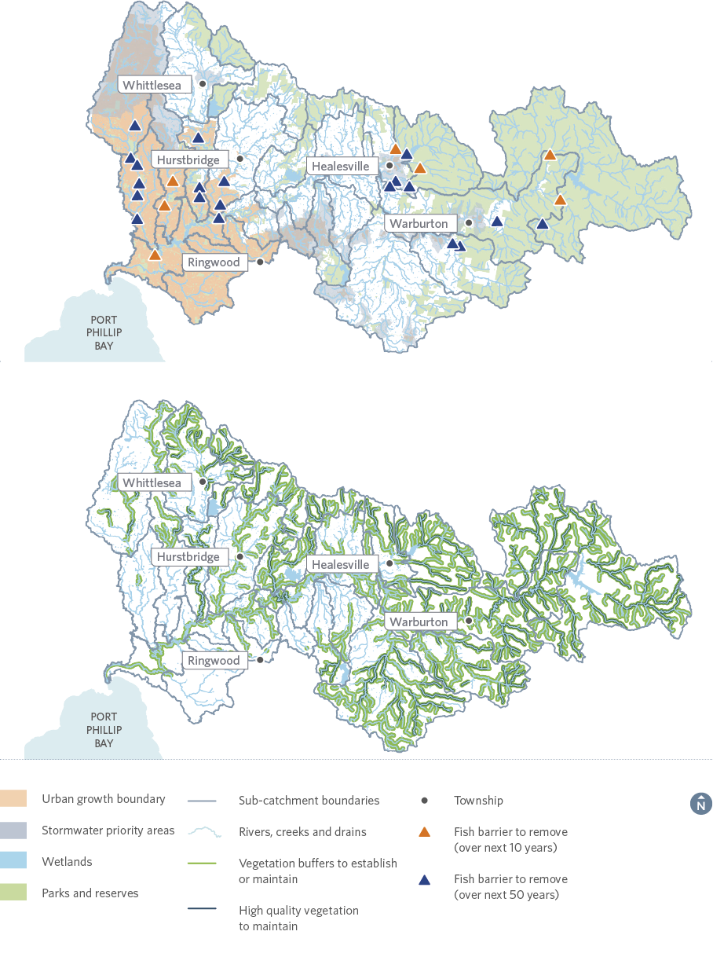
Figure 25. Summary of priorities in the Yarra catchment
Note: This map does not show headwater streams, some minor tributaries, waterbodies on private land and some wetlands less than one hectare. Due to the size of the catchment the features have been displayed over two maps.

17. Dandenong Catchment region

17.1. Catchment Overview
The Dandenong catchment region, which covers an area of about 870 square kilometres, consists of forested areas, farmland, reclaimed swampland and urban areas. Urban areas cover about 60 per cent of the catchment, 30 per cent is used for agriculture and about 10 per cent retains its natural vegetation.
People of the Woi wurrung and Boon wurrung language groups were the original occupants of this land and their descendants place enormous cultural and spiritual significance on the region’s land and waters.
Modifications to rivers and creeks for flood protection (such as piping, concrete lining and channel straightening) have been extensive. Most notably, the Carrum Carrum Swamp was drained in the late 1800s with the construction of Patterson River. This swamp previously covered about 45 square kilometres. However, the catchment has retained some natural features such as the Ramsar listed Edithvale-Seaford Wetlands (listed as a Ramsar site in 2001, and home to large concentrations of waterbirds including migratory shorebirds), The Pines Flora and Fauna Reserve, the Dandenong Ranges and parts of the middle Dandenong Creek.
Closer to the city, waterways such as Elster Creek and Albert Park Lake provide critical habitat for flora and fauna within the constraints of the urban environment.
Despite the significant impacts from urban development and agriculture across the catchment, waterways continue to support multiple and varied uses and values, including flood mitigation, extensive recreational trials and parklands and significant plant and animal species (including platypus, dwarf galaxias, Latham’s snipe and growling grass frogs).
The open space network throughout the Dandenong catchment region, which includes sites such as Dandenong Valley, Hallam Valley and the main estuaries, provide important social value and offer recreational opportunities.
Population modelling shows that the Dandenong catchment region will increase from some 1.4 million people to over 1.7 million in the next 20 years, which will require an additional 7000 dwellings per year. This will result in continued development in growth areas outwards from Dandenong and increased density in the existing urban areas.
The Dandenong catchment also encompasses part of the Fisherman’s Bend urban renewal area, which is planned to become home to approximately 80,000 residents and provide employment for up to 80,000 people by 2050.
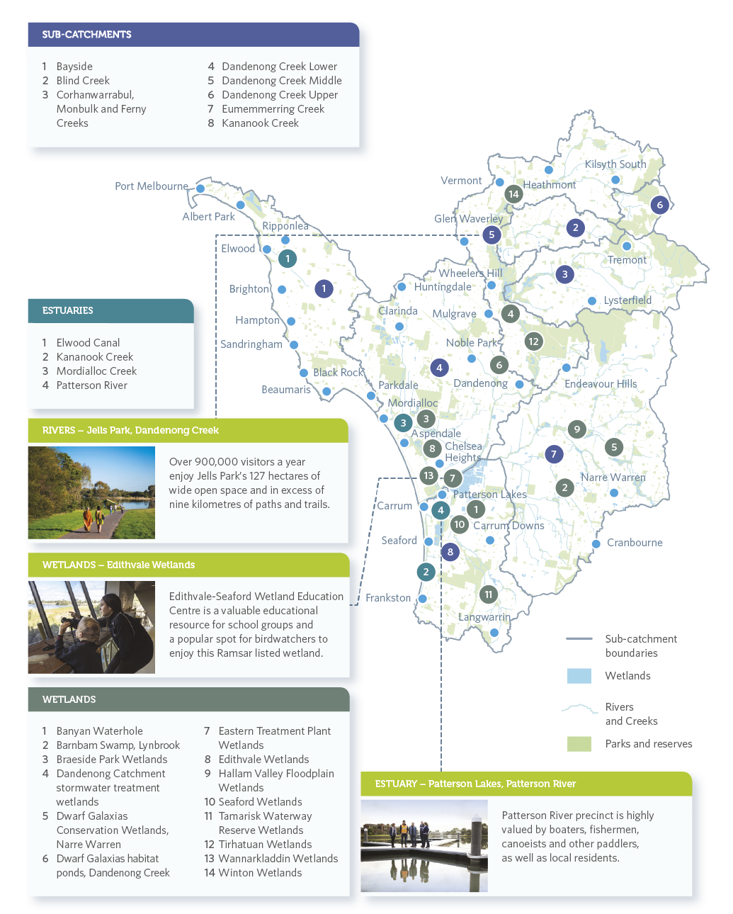
Figure 26. Sub-catchments and waterway assets including a sub-set of wetlands in the Dandenong catchment region

17.2. VISION
A vibrant valued Dandenong catchment waterway and wetland network, whose ecological health and liveability attributes continue to improve through rehabilitated waterways and connected and secured biodiversity corridors.

17.3. GOALS
- Management of the catchment is integrated and includes the whole water cycle.
- Impacts from urban, peri urban, industrial and transport activities are mitigated to protect our waterways and the Bay.
- Exemplary leadership enables informed, engaged and an empowered community who value and connect with waterways and tackle collaborative action.
- Waterways, wetlands and floodplains provide biodiversity corridors that allow the key environmental values to move and adapt to changes in condition and climate.
- Waterways, wetlands and floodplains are inviting places that are connected and accessible for public enjoyment and amenity.
- Existing sustainable habitats and refugia for iconic fish, bird and frog species and platypus are secured and rehabilitated to meet the challenge of climate change impacts.
- Remnant higher stream values and habitats are rehabilitated to ensure high quality elements remain in upper catchments.
- Secure and enhance the Edithvale–Seaford Ramsar site and surrounding creeks and wetlands within the South-east Green Wedge.
- Streamside vegetation zones and floodplains within the catchment continue to retain and expand Swamp Scrub and River Red Gum communities.

17.4. Waterway Values

Environmental
There are 295 bird species recorded, of which 126 species are riparian specialists. The overall score for fish is low which is largely a reflection of the extent of barriers to fish movement throughout the catchment that prevent some species from reaching other parts of the catchment. Nationally-significant fish species include the dwarf galaxias. Frogs across much of the catchment have been impacted by spreading urbanisation, land use intensification, introduced predators, and deteriorating water quality. However, recorded species include the threatened growling grass frog and the southern toadlet.
Vegetation value varies greatly with much of the higher value areas being in the forested upper catchment and in the large regional parks and wetlands along the Dandenong Creek.
Macroinvertebrate scores are very low as much of the catchment has been impacted by increasing expansion of urban and industrial areas.
Platypus are known to occur in the upper parts of the catchment, however, recent targeted surveys suggest they may no longer be present in some of these known areas. Key threats to platypus in the catchment are urban and industrial stormwater (including litter), clearing of streamside vegetation, loss of instream habitat and fragmentation of populations from barriers to movement.

Social
Social values for rivers are currently high. Social values for estuaries range from high to very high. Social values are based on the surveyed level of community satisfaction and are threatened by inappropriate urban development, poor environmental condition, poor access to waterways and pollution. Of note is the National Water Sports Centre on Patterson River and boating facilities in the estuaries of Mordialloc Creek, Patterson River and Kananook Creek.

Cultural
The land and waters of the region hold deep spiritual and cultural significance for Aboriginal peoples. The people of the Boon wurrung and Woi wurrung language groups were the original occupants of this land, as evidenced by the thousands of cultural sites and places recorded in the catchment, including along the coast.

Economic
Economic values vary across the catchment. In the upper and middle parts, diversions provide for domestic, stock and agricultural uses. On the floodplains, wetlands are being reinstated to increase the value of urban properties.

17.5. Targets and Performance Objectives
This section provides summaries of the long-term targets and performance objectives to be delivered through the implementation of the Strategy, in the eight sub-catchments, sub-set of 14 wetlands and four estuaries of the Dandenong catchment region. The full suite of targets and performance objectives are available in the Co-Designed Catchment Program for the Dandenong catchment region.

17.5.1. Rivers – Key values and waterway conditions (Dandenong)
The following target summaries represent an average across the Dandenong catchment region for rivers.

Key value target summaries for rivers in the Dandenong catchment region
Key Values | Current State | Current Trajectory | Target
Birds | Moderate | Moderate | Moderate
Fish | Low | Moderate | Moderate
Frogs | Low | Moderate | Moderate
Macroinvertebrates | Very low | Very low | Low
Platypus | Very low | Very low | Very low
Vegetation | Low | Very low | Low
Amenity | High | High | Very high
Community connection | High | High | Very high
Recreation | High | High | Very high

Waterway Conditions | Current State | Current Trajectory | Target
Stormwater condition | Very low | Very low | Low
Water for the environment | Moderate | Low | Moderate
Vegetation extent | Low | Low | Moderate
Vegetation quality | Low | Very low | Moderate
Water quality – environment | Very low | Very low | Low
Instream connectivity | Low | Low | High
Physical form | High | Moderate | High
Access | Moderate | Moderate | High
Water quality - recreational | Moderate | Low | High
Litter absence | Moderate | Moderate | High
Participation | Low | Very low | High

17.5.2. Rivers – Summary of performance objectives (Dandenong)
The following presents a summary of the 10-year performance objectives for rivers in the Co-Designed Catchment Program for the Dandenong catchment region.
- Progressively implement stormwater harvesting, focusing on rural townships in the Dandenong Creek Upper and the Corhanwarrabul, Monbulk and Ferny Creek sub-catchments. Once this catchment has reached its anticipated long-term urban footprint based on the current urban growth boundary, this will require around 0.4 GL/year of stormwater harvested and 0.2 GL/year infiltrated. Ensure DCI levels in the above priority catchments do not increase beyond current levels and headwater streams are retained as features in the landscape for environmental and social benefits.
- Establish 39 kilometres and maintain 83 kilometres of continuous vegetated buffers (using EVC benchmarks and to at least a level 3 vegetation quality) along at least 80 per cent of priority reaches.
- Maintain 22 kilometres of high and very high quality vegetation (vegetation quality levels 4 and 5) through effective monitoring and management of threats.
- Investigate and mitigate threats to physical form (for example, erosion) and other high values (including impacts of urbanisation) in the Corhanwarrabul, Monbulk and Ferny creeks sub-catchment.
- Increase access to and along waterways by 26 kilometres by improving connections with existing path networks and extending paths into new urban areas. Investigate opportunities to improve access for on-water activities.
- Reduce nutrient and sediment runoff through improved management of 10 hectares of rural land including works to protect and increase vegetation along headwater streams.
- Provide connectivity for fish along major waterways through the removal of two barriers along lower Dandenong Creek, Mordialloc Creek and Patterson River by 2028. This will improve fish passage from the Mordialloc estuary and Patterson River to Dandenong.
- Conserve all currently listed water dependent species and communities (16 fauna species, 33 flora species and 26 EVCs) through habitat protection, research and monitoring.
- Identify opportunities to maintain or improve the flow regime in refuge reaches to support instream values, including platypus along Monbulk Creek.
- Reduce the key threat of flow stress on waterways by addressing factors such as domestic, stock and agricultural uses, climate change, diversions or urbanisation.

17.5.3. Rivers – Summary of long-term key value outcomes (Dandenong)
The following target summaries represent an average across the Dandenong catchment region.
Birds score is currently moderate overall and likely to remain moderate over the long term. Parts of the catchment are of international significance for migratory shorebirds (includes Ramsar-listed Edithvale- Seaford wetlands) and there are critical wetlands along Dandenong Creek that provide drought refuge for many species. The target is to maintain as moderate.
Fish score is currently low overall, but can be improved to moderate through improved instream connectivity, streamside revegetation, stormwater management and provision of suitable stream flows. There are 12 freshwater species (including the nationally threatened dwarf galaxias), nine exotic species and several estuarine species (including black bream and yellow-eye mullet). The target is to improve from low to moderate.
Frogs score is currently low overall as a result of urbanisation, land use intensification, introduced predators and deteriorating water quality. The target is to improve from low to moderate.
Macroinvertebrates score for rivers is very low overall. Scores are higher in the forested headwaters, but much of the catchment is impacted by urbanisation that results in changes to stream flows, water quality and instream habitat. The target is to improve from very low to low.
Locations where a decline or very low score is expected: Blind Creek, Dandenong Creek Lower, Dandenong Creek Middle, Bayside
Platypus are known to currently occur in the Monbulk Creek system. However, with continued urbanisation and changes in climate, this population is likely to decline without intervention. The target is to retain this population.
Platypus are not expected to be in: Dandenong Creek Lower, Eumemmerring Creek, Dandenong Creek Middle, Kananook Creek, Bayside, Blind Creek
Vegetation score is currently low across the catchment. Vegetation varies, with forested areas of upper catchments having higher values. Extensive land clearing and drainage has resulted in low to moderate vegetation scores in many areas. Notable remnant forest can be found in the Dandenong Ranges, Churchill and Lysterfield parks and there are remnants of the Carrum Carrum Swamp at Edithvale-Seaford, Kananook, Carrum, Mordialloc and Braeside. The vegetation score trajectory is towards very low unless opportunities to improve vegetation are implemented. The target is to avoid further decline.
Amenity score, which is based on level of satisfaction, is currently high but likely to decline with increased urbanisation. The target is to improve to very high.
Community connection score, which is based on level of satisfaction, is currently high but likely to decline with increased urbanisation. The target is to improve to very high.
Recreation score, which is based on level of satisfaction, is currently high but likely to decline with increased urbanisation. The target is to improve to very high.

17.5.4. Wetlands – Key values and waterway conditions (Dandenong)
The following target summaries represent an average across the Dandenong catchment region for wetlands.
Key Values | Current State | Current Trajectory | Target
Birds | Low | Low | Low
Fish | Very high | Very high | Very high
Frogs | Low | Moderate | Moderate
Vegetation | Low | Low | Moderate

Waterway Conditions | Current State | Current Trajectory | Target
Water regime | Low | Low | Moderate
Wetland habitat form | Low | Low | Moderate
Wetland buffer condition | Very low | Very low | Moderate
Vegetation condition | Low | Low | Moderate
Wetland water quality | Low | Very low | Low

17.5.5. Wetlands – Summary of performance objectives (Dandenong)
The following presents a summary of the 10-year performance objectives for wetlands in the Co-Designed Catchment Program for the Dandenong catchment region.

Wetlands
- Implement the Edithvale-Seaford Ramsar Site Management Plan and plan for climate change adaptation and resilience.
- Reduce the threat of invasive animals such as dogs, cats and foxes to protect key wetland bird habitats.
- Increase the buffer of native vegetation around key wetlands and reduce the threat of invasive plant species.
- Protect and enhance water regimes in wetlands with significant fish species and other significant values.
- Re-engage key floodplain wetlands to protect habitat for significant wetland fish species.
- Reduce the threat of invasive fish species on significant wetland fish populations.
- Develop understanding of the amenity, community connection and recreation values of wetlands and develop performance objectives to enhance these values.

17.5.6. Wetlands – Summary of long-term key value outcomes (Dandenong)
The following target summaries represent an average across the Dandenong catchment region for wetlands.
Wetlands bird score in the Dandenong catchment is on average currently low. In the long term the wetland bird score will be maintained at low. Improvements to wetland water regimes, habitat form, buffer and vegetation condition will help to mitigate the impacts of climate change and urbanisation, but will not result in significant improvements to the score. Significant bird values will remain at the Edithvale-Seaford wetlands.
Locations where a decline or very low score is expected: Dandenong catchment stormwater treatment wetlands, Tirhatuan Wetlands (Dandenong Creek), Winton Wetlands (Dandenong Creek), Barnbam Swamp (Lynbrook), Dwarf Galaxias Conservation Wetland (Cranbourne Road, Narre Warren), Banyan Waterhole (aka Boundary Road Wetland), Tamarisk Waterway Reserve (Langwarrin)
Fish Very little data exists for wetland fish, and a metric for wetland fish in this region will be developed through the Strategy implementation. A number of wetlands in the Dandenong Catchment support the nationally-listed dwarf galaxias and more recently reintroduced Yarra pygmy perch. These wetlands will retain a fish status of very high due to the ongoing presence of these species.
Frogs score is currently low with a current and target trajectory of moderate. Many wetlands in the catchment provide habitat for significant frog species and these areas will be targeted to maintain their very high frog value scores. Improvements to wetland water regime, wetland habitat form and vegetation condition will help to improve frog populations. However, at some coastal wetland sites, increasing salinity associated with predicted climate change impacts may impact the frog score at these sites.
Locations where a decline or very low score is expected: Edithvale Wetland
Wetland vegetation score is currently considered low. However, there is potential to increase the vegetation score to moderate in the long term. Improvements to the wetland water regimes and wetland habitat form, along with actions to reduce the threat of invasive plant and animal species will improve the vegetation score.

17.5.7. Estuaries – Key values and waterway conditions (Dandenong)
The following target summaries represent an average across the Dandenong catchment region for estuaries.
Key Values | Current State | Current Trajectory | Target
Birds | Very low | Very low | Very low
Fish | High | High | High
Vegetation | Low | Very low | Low
Amenity | High | High | High
Community connection | Very high | Very high | Very high
Recreation | High | High | Very high

Waterway Conditions | Current State | Current Trajectory | Target
Flow regime | Very low | Very low | Low
Tidal exchange | Very high | Very high | Very high
Longitudinal extent | Low | Moderate | Moderate
Water quality | High | Low | Moderate
Estuarine vegetation | Very low | Very low | Low
Estuarine wetland connectivity | Very low | Very low | Low

17.5.8. Estuaries – Summary of performance objectives (Dandenong)
The following presents a summary of the 10-year performance objectives for estuaries in the Co-Designed Catchment Program for the Dandenong catchment region.

10-year performance objectives
- Protect remnant estuarine vegetation communities, particularly coastal saltmarsh, through targeting key invasive plant species.
- Undertake adaptation and resilience planning for estuaries to protect social and environmental values.
- Investigate opportunities to improve access for on-water activities and improve connections with existing path networks.
- Maintain existing high value opportunities for recreation (walking/ cycling, boating, fishing, etc.).
- Maintain existing high value facilities that support passive enjoyment and recreation.

17.5.9. Estuaries – Summary of long-term key value outcomes (Dandenong)
The following target summaries represent an average across the Dandenong catchment region for estuaries.
Estuary birds score is currently very low and is predicted to remain very low. The estuaries are fringed by highly urbanised areas and the predicted climate change impacts will further erode suitable bird habitat. The target is to avoid further decline.
Locations where a decline or very low score is expected: Elwood Canal Estuary, Mordialloc Creek Estuary, Patterson River Estuary, Kananook Creek Estuary
Fish value score for estuaries in the Dandenong Catchment is high and predicted to remain high in the long term. A good diversity of estuarine dependent species inhabit the estuaries and are likely to remain. The target is to maintain as high.
Estuarine vegetation score is currently considered low with a current trajectory of very low. Adopting some climate change adaption strategies may mitigate some of the risk to estuarine vegetation; however, this will only allow the value to be maintained at low. The estuaries are fringed by highly urbanised environments allowing little potential for estuarine vegetation communities to migrate into more favourable less saline conditions.
Locations where a decline or very low score is expected: Elwood Canal Estuary, Patterson River Estuary, Kananook Creek Estuary
Amenity score is currently high and predicted to remain high. Existing facilities support the amenity value.
Community connection score is currently very high with very active community groups.
Recreation score is currently high and is predicted to improve to very high. The estuaries are hubs of recreational activity.

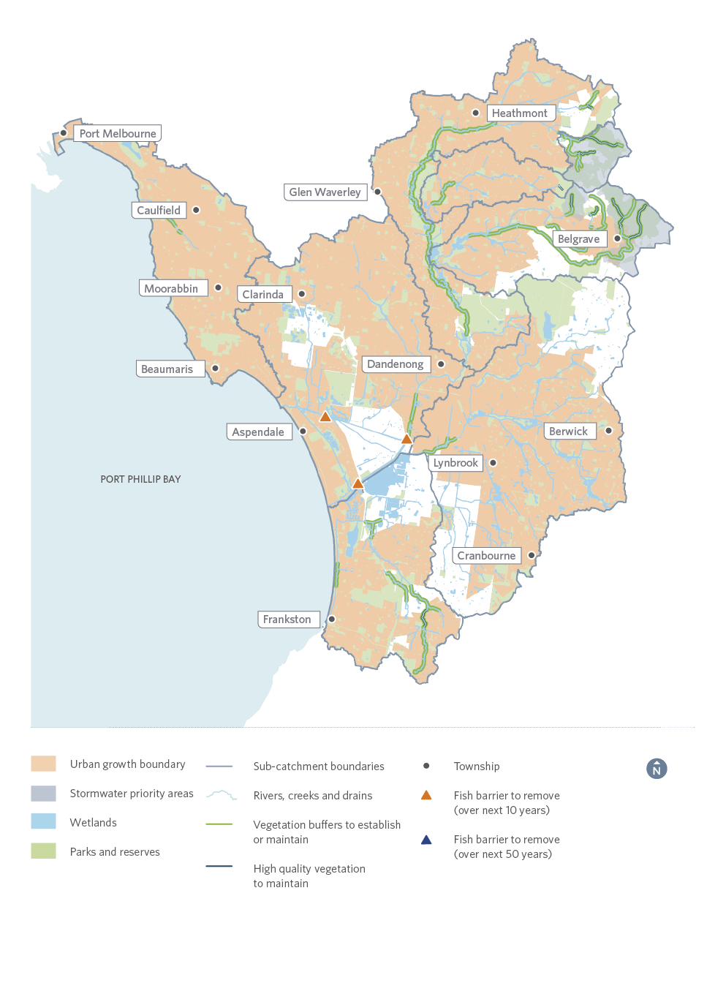
Figure 27. Summary of priorities in the Dandenong catchment region
Note: This map does not show headwater streams, some minor tributaries, waterbodies on private land and some wetlands less than one hectare.

18. Westernport and Mornington Peninsula region

18.1. Catchment Overview
The Westernport and Mornington Peninsula region occupies an area of about 3755 square kilometres and includes all the waterways within the catchment for Western Port, together with those on Phillip and French islands and the Mornington Peninsula, including those that drain to Port Phillip and Bass Strait. The landscape is varied and includes hilly regions near the Bunyip State Park and Strzelecki Ranges, the flat, undulating terrain of the former Koo Wee Rup Swamp, and the marine environment of Western Port and its islands.
Most of the catchment is modified to support rural and green wedge land uses, though there are still some significant areas of remnant vegetation. Primary industries in the catchment include dairy farming, beef production, poultry, horticulture and quarrying. Urban development, industrial zones, tourist development, lifestyle and hobby farms represent a smaller proportion of the area.
The catchment has experienced substantial changes in the past 200 years, including extensive clearing of catchment and coastal vegetation, draining of large areas of swampland and progressive agricultural, industrial and urban development. Despite the significant impacts associated with these changes, waterways continue to support multiple and varied uses and values, including water supply, flood mitigation, and significant plant and animal species. Significant features of the catchment include surface and groundwater springs, which support many streams and wetlands, and the Mornington Peninsula National Park, which was established in 1975.
The marine ecosystem within Western Port is of regional, national and international importance and supports a variety of critical habitats including mangrove, saltmarsh, mudflats, seagrass meadows and rocky reefs. These habitats are home to a diverse range of aquatic animals such as waterbirds (including migratory shorebirds), fish, marine invertebrates and mammals. Western Port was declared a Ramsar wetland of international importance in 1982 and is recognised under the East Asian-Australasian Flyway Network. The Marine National Parks of Mushroom Reef, Yaringa, French Island and Churchill Island were established in 2002.
Research over the past decade as part of Melbourne Water’s Western Port Environment Research Program has significantly increased our understanding of the environmental values of the bay, threats to those values and opportunities to protect and improve the health of Western Port and its catchment into the future.
Key pressures on the health of the catchment and the bays in the coming decades include climate change, continued sediment loads from rivers and coasts (that particularly affects seagrasses) and urban growth outwards from Frankston, Cranbourne and Berwick, and in regional towns around the bays. Modelling shows that population in the catchment will increase from some 420,000 people to over 650,000 in the next 20 years, which will require an additional 5000 dwellings per year.
People of the Boon wurrung language group were the original occupants of this land and their descendants place enormous cultural and spiritual importance on the region’s land and waters.
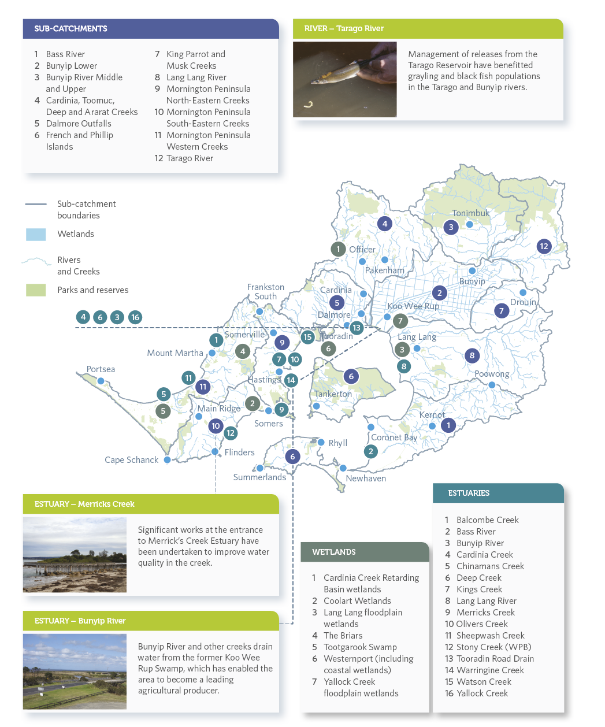
Figure 28. Sub-catchments and waterway assets including a sub-set of wetlands in the Westernport and Mornington Peninsula region

18.2. VISION
Waterways and our bays are highly valued and sustained by an informed and engaged community working together to protect and improve their value.

18.3. GOALS
- Stakeholders and the broader community are knowledgeable, engaged and working together in a transparent process creating a legacy of stewardship to value, protect and improve waterways.
- Indigenous cultural and European historical legacy be celebrated in a respectful and open dialogue.
- Waterways provide important biolinks that support indigenous plants and animals, are weed free, protected from feral animals (including deer), and connected to the wider landscape.
- Natural and modified waterways across the catchment are managed for instream habitats, long term ecological resilience and fluvial processes; balancing the needs for flood mitigation, agriculture water diversion, and social values.
- Waterways and their estuaries across the catchment are managed to maintain and improve coastal and marine ecosystems in Western Port and Port Phillip.
- Water re-use systems are established to benefit groundwater recharge, base flows, agriculture diversion and use, and to offset streamflow losses due to climate change.
- Water quality and sediment impacts from urbanisation, forestry, agriculture, industry and transport are mitigated to reduce impacts on waterways and the receiving ecosystem of Western Port.
- Flow management of waterways be improved to protect groundwater dependent ecosystems, base flows and environmental flushing flows to sustain instream ecosystems.

18.4. Waterway Values

Environmental
There have been 249 species of bird recorded, of which 131 species are expected in riparian habitats. The Westernport catchment has important bird habitats including Ramsar- listed Western Port with its extensive network of mangroves, saltmarshes and mudflats. Threatened species include Australasian bittern, hooded plover, eastern great egret and white-bellied sea-eagle, and important migratory species such as eastern curlew, red-necked stint and curlew sandpiper.
There are 18 native freshwater fish species and eight exotic fish species recorded in the catchment; nationally-significant species include dwarf galaxias, Australian grayling and Australian mudfish. Frog species include threatened species such as the growling grass frog and the southern toadlet.
Vegetation value varies, with much of the higher value areas being in the forested upper catchments, along the coast of Western Port, and in the large regional parks. Macroinvertebrates are also higher in forested headwaters and lower for streams exposed to urban runoff and limited streamside vegetation and instream habitat.
Platypus are known to occur in the north eastern parts of the catchment, including rivers and creeks in the Bunyip, Tarago and Lang Lang river systems.
There is also a reintroduced population in Cardinia Creek, with platypus released between 2004 and 2007. The Tarago River and Labertouche Creek in particular have been identified as important habitats for platypus, supporting the highest density of animals recorded anywhere around Melbourne since 2000. This result is likely to be linked to a large area of connected waterway reaches with steady stream flows and high-quality instream and streamside habitat.

Social
In the Westernport catchment social values for streams wetlands are currently high. Social values for estuaries range from low to high. Social values are based on the surveyed level of community satisfaction and are threatened by inappropriate urban development, poor environmental condition, poor access to waterways and pollution.

Cultural
The land and waters of the region hold deep spiritual and cultural significance for Aboriginal peoples. The people of the Boon wurrung language group were the original occupants of this land, as evidenced by the thousands of cultural sites and places recorded with many found along the coast and on Phillip and French islands.

Economic
Values vary across the catchment. In the upper and middle parts diversions for domestic, stock and agricultural uses, and on the floodplains, wetlands are being reinstated to increase the value of urban properties.

18.5. Targets and Performance Objectives
This section provides summaries of the long-term targets and performance objectives to be delivered through the implementation of the Strategy, in the 12 sub-catchments, sub-set of seven wetlands and 16 estuaries of the Westernport and Mornington Peninsula catchment region. The full suite of targets and performance objectives are available in the Co-Designed Catchment Program for the Westernport and Mornington Peninsula region.

18.5.1. Rivers – Key values and waterway conditions (Westernport)
The following target summaries represent an average across the Westernport and Mornington Peninsula region for rivers.

Key value target summaries for rivers in the Westernport and Mornington Peninsula region
Key Values | Current State | Current Trajectory | Target
Birds | Moderate | Moderate | Moderate
Fish | Low | High | High
Frogs | High | Moderate | High
Macroinvertebrates | Moderate | Low | High
Platypus | Moderate | Low | Moderate
Vegetation | Low | Very low | Moderate
Amenity | High | Moderate | Very high
Community connection | High | Moderate | High
Recreation | High | High | High

Waterway Conditions | Current State | Current Trajectory | Target
Stormwater condition | High | Moderate | High
Water for the environment | High | Moderate | High
Vegetation extent | Low | Low | High
Vegetation quality | Low | Very low | Moderate
Water quality – environment | Low | Very low | Low
Instream connectivity | Moderate | Moderate | High
Physical form | Moderate | Low | Moderate
Access | Very low | Very low | Low
Water quality - recreational | High | Moderate | High
Litter absence | High | Moderate | Very high
Participation | Moderate | Low | Very high

18.5.2. Rivers – Summary of performance objectives (Westernport)
The following presents a summary of the 10-year performance objectives for rivers in the Co-Designed Catchment Program for the Westernport and Mornington Peninsula region.
- Progressively implement stormwater harvesting, focusing on Casey Clyde Growth Area and outer lying towns (for example, Drouin). Once this catchment has reached its anticipated long-term urban footprint based on the current urban growth boundary, this will require around 11.8 GL/year of stormwater harvested and 4.4 GL/year infiltrated. Ensure DCI levels in these priority catchments do not increase beyond current levels and headwater streams are retained as features in the landscape for environmental and social benefits.
- Investigate options to increase the environmental water reserve by 1 GL/year by 2028 to meet ecological watering objectives and cover projected shortfalls. This will benefit the lower Bunyip River. Any water recovery for the environment will be considered through Victorian SWSs, markets and use of alternative water.
- Identify opportunities to maintain or improve the flow regime in refuge reaches to support instream values, including platypus.
- Identify opportunities to reduce the key threat of flow stress on waterways by addressing threats and other activities that impact waterways such as domestic, stock and agricultural uses, climate change, diversions or urbanisation.
- Establish 621 kilometres and maintain 776 kilometres of continuous vegetated buffers (using EVC benchmarks and to at least a level 3 vegetation quality) along at least 80 per cent of priority. In addition, increase vegetation cover in existing and planned urban areas by 1 kilometre to support social values.
- Maintain 325 kilometres of high and very high quality vegetation (vegetation quality levels 4 and 5) through effective monitoring and management of threats.
- Investigate and mitigate threats to physical form (for example, erosion) and other high values in the Bunyip River Middle and Upper, Cardinia, Toomuc, Deep and Ararat creeks, Dalmore Outfalls, French and Phillip islands, Lang Lang River, Mornington Peninsula North-Eastern Creeks, Mornington Peninsula South-Eastern creeks, Mornington Peninsula Western creeks and Tarago River sub-catchments.
- Increase access to and along waterways by 42 kilometres by improving connections with existing path networks and extending paths into new urban area, and investigate opportunities to improve access for on-water activities.
- Reduce nutrient and sediment runoff from rural land through improved management of 16,000 hectares of land including works to protect and increase vegetation along headwater streams – contributes to reducing sediment loads to Western Port.
- Provide connectivity for fish along Lang Lang River through removal of 2 barriers by 2028.
- Conserve all currently listed water dependent species and communities (16 fauna species, 106 flora species and 37 EVCs) through habitat protection, research and monitoring.

18.5.3. Rivers – Summary of long-term key value outcomes (Westernport)
The following target summaries represent an average across the Westernport and Mornington Peninsula region.
Birds score for rivers is currently moderate overall, with 249 species recorded, of which 131 are expected in riparian habitats. Of note in the catchment is the Ramsar-listed Western Port, riparian areas in forested headwaters, Tootgarook Swamp on the Mornington Peninsula and bird colonies on Phillip Island. Target is to maintain moderate for rivers.
Fish score is currently low overall for rivers, with 18 native freshwater species and eight exotic species recorded in the catchment; includes nationally significant species dwarf galaxias, Australian grayling, Australian mudfish and pale mangrove goby. Target is to improve to high for rivers.
Frogs score is currently high, with up to 14 species of frogs expected to occur across the catchment; this includes threatened species such as the growling grass frog and the southern toadlet. The current trajectory is moderate, and target is to maintain at high for rivers.
Macroinvertebrates score is currently moderate, with scores higher in forested headwaters and lower in areas affected by urbanisation. The current trajectory is low; the target is to improve to high for rivers.
Platypus score is currently moderate, with populations occurring in rivers and creeks in the Bunyip, Tarago and Lang Lang river systems and a reintroduced population in Cardinia Creek. The current trajectory is low, but increased vegetation and environmental flows will maintain the value at moderate.
Platypus are not expected in: Dalmore Outfalls, Bass River, French and Phillip islands, Mornington Peninsula North-Eastern creeks, Mornington Peninsula South-Eastern creeks, Mornington Peninsula Western creeks
Vegetation is currently low, but varies from very low to very high, with much of the high areas being in forested upper catchments, along the coast of Western Port and in the large regional parks. The current trajectory is very low; the target is to improve to moderate for rivers.
Amenity, which is based on level of satisfaction, is currently high but likely to decline with increased urbanisation; the target is to improve to very high.
Community connection, which is based on level of satisfaction, is currently high but likely to decline with increased urbanisation; the target is to maintain at high.
Recreation, which is based on level of satisfaction, is currently high but likely to decline with increased urbanisation; the target is to maintain at high.

18.5.4. Wetlands – Key values and waterway conditions (Westernport)
The following target summaries represent an average across the Westernport and Mornington Peninsula region for wetlands.
Key Values | Current State | Current Trajectory | Target
Birds | Very low | Very low | Low
Fish | High | Low | Very high
Frogs | High | Low | High
Vegetation | Moderate | Low | High

Waterway Conditions | Current State | Current Trajectory | Target
Water regime | Low | Low | Moderate
Wetland habitat form | Moderate | Low | Moderate
Wetland buffer condition | Low | Low | High
Vegetation condition | Low | Low | High
Wetland water quality | Low | Very low | Moderate

18.5.5. Wetlands – Summary of performance objectives (Westernport)
The following presents a summary of the 10-year performance objectives for wetlands in the Co-Designed Catchment Program for the Westernport and Mornington Peninsula region.

Wetlands
- Reduce threat of invasive animals such as dogs, cats and foxes to protect significant bird habitats.
- Increase buffer of native vegetation around key wetlands.
- Implement the Western Port Ramsar Site Management Plan and undertake planning for climate change adaptation and resilience.
- Investigate opportunities to improve water regime of key wetlands to meet ecological watering objectives, improve ecosystem services, cultural and social values.
- Reduce threat of invasive plant species, including the impact of salt tolerant species in significant coastal wetlands.
- Identify and assess management options for addressing risk to coastal wetland habitat from sea level rise and increasing coastal storm surge.
- Prepare adaption pathways for climate change impacts, including opportunities to maintain water regime through prevention of activities that increase the altered wetland area and altered wetland form threats (for example, construction of levees).
- Reduce threat of invasive fish species on significant wetland fish populations.
- Protect wetland vegetation that provides habitat for significant wetland fish populations.

18.5.6. Wetlands – Summary of long-term key value outcomes (Westernport)
The following target summaries represent an average across the Westernport and Mornington Peninsula region for wetlands.
Wetlands bird value in the Westernport catchment is on average very low and is likely to remain at this level. However, wetlands in the Western Port Ramsar site are recognised for their significance as bird habitat and this will be maintained in the long term. Bird habitat at coastal wetlands may be severely impacted by the predicted impacts of climate change which may impact wetland watering regimes, salinity regimes and vegetation communities. Target is to improve bird scores for wetlands from very low to low.
Locations where a decline or very low score is expected: Cardinia Creek Retarding Basin Wetlands, Coolart Wetlands, The Briars Wetlands, Tootgarook Swamp (Boneo Swamp/Browns Road)
Fish score for wetlands is high, with a currently trajectory of low. However, a number of wetlands in the Westernport catchment support the nationally-listed dwarf galaxias and other significant species. Work to re-engage floodplain wetlands will further improve the fish status to protect these species in additional wetlands. Target is to improve from high to very high for wetlands.
Frogs score for wetlands in the Westernport catchment is currently high with a significant decline to low predicted. However, actions to reduce the threats of water regime change, lack of wetland buffers and poor wetland vegetation condition may mitigate some of the risk posed by climate change and urbanisation. Target is to maintain at high for wetlands.
Wetland vegetation is currently considered moderate with a current trajectory of low. Implementing programs to improve wetland buffers, vegetation condition and water regime is predicted to improve the vegetation value score to an average of high for wetlands.

18.5.7. Estuaries – Key values and waterway conditions (Westernport)
The following target summaries represent an average across the Westernport and Mornington Peninsula region for estuaries.
Key Values | Current State | Current Trajectory | Target
Birds | Moderate | Low | Moderate
Fish | High | High | High
Vegetation | Moderate | Very low | Moderate
Amenity | Moderate | Moderate | Moderate
Community connection | High | High | High
Recreation | Low | Low | Moderate

Waterway Conditions | Current State | Current Trajectory | Target
Flow regime | Moderate | Very low | Low
Tidal exchange | Very high | Very high | Very high
Longitudinal extent | Very high | Very high | Very high
Water quality | Low | Very low | Moderate
Estuarine vegetation | Moderate | Very low | High
Estuarine wetland connectivity | Low | Low | Moderate

18.5.8. Estuaries – Summary of performance objectives (Westernport)
The following presents a summary of the 10-year performance objectives for estuaries in the Co-Designed Catchment Program for the Westernport and Mornington Peninsula region.

10-year performance objectives
- Plan to enable lateral and longitudinal migration of estuarine vegetation communities on the floodplain to allow adaption to climate change risks.
- Enhance estuarine vegetation condition and reduce threat of invasive plant species to significant estuarine vegetation communities.
- Reduce threat of invasive animals such as foxes, cats and dogs to key estuarine habitats.
- Identify opportunities and undertake planning to re-engage estuarine floodplains in the long term.
- Investigate opportunities to improve access for on-water activities, and improve connections with existing path networks.
- Enhance site appropriate opportunities for recreation (boating, fishing, walking/cycling, swimming).
- Enhance site appropriate facilities that support passive enjoyment and recreation.

18.5.9. Estuaries – Summary of long-term key value outcomes (Westernport)
The following target summaries represent an average across the Westernport and Mornington Peninsula region for estuaries.
Estuary birds score is currently moderate overall, but is likely to decline due to predicted climate change impacts. These impacts can be somewhat mitigated so the long-term target is to maintain at moderate.
Locations where a decline or very low score is expected: Sheepwash Creek estuary
Fish score for estuaries is high and is predicted to remain high in the long term. A good diversity of estuarine dependent species inhabit the estuaries and are likely to remain. Target is to maintain at high for estuaries.
Estuarine vegetation score is currently considered moderate, with a current trajectory of very low. Forward planning for adaption and migration of coastal wetland and estuarine vegetation is essential in light of predicted climate change impacts. Protection of significant coastal saltmarsh vegetation is a priority. Target is to maintain at moderate for estuaries.
Amenity value is currently moderate. In the long term the amenity value will remain at moderate.
Community connection value is currently high with community groups activity working on the estuaries.
Locations where a decline or very low score is expected: Kings Creek estuary, Deep Creek estuary, Yallock Creek estuary
Recreation is currently low and is predicted to be maintained at low. Target is to improve to moderate. Fishing and boating are popular in this catchment, along with walking and passive recreation in some estuaries.
Locations where a decline or very low score is expected: Sheepwash Creek estuary, Kings Creek estuary, Watson Creek estuary, Yallock Creek estuary

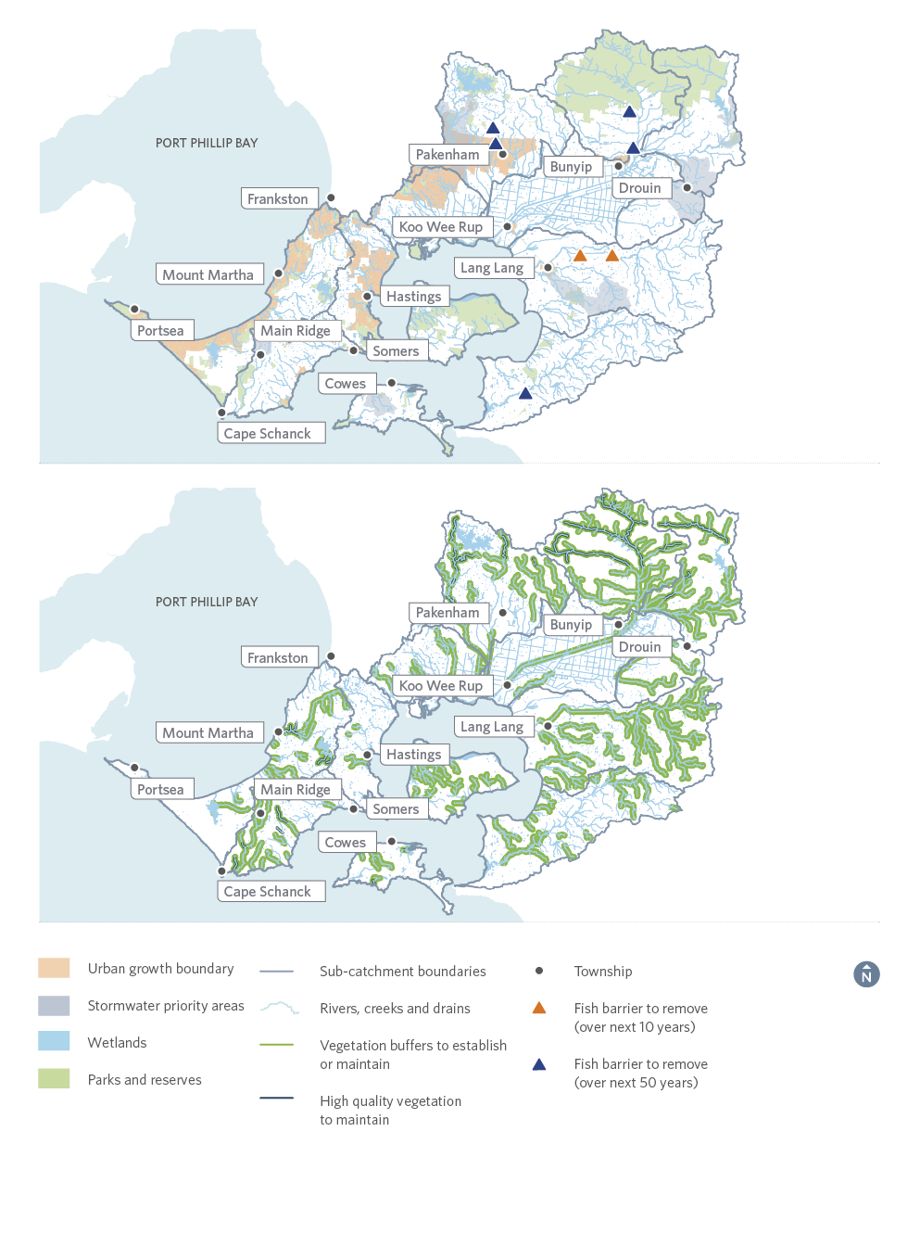
Figure 29. Summary of priorities in the Westernport and Mornington Peninsula region
Note: This map does not show headwater streams, some minor tributaries, waterbodies on private land and some wetlands less than one hectare. Due to the size of the catchment the features have been displayed over two maps.

Part E

Collaborative Implementation

19. Co-Delivering the Strategy
Waterway management pursues many needs and values. Successful implementation will coordinate the work of many willing partners who share roles and costs according to their means, needs, responsibilities and interests. This Strategy will provide ongoing evaluation and reporting so that collaborative partners can improve their work along the way.
This Healthy Waterways Strategy recognises that the community holds valuable local expertise, passion and continuous on-ground presence; and that institutions hold technical skill, resourcing, regulatory authority and broader contextual data. Bringing these together in a structured collaboration will leverage and make best use of all stakeholders capabilities, resources and skills.
As the waterway manager for the region, Melbourne Water is committed to undertake its share of this Healthy Waterways Strategy. However, it has been recognised that action by Melbourne Water alone is not sufficient to unlock the full value of the region’s waterways, nor stem their decline due to climate, development or land use change. For this Strategy to be effective, collective action is required from State government and regulators (such as the EPA), local government and other land managers such as Parks Victoria. Even more so, it needs collective action by the development sector, landholders, Traditional Owners and community groups. Working together, the full economic, social, cultural and environmental values of the region’s waterways can be realised.
Melbourne Water invests in an extensive program to manage waterways, flood and drainage services across metropolitan Melbourne, on behalf of the community. This work is primarily funded by the Waterways and Drainage Charge, which appears on customer water bills. This charge is collected from residential and non-residential customers in metropolitan Melbourne and from rural landowners.
Melbourne Water’s Waterways and Drainage Investment Plan 2016/17 – 2020/21 outlines the program of works that is being implemented by Melbourne Water over this current five year period to manage our waterways and drainage systems. This plan is developed in accordance with the amended Statement of Obligations (2015). The five year investment program is subject to independent economic review by the Essential Services Commission. It is guided by policy, legislation and extensive engagement with our customers and community to understand customer value and willingness to pay.
A total investment of $1.69 billion has been identified for the five year period of 2016/17-2020/21. Of this, $348 million is allocated to waterway health and amenity and $208 million has been allocated to stormwater quality and quantity. Figure 50 provides a breakdown of expenditure across waterways, flood and drainage services.
The current Waterways and Drainage Investment Plan is under review and a new plan will be developed to guide investment for the next pricing period of 2021-2026. This plan will be aligned with the Essential Services Commission’s PREMO (Performance, Risk, Engagement, Management, Outcomes) framework and will be subject to review by the Essential Services Commission. Under this model Melbourne Water will work collaboratively with our customers and community to ensure we meet expectations, as well as our obligations.

19.1. A supporting governance framework
Clear governance is required to coordinate and align collective action. This governance requires commitment both from key agencies and our engaged, knowledgeable community. It must be supported by robust monitoring, evaluation and reporting arrangements. Figure 30 on the following page shows the collaboratively-developed governance model for the implementation of this Strategy.

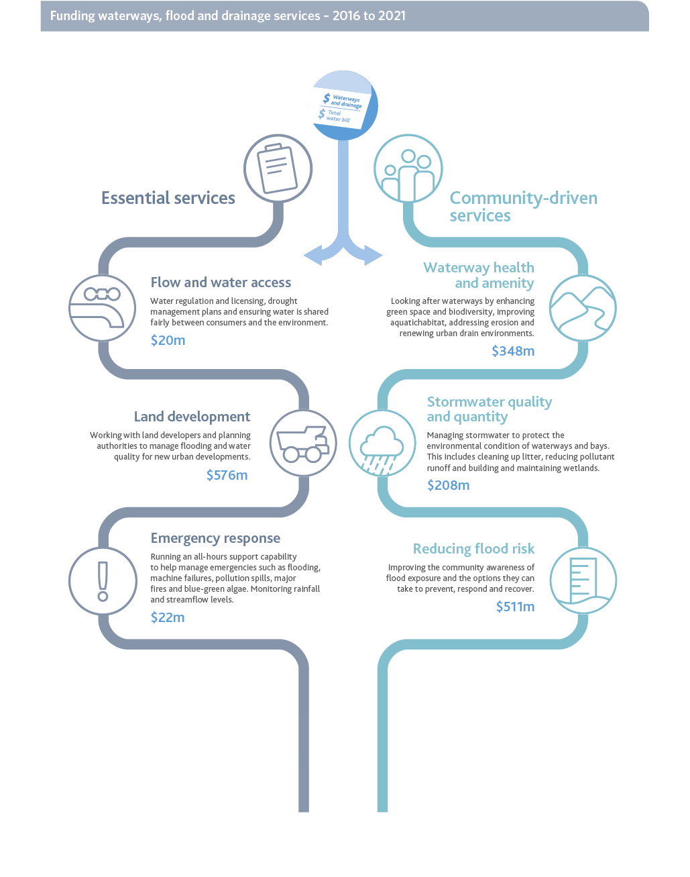
Figure 30. Funding waterways, flood and drainage services over a five year period
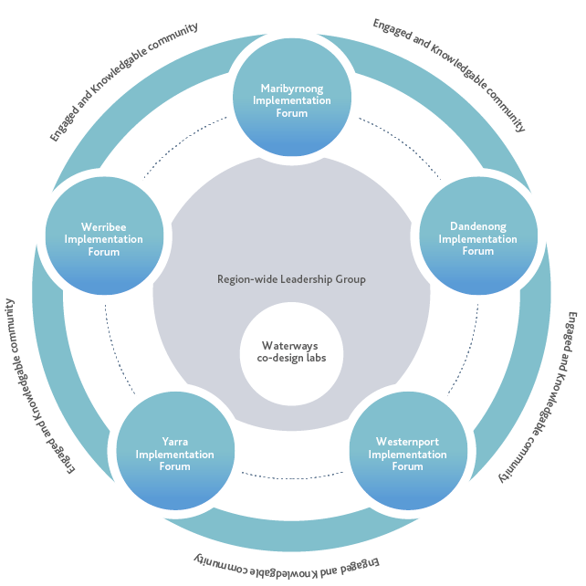

Figure 31. Collaborative Governance Model
The following performance objectives are designed to support the governance framework and reporting mechanisms.

Performance Objectives
RPO-33 | A Region-wide Leadership Group and Catchment Implementation Forums are established to support work towards the vison and goals of the Healthy Waterways Strategy at the regional and catchment scales.
RPO-34 | Waterway Labs are established as needed to tackle complex or region-wide priorities.
RPO-35 | The effectiveness of the Leadership Group, Catchment Implementation Forums and Waterways Lab are evaluated, through ongoing feedback, and one interim and one final assessment undertaken during the life of the Strategy.
RPO-36 | The Catchment Implementation Forums improve the coordination of information and activities by catchment stakeholders and communities (while ensuring waterway management includes the whole of catchment perspective).

19.1.1. Region-wide Leadership Group
This Healthy Waterways Strategy provides direction to guide regional, catchment and sub-catchment-scale decisions about the planning, delivery and integration of works. A region-wide Leadership Group will be established to govern this Strategy. Its role will include ensuring good linkages with related processes and policies, overseeing strategy implementation, reporting and adaptive management. The group will be established with key agencies, Traditional Owners (where possible) and include at least one catchment representative.

19.1.2. Catchment implementation forums
On-ground change can be led by communities in any waterway, and the type of activities will vary from season to season. The Co-Designed Catchment Programs provide a flexible framework for managing waterways that take into account variable climatic and development conditions and changing community needs. These programs include 10 to 50-year targets for waterway values and condition supported by 10-year performance objectives. Their implementation involves:
- recognising the catchment summaries in this Healthy Waterways Strategy as the bounds in which adaptive management operates
- enabling a catchment-specific catchment implementation forum to set short-term management aims through annual planning processes
- adapting management activities to prevailing climate conditions in any year and impacts of extreme events such as drought, flood or bushfire
- improving community awareness of the need to adapt management actions depending on current climatic conditions and impacts of extreme events.
Catchment Implementation Forums will be established, at a minimum, in each of the five catchments to guide collaborative implementation of and monitor progress on these Co-Designed Catchment Programs. All stakeholders and community organisations (and members) who play a role in waterway management will be invited to join the forums. Other forums may also be established on an as-needs basis. The work of the forums may also be supported by project groups, to be created on an as-needs basis.
Strong connections will be established between the Healthy Waterways Catchment Implementation Forums and the Integrated Water Management Forums (IWM Forums) that have been established by DELWP in each of the five catchments. The IWM Forums promote collaboration between critical agencies including water corporations, catchment management authorities, local government, Traditional Owner groups and the Victorian Planning Authority. It is foreseen that the IWM Forums will look to the Healthy Waterways Leadership Group and Catchment Implementation Forums for progress reports on the implementation of the Healthy Waterways Strategy and the identification of key strategic projects and issues that may require additional support.

What is a catchment implementation forum?
Catchment implementation forums provide an opportunity for multiple organisations or entities from different sectors to abandon their own agendas in favour of a common agenda to tackle deeply entrenched and complex problems. These types of approaches have been successfully used in the fields of public health and education, to clean up contaminated waterways and to reduce and prevent childhood obesity. These successes are all based on the concept that large-scale social and environmental change comes from better cross-sector coordination rather than from the isolated intervention of individual organisations.
Five conditions are typically required for a catchment implementation forum to succeed:
- A common agenda
- Shared measurement systems
- Mutually reinforcing activities
- Continuous communication
- Backbone support organisations.
This Strategy offers a common agenda for managing healthy waterways. The catchment implementation forums will determine how best to work together in each catchment to deliver that agenda, considering:
- what the shared challenges are and who should be involved in resolving them
- communication and meeting frequency, existing forums that could support the collaborative implementation of the Strategy
- discussion and resolutions of points of difference
- joint approaches to solving key issues through agreed-upon actions
- coordination of differentiated activities through a mutually reinforcing plan of action
- a structured process for effective decision making, including the consideration of new knowledge, threats, risks and adaptive management
- ways success will be measured and reported
- ways to experiment and learn together
- engagement with funding organisations towards a long-term process of change that mobilises the organisations and individuals involved to develop solutions themselves
- knowledge gaps.

19.1.3. Waterways Lab
Many of the factors influencing waterways are systemic and require input from organisations which may not be represented effectively at the region-wide Leadership Group or Catchment Implementation Forums. This Strategy therefore proposes to also institute a Waterways Lab that would consider region-wide issues which cannot effectively be managed by the Region-wide Group or Catchment Implementation Forums. The Labs would be instituted on an as-needs basis as directed by the Leadership Group and typically operate for a short period of time to consider a well-defined issue and agree a way forward.

Case study: The Moonee Ponds Creek collaboration project
Moonee Ponds Creek catchment is one of Melbourne’s most urbanised and modified creek systems. Historically the creek was seen solely as a drain or water conduit, a perception that led to inappropriate development, neglect and degradation.
Past collaboration, including through the Moonee Ponds Creek Coordination Committee, friends groups and cross-governmental partnerships, has resulted in some social and environmental improvements; however, significant issues persist across the catchment.
While several plans have been developed to set a clear direction for the catchment, progress has been hindered by lack of catchment-wide governance.
In February 2017, 60 stakeholders came together to talk about collaboration in the Moonee Ponds Creek catchment. This was the beginning of the collaboration process that has resulted in a commitment by representatives of 18 organisations and 10 supporting partners to work together to:
Transform the Moonee Ponds Creek into an iconic waterway for Melbourne that enhances its natural capital and provides high social and environmental benefits to local and wider communities.
The collaboration group includes representatives from local and State Government, community groups, not-for-profits, businesses and research organisations – all with a strong interest in improving the Moonee Ponds Creek.
The group has developed three sub-groups to look at three projects which will enable a catchment-wide approach for:
- a shared portal for research and mapping
- strengthening planning controls
- formalising the collaboration group.
- End Case study –

19.2. Engaged and knowledgeable community and stakeholders
During the development of the Strategy, discussions in each catchment highlighted the importance and need to enhance the community’s knowledge and connection to waterways. There was agreement that broader community understanding of the key issues facing our waterways, as well as supporting people to find a connection to waterways, will likely lead to greater involvement and action for our waterways.
In some cases this thinking translated into high level goals for the catchment:
- ‘Stakeholders and the broader community are knowledgeable, engaged and working together in a transparent process creating a legacy of stewardship to value, protect and improve waterways’ (Westernport Goal 1)
44%
55%
59%
- ‘An engaged and knowledgeable community in the Yarra catchment acts to protect and promote sustained waterway values. Our waterways are a place of continuous learning’ (Yarra Goal 5).
The co-design process itself also demonstrated the value of connecting individuals who work on and share a passion for waterways.
Between 60 and 90 per cent of participants who filled out the evaluation in each of the July 2018 catchment collaborations, agreed or strongly agreed with the statement ‘I am now making a stronger contribution to waterway health’, as shown in Figure 32.
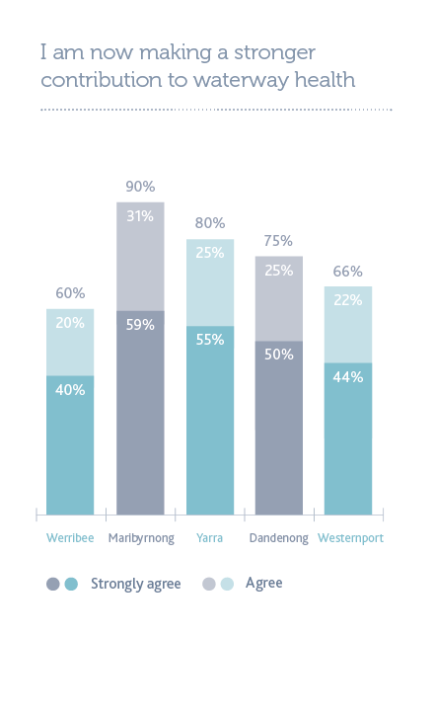
Figure 32. Participant evaluation of their contribution
This Strategy seeks to elevate the importance of education, capacity building, and citizen science to create a more engaged and knowledgeable community and stakeholders.
The following performance objectives are designed to support this.

Performance Objectives
RPO-37 | Participation rates in education, capacity building, incentive programs and citizen science activities have increased and enable greater levels of environmental stewardship for our waterways.
RPO-38 | Key messages, stories and resources for waterways and waterway health are collaboratively developed and broadly distributed, increasing community knowledge and engagement around waterways.
RPO-39 | Systems and pathways to share knowledge and information between communities and stakeholders have been developed and expanded to empower communities to participate and influence waterway management (for example, digital portals, social media, Communities of Practice, signage programs).
RPO-40 | The profile of waterways is lifted, local connections to waterways are increased, and leaders  in waterway management are celebrated and fostered.

Case study: Frog Census – a practical application
Since its 2016 release, the Frog Census app has increased the number of community frog reports by 632 per cent and helped to fill gaps in frog knowledge across Melbourne. The app has also been useful to evaluate the success of waterway management.
Bolin Bolin Billabong in Bulleen is an ecologically and culturally significant wetland. In October 2017 Melbourne Water and the Victorian Environmental Water Holder (VEWH) provided environmental watering to bring the wetland closer to a more natural water regime. The Frog Census app was used to track the response of frogs before and after environmental watering.
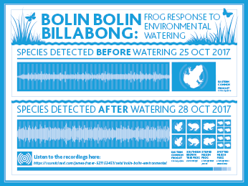
Figure 33. Bolin Bolin frog census
- End Case Study -

20. Approaches and concepts for delivery
A variety of approaches and concepts are required to effectively manage waterways and to protect and improve their condition to the level required to support values. This Strategy does not include specific actions. Instead, the Co-Designed Catchment Programs aim to provide a flexible framework for meeting the outcomes described in the performance objectives, waterway targets, goals and vision.
Through the process to develop this Strategy (see Part B), a significant number of actions were identified to meet the vision and goals in each catchment. These have been summarised in each of the Co-Designed Catchment Programs.
Several overarching concepts and approaches will be incorporated in the implementation of this Strategy across all catchments.

20.1. Planning, strategy and guidelines
This Strategy will need to be incorporated into the strategic planning of many government and non-government organisations, so that activities are aligned, effort and investment can be leveraged, and gains made by one are not removed by another.
The Healthy Waterways Strategy should be a key input to the development and implementation of such planning documents as:
- the Port Phillip and Westernport Regional Catchment Strategy
- the Victorian Waterway Management Strategy
- Plan Melbourne
- local government land-use and environmental plans, precinct structure plans and planning scheme amendments
- water corporations water and wastewater management plans
- regional water extraction planning.

20.2. Land use and development planning
Changes in land use and development have the potential to adversely affect waterway health, and the social and environmental values of waterways. This Strategy acknowledges the important role of Victoria’s planning system, and the role of State Government, councils and referral authorities under this system to help protect and enhance the region’s waterways.
Catchment and natural resource managers can support place-based approaches through local planning scheme amendments and setting development standards as part of providing referral authorities comments on strategic plans and development applications. Community groups can play an important role in working with government and industry to support adoption of best practice to ensure outcomes are focused on long-term ecosystem resilience and net community benefits and aspirations, including health, wellness and inclusion.

20.3. Advocacy
Advocacy means working with others to influence outcomes for waterways. It is an important tool in securing good outcomes for waterways. Advocacy gives the region’s stakeholders the opportunity to influence areas in which they do not have direct responsibility for decision making or action.

20.4. Building stewardship and sharing knowledge
Waterway protection and improvement requires the work and support of many dedicated individuals, community groups and organisations. This dedication is due to a sense of connection to waterways. Many people in the region have extensive knowledge of waterway management and a passion for caring (or providing stewardship) for waterways. Agencies, community and stakeholders must engage to share knowledge and foster increased interest in and stewardship of our waterways.

20.5. Enforcement and compliance
Encouraging good land and waterway stewardship, building relationships and advocating for improved outcomes are among the most cost-effective ways to achieve positive outcomes for healthy waterways. But, in some instances, these activities alone are not enough to ensure good outcomes, and enforcement of legislation and regulation is required.

20.6. Catchment-wide ongoing on-ground management programs
A huge range of on-ground activity should be encouraged and supported, including: revegetation; pest plant and animal control; protection and enhancement of important waterway sites and habitats; encouragement of future-climate ready plant species; enhancement of instream habitat; and rehabilitation of highly modified waterway channels.

20.7. Asset planning and renewal
Water corporations and infrastructure managers should prioritise the protection of waterways, through appropriate asset protection, maintenance, risk management and placement.

20.8. Water quality
Region-wide actions on water quality should be taken to protect waterways (rivers, wetlands and estuaries), Port Phillip Bay and Western Port. Constructed wetlands used as stormwater management should be maintained at design capabilities (or offset). Broad efforts should be implemented to reduce contamination of waterways from litter, microplastics, chemicals, metals, nutrients and sediment.

20.9. Environmental water
In its role as waterway manager, Melbourne Water is responsible for advising the Victorian Environmental Water Holder (VEWH) on the environmental water entitlement across the Port Phillip and Westernport region that will achieve the best environmental outcomes with the water that is available. Melbourne Water manages the environmental water through a variety of mechanisms or processes that help monitor each aspect of the Environmental Water Reserve.
Under the Water Act 1989, Melbourne Water prepares seasonal watering proposals for each environmental entitlement within the region to assist the VEWH to develop the Seasonal Watering Plan for the State. Seasonal watering proposals are prepared each year and identify priority reaches or wetlands for watering actions in the coming year. Melbourne Water takes into consideration expected water availability, climatic conditions and environmental objectives to determine priority watering actions and optimise the use of water to deliver environmental outcomes and where possible achieve shared benefits for other values, for example, irrigation, amenity and recreation.
In regulated rivers (those with dams), the environmental water reserve is made up of the entitlement held by the VEWH and the negotiated conditions on consumptive entitlements such as passing flows included in retail water business bulk entitlements.
In unregulated rivers (those without dams), this is managed through private diversions in streamflow management plans or local management plans, which are developed in consultation with landholders, government agencies and the community to share water equitably between users and the environment.

20.10. Diversions management
The right amount and diversity of flows in waterways is a critical part of waterway health. Water is a limited resource and careful management is needed, particularly in low flow periods, to protect waterway health and ensure water is available for agriculture, recreation and other beneficial uses. It is important that diverters (businesses that extract water from waterways under license) and competing uses for water from waterways are effectively and equitably managed.

21. Safety
Safety for people, assets and the community is of the greatest importance to the many stakeholders involved in the implementation of this Strategy, including Melbourne Water.
As programs of work are designed and developed to achieve the goals, targets and performance objectives of this Strategy, they must prioritise the health, safety and wellbeing of those delivering these programs.
Safety must be embedded and considered upfront in all planning and strategic decisions. In some instances this may mean deciding not to undertake a task towards a performance objective if the safety controls or alternatives available are not adequate to reduce the risk.
Safety will be a key aspect of the feasibility assessment of any activities proposed. Safety in strategy and design refers to the integration of hazard identification and risk assessment methods early in the design process to eliminate or minimise the risks of injury throughout the delivery of the agreed outcomes. Where effective safety risk mitigation measures cannot be implemented or funded, an alternative safer management approach will be chosen. Advice will be sought from the respective Catchment Implementation Forum where safer alternative management approaches are not available and this impacts the ability to achieve a performance objective. Such situations will also be considered as part of the Strategy evaluation.
For example, the implementation of this Strategy could involve working on difficult terrain or in remote locations, where it may be difficult to receive timely assistance if, despite careful planning, an emergency situation should arise. Sometimes such risks cannot be eliminated via alternative equipment, technology or controls as they are inherent to the catchment and the environment. In such situations, the achievement of a strategic objective should not be at the expense of the safety and wellbeing of our people, assets or the community.

Adapting the way we work in remote areas to remain safe everywhere, every day: weed control along Pyrites and Djerriwarrah Creeks (Lerderderg State Park – Pyrete Range)
Pyrete Range supports a variety of flora and fauna communities of State significance and the range itself is a site of regional geological and geomorphological significance. It is home to threatened growling grass frog, brush-tailed phascogale, common and lace goanna as well as over 130 species of birds. More than 300 native plant species have been recorded in the park including spiny rice-flower, brittle greenhood, cane spear-grass, heath spear-grass, austral tobacco, forked rice-flower and fragrant saltbush.
The quality of streamside and surrounding terrestrial vegetation is currently ‘high’ to ‘very high’. Nevertheless, small infestations of highly invasive weeds have become established along the watercourses. The elimination of these infestations is crucial to ensure the environmental values of the site are retained. However, access to the watercourses is restricted by both the steep rocky terrain and a sparse track network. In addition, a number of tracks are particularly steep and cannot be accessed when wet.
Given the difficult access, the safety profile for the project was reviewed taking into account the learnings from an incident where an injured person had to be extracted from a similarly remote site in the Watts River catchment.
The review led to the following operational changes:
- Project mapping and access – A detailed map showing weed infestation locations, access points and terrain details was developed for the entire project area and used to refine project scope. At all times crews were required to be in proximity of an access point which would enable medical assistance within 90 minutes. Some creek reaches were removed from scope where these emergency rescue requirements could not be met.
- Pre-mobilisation site inspections – Access routes were inspected for adequacy and identified issues rectified prior to works beginning (that is, fallen trees removed, tracks repaired).
- Safety plan – The safety plan was reviewed by staff experienced in working in remote locations, and Parks Victoria rangers who manage the track network.
- Training and equipment – Additional equipment was made available to the field crews, including stretchers, more vehicles, satellite phones and trunk radio.
- Spotters and communication routes – Given the terrain and lack of phone and radio reception, relay points were set up to ensure adequate communication.
This review of the project safety profile resulted in the safer completion of the project while continuing to meet the strategic outcomes, despite the removal of some creek reaches from scope and additional resources requirements.

22. Adaptive management
The management of rivers, wetlands and estuaries in the region is conducted within an adaptive management framework. At the core of adaptive management is the ability to learn from previous experience, update management approaches to reflect the knowledge gained and changes in our environment that occur during implementation, and manage uncertainty such as increase in temperature, changed rainfall patterns or sea level rise. The adaptive management cycle includes:
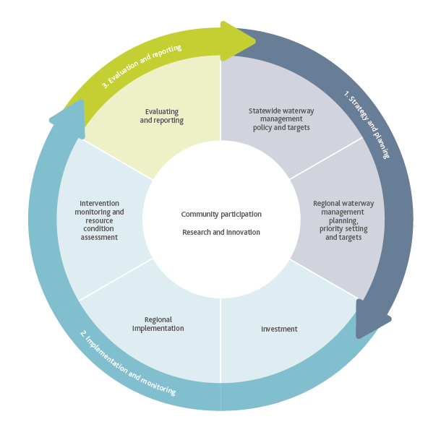
Figure 34. The adaptive management cycle
A detailed monitoring, evaluation and reporting (MER) plan will be developed together with the Catchment Implementation Forums to support adaptive management from planning to Strategy completion. The monitoring, evaluation and reporting plan will:
- present the program logic underpinning the Strategy
- clarify the assumptions associated with the program logic and identify strategies to manage potential risks
- identify the key questions for evaluation and establish processes to monitor progress within the framework of the statewide monitoring program
- clarify the communication and reporting needs and identify the processes required to support these needs
- enable lessons learned from monitoring and evaluation to be gathered and inform improvement
- consider the monitoring, evaluation and reporting needs and practices of collaborating organisations
- address data gaps for environmental, social, economic and cultural values to enable a more comprehensive assessment and communication of management priorities
- facilitate synergies with the MER undertaken to support the Regional Catchment Strategy, the Yarra Strategic Plan, and other relevant plans or strategies
- acknowledge and review State of the Bays and State of the Yarra reporting, as they provide relevant benchmark data.
The MER plan will be reviewed, at minimum, on an annual basis to ensure it remains current and relevant to informing adaptive management.

22.1. Monitoring
Monitoring activities aim to inform evaluation of and reporting on Strategy implementation. Monitoring activities also include the collection of information relating to foundational influences and externalities that impact on Strategy implementation. Foundational influences include factors such as climatic variability, drought, flood, bushfire and potential impacts of climate change.
Externalities include factors such as land use change, population growth, government support, economic conditions, community expectations and landholder attitudes.
Monitoring activities will be consistent with the statewide monitoring processes coordinated through the Victorian Waterway Management Program. This program includes targeted resource condition and intervention monitoring to inform both state and regional evaluation and reporting processes.

22.2. Evaluation
The strategy and planning phase of the adaptive management cycle includes the development of pre-determined key evaluation questions by which to assess the Strategy and gain new knowledge and information. Evaluation questions provide the basis for evaluation design and associated monitoring processes.
Evaluation of the Strategy will include an assessment of the extent to which the outcomes have been achieved at each level of the program logic underpinning the Strategy. It will also address the assumptions in the program logic and provide direction and improved knowledge for subsequent planning cycles.
The evaluation questions developed for the Strategy will address the following five categories:
- Impact – changes to resource condition, management activities or institutions
- Appropriateness – addressing the needs of beneficiaries and against best practice
- Effectiveness – achievement of desired management outputs and resource condition objectives
- Efficiency – value or return from investment
- Legacy – after the activity/program ends.
Example of evaluation questions are provided in Table 4.
The scale and frequency of evaluation will vary throughout the life of the Strategy, and will include an annual review cycle and at least one more detailed review at the mid-point of the Strategy.
Table 4. Example of evaluation questions for the Strategy

Evaluation question examples
Impact | - To what extent did the Strategy inform the strategic directions and the action plans for the region’s waterways?  - What activities/outputs were delivered through implementation of the Strategy?  - To what extent has the implementation of the Strategy improved our knowledge?
Appropriateness | - To what extent have the planned (original and updated) strategy targets been achieved?  - What factors impacted on the efficiency and effectiveness of Strategy implementation, either positively or negatively?
Effectiveness | - To what extent was the Strategy updated in response to new knowledge, information or changed circumstances?  - To what extent were governance and risk management practices undertaken throughout the implementation of the Strategy?
Efficiency | - To what extent did the Strategy implementation attain the best value out of available resources?
Legacy | - To what extent do the outputs need to be maintained/managed into the future to ensure sustained outcomes?

22.3. Reporting
Reporting is an important tool to ensure accountability for the investment of government and other funds into waterway management activities. Over the long term, consistent and effective reporting provides evidence to evaluate and communicate the effectiveness of the Strategy.
Annual management reporting is a component of the annual review cycle, and includes reporting on the activities and outputs achieved for the year and their associated financials. This reporting is to be undertaken centrally as well as via reporting arrangements determined by each catchment collaboration forum.
Public reporting against the Strategy targets and performance objectives will occur at meaningful intervals reflecting the ability to detect change.
This Strategy proposes that the adaptive management program is supported by independent oversight to hold everyone to account – including Melbourne Water – and at least one interim and one final assessment during the life of the strategy.
The MER plan for the Strategy will identify the key stakeholders at organisational, community, regional, State and Commonwealth levels who will participate in the Strategy reporting, should be kept informed on the progress of the Strategy or would benefit from Strategy information, including the sharing of spatial data. It will also identify what they need to know and how it will be communicated.

Performance Objectives
RPO-41 | A monitoring, evaluation and reporting plan is in place by 30 June 2019.
RPO-42 | Wetland condition information and prioritisation with a focus on vulnerable wetlands is understood and informs collaborative planning.
RPO-43 | The social values framework, information and methods used to develop values assessments, targets and performance objectives are further developed and improved during the life of the Strategy.
RPO-44 | Web-based systems are established to report performance and measure outcomes of the catchment implementation forums (by 30 June 2020).

22.4. Knowledge gaps and research
The process of developing the program logic and evaluation questions demonstrates the areas where critical knowledge gaps exist. The MER plan for the Strategy will document these key knowledge gaps and the strategies for addressing them. These strategies may involve collating existing information or proposing areas for further research programs. Table 5 lists the initial key research areas identified for this Strategy. They were developed based on an extensive engagement process that involved waterway managers within Melbourne Water and other organisations, and major research. These research areas will evolve during the life of the Strategy. In particular, knowledge gaps regarding cultural values will need to be added.
In alignment with the Victorian Waterway Management Program, the Strategy supports research that:
- Provides essential knowledge to address critical short-term and/or strategic long-term knowledge gaps. The resulting research findings will be incorporated into policy and management.
- Targets knowledge gaps or low confidence in the relationships between performance objectives, waterway conditions and key values.
Research will be directed to investigating relationships where there is likely to be strong relationships between threats and values but confidence in the effectiveness of certain management actions is low. This targeted approach to research provides an increased focus on prediction and testing of predictions, rather than more general, descriptive research.
It is vital that research is targeted to better understanding the effectiveness of management activities with significant Victorian Government investment (for example, streamside revegetation).
It is also acknowledged that the State of the Bays and State of the Yarra reporting will provide benchmark data that may identify relevant waterways knowledge gaps, to which the Healthy Waterways Strategy will then be able to respond.

Performance Objectives
RPO-45 | Research partnerships with universities and other research institutions are in place to address the key research areas and build our knowledge and capacity to efficiently and effectively achieve the Healthy Waterways Strategy performance objectives and targets.

Table 5. Key research areas identified
Liveability, community engagement, and social research | Stormwater management and flooding | Water quality | Hydrology and environmental flows
Refining our conceptual models and developing tools to support investment in waterway works for recreation and amenity  Defining public health and wellbeing benefits of waterway, stormwater and urban cooling programs to support investment decisions  Understanding the compatibility between social and environmental values and whether management actions are required to balance potentially competing objectives  Understanding demographics, preferences, values and water awareness of our customers to inform waterway works planning and delivery  Understanding, involving and supporting volunteers in waterway management to facilitate shared waterway objectives  Increasing community awareness and connection to waterways so we have informed and engaged partners  Understanding aboriginal cultural values of waterways and establishing a framework to better integrate these values in waterway management decision making | Improving our understanding of how system design to prevent flooding needs to be altered to accommodate the impacts of climate change  Improving stormwater treatment performance and determining the optimal maintenance of WSUD systems  Understanding the costs and benefits of various stormwater management interventions for biodiversity, amenity and recreational outcomes  Developing imp roved technologies and systems to support stormwater harvesting and re-use  Identifying and addressing institutional and structural barriers to implementation of IWM  Developing decision support tools to inform the most effective stormwater treatment systems and locations to protect waterway biodiversity, amenity and recreation | Understanding the environmental impacts of pollutants, including contaminants of concern, to inform risk-based management of waterways across the region  Quantifying ecosystem services in waterways for improving water quality to better account for the benefits of healthy waterways  Developing improved water quality indicators and monitoring methods to better understand the impacts of pollutants on waterway health  Developing tools and approaches to assist in strategic planning of pollution management to protect biodiversity, amenity and recreation in waterways across the region  Understanding and managing public health risks from recreation along waterways in the region  Understanding the impact of climate change on water quality and management implications for the protection of aquatic biodiversity, amenity and recreation along waterways | Developing improved approaches to flow data collection and data management to support flow management decisions  Understanding and mitigating climate change effects on the hydrology of waterways, estuaries and wetlands  Improving our understanding of the responses of key environmental values to flow regimes to refine our environmental flow objectives  Developing tools and frameworks to assist improved decision-making in the management of flows to meet environmental flow objectives  Investigating opportunities for managing stream flows in urban catchments to protect and improve aquatic biodiversity, amenity, recreation and reduce flooding  Improving our understanding of the hydrology of floodplains, wetlands and estuaries, including groundwater-surface water interactions to protect and improve aquatic biodiversity  Improving our understanding of the flow requirements of estuaries to develop and refine environmental flow objectives  Exploring opportunities to integrate methods for determining ecological flows objectives in urban and rural streams to improve approaches to objective setting across both stream types

Streamside vegetation and instream habitat | Wetlands and estuaries | Other aquatic biodiversity | Port Phillip Bay and Western Port
Understanding the potential impacts of climate change on riparian vegetation communities and opportunities to effectively build resilience or transition vegetation communities  Understanding the impact and effective management of pest plants and animals on riparian vegetation  Developing decision support tools to support improved investment in riparian and instream habitat activities and locations  Identifying critical constraints to revegetation success and opportunities to improve vegetation outcomes  Improving our understanding of instream habitat conditions, threats and processes across the region to inform works planning | Developing strategic decision-making tools and frameworks for the prioritisation of management interventions for wetlands and estuaries  Improving our understanding of management techniques that are most effective to protect and improve the ecological health of wetlands and estuaries  Developing improved monitoring, assessment and reporting methods to understand environmental conditions and values of wetlands and estuaries | Improving our understanding of critical ecological processes and the ecology of key species to improve our conceptual and quantitative models  Understanding the unintended consequences of our management activities on aquatic biodiversity to inform works planning and programming to reduce impacts on environmental values  Understanding areas of high biodiversity significance (for example, Melbourne Water’s Sites of Biodiversity Significance, Ramsar) and appropriate management responses to manage key threats to environmental values | Undertaking priority research projects identified in the Port Phillip Environmental Management Plan  Undertaking priority research projects identified in the Western Port Environment Science Review and synthesis report  Undertaking priority research projects identified in the Ramsar management plans for the Port Phillip and Westernport region

Glossary
Term | Definition
Algal bloom | A rapid increase in the population of algae that can occur in waterways, often caused by excess nutrients (particularly phosphorus and nitrogen), low flows, high light levels and warm temperatures.
Alternative water | Water supply from non-traditional water sources, usually originating from a poorer quality source, but cleaned and treated to legislated standards before use. Includes sources such as stormwater and recycled water from sewage.
Asset | (In the context of the ‘asset-based approach.’) A spatially defined, biophysical component of the environment (for example, a river reach, an estuary or an individual wetland or wetland complex) that has particular values associated with it.
Barriers | Artificial instream structures, such as dams, weirs, causeways and culverts, that restrict the migration and movement of fish or other biota and can interrupt transport of organic material and sediment.
Baseflow | The component of streamflow supplied by groundwater discharge.
Best practice | The best combination of techniques, processes or technology used in an industry or activity that minimise the environmental impact of that industry or activity.
Biodiversity | A measure of the number and variety of plants, animals and other living things (including microorganisms) across our land, waterways and seas. It includes the diversity of their genetic information, the habitats and ecosystems within which they live, and their connections with other life forms and the natural world. Reduced biodiversity is considered a negative influence on the health of an ecosystem.
Biolinks | Parts of the landscape which increase the connectivity of areas of intact native vegetation to enhance the ability of native plants and animals to disperse, recolonise and adapt naturally to climate change.
Brackish water | Water that is saltier than fresh water, but not as salty as sea water. It may result from the mixing of sea water with fresh water, as in estuaries.
Bulk Entitlement | The right to water held by water and other authorities defined in the Water Act 1989. It defines the amount of water that an authority is entitled to from a river or storage, and may include the rate at which it may be taken and the reliability of the entitlement.
Capacity building | Typically includes the provision of access to technical advice, training, resources and tools on contemporary science and management techniques. It also includes access to strategic advice on group administrative matters, governance, where to source funding, and fostering of peer-to-peer learning across groups. Increases the ability of a third party to participate, contribute and function autonomously in the field of expertise.
Catchment | The region from which all rainfall flows, other than that removed by evaporation, into waterways and then to the sea. In the Port Phillip and Westernport region there are five catchments – Werribee, Maribyrnong, Yarra, Dandenong and Westernport.
Citizen science | Partnerships between scientists, organisations and enthusiastic community members which enable the wider community to contribute to scientific knowledge. Citizens contribute through the collection or processing of scientific data. They also assist in the design, analysis and/or communication of projects and key findings, and are important ambassadors to lead awareness campaigns.
Connectivity | Refers to the links between different waterways, habitats and species within a landscape.
Consumptive use | Water that is provided for all human uses (that is, non-environmental uses, use for people, agriculture or industry).
Dissolved oxygen | The oxygen dissolved in water and freely available for use by aquatic organisms. It is vital for the survival of fish, invertebrates, bacteria and underwater plants.
Drought refuge | A critical remaining water habitat in otherwise dry landscapes that help species survive drought. A typical example is a pool in a non-flowing stream channel fed by groundwater.
Ecological Vegetation Classes (EVC) | The standard unit for classifying vegetation types in Victoria. EVCs are described through a combination of floristics, lifeforms and ecological characteristics, and through an inferred fidelity to particular environmental attributes. Each EVC includes a collection of floristic communities (that is, lower level in the classification) that occur across a biogeographic range, and although differing in species, have similar habitat and ecological processes operating.
Ecological Vegetation Class (EVC) benchmarks | These relate to a single EVC within one bioregion. They have been developed to assess the vegetation quality of EVCs at the site scale in comparison to a 'benchmark' condition.
Ecosystem services | The many and varied benefits that humans freely gain from the natural environment and from properly-functioning ecosystems.
Environmental flow assessment | Assessments of the water regimes needed to sustain the ecological values of water-dependent ecosystems at a low level of risk.
Environmental flow regime | The timing, frequency, duration and magnitude of flows for the environment.
Environmental flow studies | The study of the flow requirements of a particular basin’s river and wetland systems used to inform policy decisions on the management and allocation of water resources.
Environmental water | Water managed to maintain the health of waterways, and to support environmental values and ecological processes. Although it refers to any water in waterways, there is a specific emphasis on water held under environmental entitlements.
Environmental Water Reserve | The Water Act 1989 (Vic) establishes the Environmental Water Reserve, which consists of water held in environmental entitlements, along with other water in the system, that can contribute to environmental outcomes, such as passing flows, and ‘above cap’ water. The Environmental Water reserve is managed by the VEWH.
Estuary | The zone where a river meets the sea, influenced by river flows and tides and characterised by a gradient from fresh to salt water. For this Strategy, the definition of an estuary is that it must be at least 1 kilometre in length or have a lagoon greater than 300 metres in length. The downstream extent of an estuary is where the banks of the river end and the waterway meets the bay or ocean.
Fish passage | Provision for the movement or migration of fish past barriers.
Fishway | A structure that facilitates fish passage past a barrier.
Floodplain | Low-lying land adjacent to a river or stream with unique ecosystems dependent on overflow from flood events.
Flow regime | The range of flows experienced by a waterway throughout the seasons and years which may include base flows, low flows, high flows, overbank flow and cease to flow (drying) events.
Gigalitre | (GL) One billion (1,000,000,000) litres.
Groundwater dependent ecosystem | Natural ecosystems that require access to groundwater to meet all or some of their water requirements in order to maintain their ecological processes.
Habitat | The natural home or environment of an animal, plant, or other organism.
Hectare (ha) | Ten thousand square metres.
Hydrological regime | Changes with time in the rates of flow of rivers and in the levels and volumes of water in rivers, lakes, reservoirs and wetlands. The hydrologic regime is closely related to seasonal changes in climate.
Instream | The component of a river within the river channel, including pools, riffles, woody debris, the river bank and benches.
Instream structures | Infrastructure constructed within waterways to alter, contain or control water flows. Examples include weirs and dams.
Integrated catchment management | Integrated catchment management is the coordinated involvement of agencies, stakeholders and the general public in policy making, planning and management to promote sustainable use of natural resources.
Litter | Litter constitutes any solid or liquid domestic or commercial waste that is deposited inappropriately. Litter includes plastic garbage, cigarette butts, dog faeces, fast-food wrappers or building site waste.
Liveability | The wellbeing of a community comprising the many characteristics that make a location a place where people want to live now and in the future.
Low flow | Water that creates a continuous flow over the bottom of the waterway channel, but does not fill the channel to any great depth. The term is most often used in relation to baseflows that occur over the drier periods of the year that are sustained for some period (weeks to months), due to short bursts of rain.
Macroinvertebrate | Insects, bugs and other small animals without a backbone that live in waterways.
Megalitre | (ML) One million (1,000,000) litres.
Microplastics | Pieces of plastic with a diameter less than 5 millimetres. Sources of microplastics include granules (microbeads) used in cosmetic and personal care products, nurdles (plastic pre-production pellets), by-products from and blasting with microplastic particles, plastic packaging that has disintegrated, and fibres from washing water used to clean synthetic clothes. Microplastics are of a size that allows them to be ingested by animals.
Nutrients | Promote plant and algal growth and, in the context of this Strategy, are predominantly nitrogen and phosphorus. In high concentrations, nutrients can contribute to nuisance plant growth and potentially toxic algal blooms. The death and decay of algal blooms can also reduce the amount of dissolved oxygen available to support aquatic life, which can lead to fish kills. Some other forms of nutrients, such as ammonia, can be directly toxic to wildlife.
Overbank flows | Water that spills over the waterway channel onto the floodplain.
Pathogens | Disease-causing microorganisms, such as bacteria, fungi and viruses, found commonly in sewage, hospital waste and runoff from farms. Pathogens affect recreational water quality and can make water unsafe for swimming and other recreational activities.
Peri-urban | The area of land immediately adjoining an urban area; between the suburbs and the countryside.
Planning mechanisms | A collective term for the State and metropolitan strategies, legislation (Planning and Environment Act 1987), regulation (Planning and Environment Regulations 2005), State provisions (Victoria Planning Provisions), Ministerial Directions and planning schemes that are used to manage land use across Victoria. Planning schemes for each municipality incorporate both policy (which provides guidance for planning decision) and controls (zones, overlays and local provisions). These mechanisms can be used to provide local area or statewide guidance and controls on issues such as stormwater management.
Ramsar Convention | Provides the framework for national action and international cooperation for the conservation and wise use of wetlands and their resources. The convention was agreed in Ramsar, Iran during 1971 and signed by the delegates of 18 nations.
Ramsar Site | Wetlands of international importance, designated under the Ramsar Convention.
Reach | A section of stream that is relatively homogenous with regard to the hydrology, physical form, water quality and aquatic life.
Refuge | Areas where plants and animals can take refuge, during times of climatic or biological stress and which support the individuals that will recolonise the surrounding landscape when conditions improve. Refuges provide conditions suitable for survival of species that may be declining elsewhere.
Regulated flows/ systems | Systems where the flow of the river is controlled through the operation of large dams or weirs.
Riparian | Land and vegetation that adjoins a river, creek, estuary, lake or wetland.
Stewardship | A commitment to conserve and enhance the value of environmental assets, such as streamside plants and animals and ecosystem services. This will ensure our waterways can continue to provide value for current and future generations.
Stormwater | Rainfall that runs off roofs, roads and other urban surfaces into gutters, drains, creeks and rivers, and eventually into the sea. This water can carry contaminants such as sediments, litter, oils, detergents, heavy metals, nutrients, pathogens and other toxicants.
Sediments | Generated from the erosion of waterway beds and banks, together with runoff from roads, urban, agricultural and forested lands. High levels of sediments in water can reduce the amount of light available for plants, smother bottom dwelling (benthic) plants and animals, block estuaries and river mouths, and have detrimental impacts on the suitability of water for recreational activities and aquaculture. The concentration of sediments in stormwater is used as an indicator of potential contamination by toxicants.
Toxicants | Chemical compounds that can have a negative effect on organisms.
Unregulated system | A system that does not contain any major dams or diversion weirs which control the flow of water in the system.
Waterways | Rivers, creeks and other streams, their associated estuaries and floodplains (including floodplain wetlands), and non-riverine wetlands.
Waterway condition/ waterway health | Waterway condition (or waterway health) is an umbrella term for the overall state of key features and processes that underpin functioning waterway ecosystems (such as species and communities, habitat, connectivity, water quality, riparian vegetation, physical form, and ecosystem processes such as nutrient cycling and carbon storage).
Wetland | Wetlands are areas, whether natural, modified or artificial, subject to permanent or temporary inundation, that hold static or very slow moving water and develop, or have the potential to develop, biota adapted to inundation and the aquatic environment. They may be fresh or saline.

Appendices

Appendix 1

23. Policies, agreements and legislation

23.1. State
The Victorian Waterway Management Strategy (VWMS) provides the framework for government, in partnership with the community, to manage rivers, wetlands and estuaries so it can support environmental, social, cultural and economic values now and into the future.
Under the Water Act 1989 (the Act), the Victorian Government retains the overall right to the use, flow and control of all surface water and groundwater on behalf of all Victorians. Victoria’s water allocation framework provides the basis for the management of Victoria’s water resources. All water taken for consumptive purposes is done so under entitlements set out in the Act. Victoria’s water allocation framework takes a whole-of-system water management approach and considers all water resources (surface water and groundwater) for both consumptive and environmental purposes at all phases of the water cycle. The Act also defines the Environmental Water Reserve as the amount of water set aside to meet environmental needs. The Victorian Environmental Water Holder (VEWH) was established in 2011, under the Act, as an independent statutory body responsible for making decisions on the most efficient and effective use of Victoria’s environmental entitlements. The Act provides the power for Melbourne Water to impose and collect owner contributions and require landowners to enter agreements for the discharge of stormwater into Melbourne Water’s drainage assets. The Victorian Parliament considered amendments to the Act in late 2017 and early 2018. The amendments require Water Corporations and Catchment Management Authorities to consider recreational, social and Aboriginal values in waterway planning and management.
Water for Victoria is the Victorian Government’s plan to meet the challenges of climate change and population growth to support a healthy environment, a prosperous economy and thriving communities, now and into the future. Water for Victoria sets out broad policy directions in the areas of:
- climate change
- waterway and catchment health
- water for agriculture
- resilient and liveable cities and towns
- recognising and managing for Aboriginal values
- recognising recreational values
- water entitlements and planning
- realising the potential of the grid and markets
- jobs, economy and innovation.
The Environment Protection Act 1970/2018 (the Act) deals with a wide range of environmental safeguards, including regulation of discharges into waters. The Act establishes EPA Victoria and outlines its and other authorities’ powers, duties, and functions including improving air quality, land and water environments by managing waters, control of noise and control of pollution including litter.
It includes a new approach to environmental issues, focusing on preventing waste and pollution impacts rather than managing those impacts after they have occurred.
The legislation will enhance the protection of Victoria’s environment and human health through a more proportionate, risk-based environment protection framework that includes:
- a preventative approach through a general environmental duty
- a tiered system of EPA permissions to support risk-based and proportionate regulatory oversight
- significant reforms to contaminated land and waste management
- increased maximum penalties
- requirements for more environmental information to be publicly available
- modernising and strengthening EPA’s compliance and enforcement powers.
The draft State Environment Protection Policy (Waters) (draft SEPP (Waters)) is the key statewide policy framework for water quality protection in Victoria. It provides a statutory framework for State and local government agencies, businesses and communities to work together to protect and rehabilitate Victoria’s surface water environments. The draft SEPP (Waters) identifies beneficial uses of water and sets the environmental quality objectives and policy directions required to address higher risk impacts and activities. The draft SEPP (Waters) is currently under review.
The Victorian Government’s policy and regulation framework for stormwater is set out in the draft State Environment Protection Policy (Waters), Victoria’s Urban Stormwater – Best Practice Environmental Management Guidelines (BPEM) and the Victoria Planning Provisions, Clause 56.07. These policies, guidelines and provisions inform minimum environmental standards for stormwater discharge for all new development. Clause 56.07 codifies the BPEM standards for residential subdivision of two lots or greater. BPEM is the legally sanctioned instrument for establishing standards for ecological protection of waterways from urban stormwater.
The Port Phillip Bay Environmental Management Plan 2017– 2027 is an important step towards ensuring that Port Phillip Bay remains healthy and resilient over the coming decade. Development of the Plan was coordinated by DELWP in partnership with Melbourne Water and the EPA over a two-and-a-half year period. Community and stakeholder groups have had a significant contribution to the Plan’s development. Their input and knowledge helped shape the vision and long-term aspirations, goals, priority areas and actions.
The Climate Change Act 2017 (the Act) provides Victoria with a legislative foundation to manage climate change risks, maximise the opportunities that arise from decisive action, and drive our transition to a climate-resilient community and economy with net zero emissions by 2050.
The Act sits alongside other key Victorian Government energy and climate change initiatives including Victoria’s Climate Change Framework, Victoria’s Climate Change Adaptation Plan 2017-2020 and the Victorian Renewable Energy Action Plan.
The Flora and Fauna Guarantee Act 1988 (FFG Act) is the key piece of Victorian legislation for the conservation of threatened species and communities and for the management of potentially threatening processes. The FFG Act provided for the preparation of a Flora and Fauna Guarantee Strategy which was launched in 2017 as Protecting Victoria’s Environment – Biodiversity 2037.
The Marine and Coastal Act 2018 provides an integrated and coordinated approach to planning and managing the marine and coastal environment. It enables protection of the coastline and the ability to address the long-term challenges of climate change, population growth and ageing coastal structures; and ensures all partners work together to achieve the best outcomes for Victoria’s marine and coastal environment.
The Heritage Rivers Act 1992 identifies heritage rivers and associated public land that have significant nature conservation, recreation, scenic or cultural heritage attributes that require protection.
Water quality for drinking water in Victoria is managed under a risk-based framework, governed by the Safe Drinking Water Act 2003. Victorian communities can rely on the safety of drinking water as a basic fundamental, public health provision, as well as valuing the environmental and recreational opportunities associated with waterways and catchments. Managing our protected drinking water catchments in the Yarra and Westernport regions is paramount to ensuring that current and future generations continue to enjoy safe, good quality and affordable drinking water supplies. Integrated catchment management of drinking water supply catchments for both public health and waterway health outcomes is fundamental for the liveability of our city.
The Planning and Environment Act 1987 establishes a framework for planning the use, development and protection of land in Victoria in the present and long-term interests of all Victorians. Councils are responsible for preparing and administering their planning schemes and ensuring use and development of land is consistent with waterway objectives outlined in state and local policies.
As the regional drainage and floodplain management authority for the Port Phillip and Westernport Region, Melbourne Water is a determining referral authority under the Victoria Planning Provisions for planning permit applications to subdivide land or develop flood prone land. Councils develop local Ecologically Sustainable Development, Integrated Water Management and related policies to deliver Planning and Environment Act objectives in local areas.
The Catchment and Land Protection Act 1994 establishes Regional Catchment Strategies (RCSs) as the primary framework for integrated management of land, water and biodiversity in each of the 10 catchment regions of Victoria. The Port Phillip and Westernport Catchment Management Authority (PPWCMA) is responsible for preparing the Port Phillip and Westernport RCS and coordinating and monitoring its implementation. The Port Phillip and Westernport RCS is the overarching strategy, under which are a range of sub-strategies and action plans for the Port Phillip and Westernport region. The long-term objectives and priorities for action in the Port Phillip and Westernport RCS that relate to waterways will be implemented through this Strategy.
Water resource planning in Victoria is addressed through development of Sustainable Water Strategies (SWSs) that set out long-term regional plans to secure water for regional growth, while safeguarding the future of its rivers and other natural water sources. Sustainable water strategies identify and manage threats to the supply and quality of the state’s water sources, and identify the potential to improve waterway health. The process provides a mechanism for methodical and thoughtful engagement to set priorities and directions in the regions. Between 2006 and 2011, four sustainable water strategies were developed across the state in the central, northern, Gippsland and western regions. The Water Act requires the strategies to be comprehensively reviewed at least every 10 years.
The Yarra River Protection (Wilip-gin Birrarung Murron) Act 2017 identifies the Yarra River and the many hundreds of parcels of public land it flows through as one living, integrated natural entity for protection and improvement and acknowledges the spiritual connection between the river and the descendants of the Woi-wurrung. Melbourne Water is the lead agency for developing a 50-year Community Vision for the Yarra River, which will become the foundation for an overarching Yarra Strategic Plan (YSP). The YSP will provide the basis for the future planning of the river corridor and each of its reaches. Melbourne Water will work in partnership with the Wurundjeri people and other public entities with delivery responsibilities along the river to develop the YSP.

23.2. National
At the federal level, water reform has been guided by the National Water Initiative (NWI) since 2004. Under this agreement, governments across Australia have committed to actions to achieve a more cohesive national approach to the way Australia manages, measures, plans for, prices, and trades water. The NWI recognises the need to build on the water reforms of the 1994 Council of Australian Government (COAG) agreement to ensure increased productivity and efficiency of Australia’s water use. It includes clear steps to return river and groundwater systems to environmentally sustainable levels of extraction and achieve integrated management of environmental water.
There has also been significant legislative reform in water resource management at the federal level. The Water Act 2007 (Cwlth) (the Act) established the Murray-Darling Basin Authority (MDBA) and requires them to prepare the Basin Plan – a strategic plan for the integrated and sustainable management of water resources in the Murray-Darling Basin. The Act also established the Commonwealth Environmental Water Holder to manage the Commonwealth’s environmental water.
The Environment Protection and Biodiversity Conservation Act 1999 (Cwlth) (the Act) is the Australian Government’s central piece of environmental legislation. It provides a legal framework to protect and manage nationally and internationally important flora, fauna, ecological communities and heritage places defined in the Act as matters of national environmental significance (such as Ramsar sites).
The Native Title Act 1993 (Cwlth) (the Act) provides a framework for the protection and recognition of native title rights. The Act gives Indigenous Australians who hold native title rights and interests – or who have made a native title claim – the right to be consulted and, in some cases, to participate in decisions about activities proposed to be undertaken on the land.

23.3. International
The Australian Government (along with all 193 member states) has signed the United Nations Sustainable Development Goals that define the 2030 Agenda for Sustainable Development. The key pillars underpinning the goals (economic prosperity, social inclusion and environmental sustainability) are consistent with the vision, goals and targets of this Strategy. The monitoring framework proposed for this Strategy provides an opportunity to track the Strategy’s progress towards achieving the Sustainable Development Goals. It will include indicators that are matched to the goals, which could also be used by other Australian cities.
The Australian Government has also ratified several international human rights instruments that recognise and protect Indigenous peoples’ special connection to land and waters and provide for the right to practice, revitalise, teach and develop culture, customs and spiritual practices and to utilise natural resources (for example, the United Nations Declaration of Rights of Indigenous Peoples).
The Convention on Wetlands of International Importance (the Ramsar Convention) provides the framework for national action and international cooperation for the conservation and wise use of wetlands and their resources. The Convention encourages member countries to nominate sites containing sub-sets, rare or unique wetlands, or that are important for conserving biological diversity, to the List of Wetlands of International Importance (Ramsar sites). Ramsar sites are a Matter of National Environmental Significance (MNES) under the Environment Protection and Biodiversity Act 1999 (Cwlth). The Ramsar sites in this region are Port Phillip Bay (Western Shoreline) and Bellarine Peninsula, Western Port and the Edithvale-Seaford Wetlands.

Appendix 2

24. Roles and responsibilities

24.1. Partnerships
Industry groups, such as the Urban Development Institute of Australia, can drive improvements in best practice environmental management through industry accreditation programs such as EnviroDevelopment, a nationally recognised certification and branding system that provides a critical edge for developers looking to differentiate their properties and achieve better business returns.
Industry can assist in the maintenance and improvement of waterway condition by managing its activities in accordance with the principles of ecologically sustainable development and minimising impact on the environment by the implementation of best management practices, in accordance with ‘duty of care’ responsibilities and good corporate citizenship.
Non-government organisations (such as Environment Victoria, Werribee and Yarra Riverkeepers, Merri Creek Management Committee and numerous Friends groups) advocate the importance of healthy rivers, wetlands and estuaries, provide input on waterway policies and strategies and contribute to the implementation of waterway programs.
Trust for Nature, a not-for-profit organisation, facilitates the permanent protection of waterways on private land through covenanting.
Community groups and individuals participate in regional planning, priority setting, implementation of regional programs, citizen science, monitoring waterway condition and undertake important projects.
Individuals contribute to maintaining healthy waterways by managing their own enterprises and property in ways that acknowledge their ‘duty of care’ and their role in the stewardship of natural resources and may also enter into land management agreements.
Research institutions further the knowledge of waterways, develop tools and systems for effective waterway management and undertake targeted research on key waterway management issues. Educational institutions raise awareness and increase general understanding of waterways and train resource management professionals in waterway management.

24.2. Melbourne Water
The Water Act 1989 outlines the functions and powers of Melbourne Water as the waterway manager for the Port Phillip and Westernport region. The range of functions that Melbourne Water undertakes as the regional waterway manager includes:
- facilitating the regional Waterway Strategy
- developing and implementing regional works programs to maintain or improve the condition of waterways
- authorising works on waterways and acting as a referral body for planning applications, licences to take and use water and construct dams, for water use and other waterway management issues
- improving the environmental values and health of water ecosystems, including their biodiversity, ecological functions, quality of water and other uses that depend on environmental condition
- developing and implementing schemes for the use, protection and enhancement of land and waterways
- identifying regional priorities for environmental watering and facilitating environmental water delivery
- providing input into water allocation processes
- developing and coordinating regional floodplain management plans
- providing advice and undertaking investigations regarding flood risk and flood events
- managing regional drainage including to develop and implement schemes for the use, protection and enhancement of land and waterways
- assisting response to natural disasters and extreme events (such as bushfires and floods) where they affect waterways
- providing water quality advice for emergency water quality management
- undertaking community participation and awareness programs
- participating in coastal flood and erosion risk assessment, including impacts of sea level rise on waterways.
The Environment Protection Act 1970/2018 and draft State Environment Protection Policy (Waters of Victoria) require Melbourne Water have a role in managing water quality in individual waterways and protecting Port Phillip Bay and Western Port to protect and improve values.
As the waterway, drainage and floodplain authority for the Port Phillip and Westernport region, Melbourne Water is a statutory referral authority under the Planning and Environment Act 1987 for planning applications that may affect waterways.

24.3. Parks Victoria
Parks Victoria, established under the Parks Victoria Act 1998, is responsible for managing an expanding public land estate that covers more than four million hectares (about 18 per cent) of Victoria. Parks Victoria delivers on-ground services across the State to ensure that Victoria’s parks and waterways remain healthy and resilient. Management is focused on conserving park and waterway ecosystems, protecting cultural heritage, continuously developing opportunities for community involvement in parks and preparing for, responding to and recovering from fire, floods and other emergencies.
Parks Victoria is also Marine Safety Act 2010 waterway manager for several waterways in our region, including the Maribyrnong River upstream of Shepherd Bridge on Footscray Road, the Patterson River upstream of Nepean Highway Bridge to Eumemmering Creek, the Local Port of Port Phillip, the waters of Western Port, the Yarra River upstream of port waters of the Port of Melbourne to Dights Falls and Albert Park Lake. This role covers management of vessel activities including control of navigation and vessel movement, removing and marking in-water obstructions, and channel maintenance within the local port area.
The Parks Victoria Act 2018 re-establishes Parks Victoria as a strengthened park management agency able to operate with greater strategic autonomy within an appropriate accountability framework.

24.4. Local government
Thirty-eight local councils make up the local government sector in this region, which manages local issues and plans for community needs. Local government has a role in managing drainage, stormwater and litter. In the Port Phillip and Westernport region, Mornington Peninsula Shire Council and Whitehorse City Council are also appointed as Marine Safety Act 2010 waterway managers.
Local government contributes to waterway management by regulating land use and development through municipal planning schemes, developing and implementing urban stormwater standards and plans, facilitating local industry involvement in waterway activities and providing support for local interest groups.

24.5. Environment Protection Authority
The Environment Protection Authority (EPA) Victoria is established under the Environment Protection Act 1970/2018 to protect the environment and people by preventing and reducing harm from pollution and waste. The EPA identifies the beneficial uses of water environments and the level of environmental quality needed to protect them through the draft SEPP (Waters), provides specific direction on the management of various activities that affect water quality and uses mandatory and regulatory processes, such as licensing and other discretionary tools, to assist in the achievement of environmental and public health objectives. The EPA also produces a range of guidelines to protect the environment, such as the Environmental Water Quality Guidelines for Victorian Riverine Estuaries, and undertakes scientific reviews to inform State guidelines, such as the Urban Stormwater Best Practice Environmental Management Guidelines.

24.6. Port Phillip and Westernport Catchment Management Authority
The Port Phillip and Westernport Catchment Management Authority (PPWCMA) is one of 10 regional catchment management authorities established under the Catchment and Land Protection Act 1994. The PPW CMA is responsible for preparing and coordinating the implementation of the regional catchment strategy, promoting cooperation in the management of land, biodiversity and water resources, advising on a range of related matters and promoting community awareness of the importance of land and water resources, their sustainable use, conservation and rehabilitation.

24.7. Department of Economic Development, Jobs, Transport and Resources
The Department of Economic Development, Jobs, Transport and Resources (DEDJTR) has a critical role in ensuring sustainable development of the Victorian economy and employment. DEDJTR oversees Agriculture Victoria which has been identified as a sector vital to economic prosperity. Agriculture Victoria provides key links with policy, research and resources particularly in farm productivity, soil and water science, and regulation of invasive (pest) plants and animals.

24.8. Department of Environment, Land, Water and Planning (DELWP)
DELWP is the lead agency for the development of policy regarding water resource management and waterway management. It is also responsible for other aspects of natural resource management that are relevant to waterways, including delivery of services at a regional level, some services that relate to waterway management, management of biosecurity (including aquatic invasive species), oversight of the catchment planning framework to promote integrated catchment management throughout Victoria, management of biodiversity, and the management of public land, including waterways and bushfire management.

24.9. Department of Health and Human Services (DHHS)
DHHS delivers policies, programs and services that support and enhance the health and wellbeing of all Victorians. It is Victoria’s regulator for ensuring safe drinking water supplies for Victoria’s communities. Melbourne Water is a water storage manager under the Safe Drinking Water Act 2003 and is required to demonstrate the provision of safe drinking water, including through appropriate management of drinking water catchments. DHHS also contributes to public health advice associated with polluted waters, including stormwater and sewerage discharges.

24.10. Urban water corporations
Water corporations in Victoria are established under the Water Act 1989 and provide a range of water services to customers within their service areas. Melbourne Water provides bulk water and bulk sewerage services in the Melbourne metropolitan area in addition to waterway management. Six urban water corporations provide water, sewerage and recycled water services throughout the region – Gippsland Water, Westernport Water, South East Water, Yarra Valley Water, City West Water and Western Water. Southern Rural Water operates the two irrigation districts in the region at Bacchus Marsh and Werribee, and licences groundwater ‘take and use’ and bore construction licences throughout the region.

24.11. Southern Rural Water
Southern Rural Water is a regional water authority owned by the State Government and operates irrigation districts in the region of this Strategy in Bacchus Marsh and Werribee, manages four major dams in the region’s west, licences river diverters across the southern half of Victoria (except the Yarra River and the lower reaches of the Maribyrnong and Werribee River), and manages groundwater management areas across the Port Phillip and Westernport region, including the Deutgam, Koo Wee Rup, Frankston and Nepean Groundwater Management Areas. Southern Rural Water is also the Marine Safety Act 2010 waterway manager for Melton Reservoir and Pykes Creek Reservoir.

24.12. Traditional Owners and land management councils
Traditional Owners are critically important in land and water management. Prior to colonisation, the land covered by this Strategy was managed by the language groups of the Wada wurrung in the west, Woi wurrung in the west, north and east, and Boon wurrung in the south-east. Today, descendants of these people are the Wathaurung Aboriginal Corporation (Wadawurrung), Wurundjeri Land and Compensation Heritage Council, and Bunurong Land Council Aboriginal Corporation and Boon Wurrung Foundation (Yaluk-Ut Weelam Elders Council Aboriginal Corporation). Other groups that are not formally recognised under the Aboriginal Heritage Act 2006 may also represent the interests of Traditional Owners or Aboriginal people living in the region.

24.13. Committees of management
Crown land reserves (public land set aside for the Victorian community) have historically been managed by committees of management (CoMs). CoMs can consist of locally elected or appointed citizens, local government, statutory bodies or trustees and are appointed under the Crown Land (Reserves) Act 1978. CoMs have the responsibility and authority to manage, improve, maintain and control their reserve.

24.14. Victorian Environmental Water Holder
The VEWH is an independent statutory body responsible for holding and managing Victoria’s environmental water entitlements. Established on 1 July 2011 through an amendment to the Victorian Water Act 1989, the VEWH works with Melbourne Water and CMAs to ensure environmental water entitlements are used to achieve the best environmental outcomes with the water that is available.
Under the Water Act 1989, Melbourne Water prepares seasonal watering proposals for each environmental entitlement within the region to assist the VEWH to develop the Seasonal Watering Plan for the State. Seasonal watering proposals are prepared each year and identify priority reaches or wetlands for watering actions in the coming year. The VEWH analyses the seasonal water proposals and is responsible for decisions on the use of environmental allocations on a priority basis. These decisions are communicated through the VEWH’s seasonal watering statements which authorise Melbourne Water to make the necessary water delivery arrangements.

24.15. VicRoads
VicRoads strives to manage a road network that supports social, economic and environmental benefits for Victorian communities. It is challenged with supporting further development while protecting biodiversity and water values. It seeks to identify environmental assets and local community values and design infrastructure to best mitigate impacts to these water and biodiversity resources.

Appendix 3

25. Metrics for catchment summaries

Key values metrics for rivers
Amenity is based on data from Melbourne Water community perceptions of waterways research on ‘satisfaction with waterways’ in relation to amenity related activities.
Score | Explanation of Score
Very High | Very high level of satisfaction that waterways provide amenity
High | High level of satisfaction that waterways provide amenity
Moderate | Moderate level of satisfaction that waterways provide amenity
Low | Low level of satisfaction that waterways provide amenity
Very Low | Very low level of satisfaction that waterways provide amenity

Community connection is based on data from Melbourne Water community perceptions of waterways research on ‘satisfaction with waterways’ in relation to community connection activities.
Score | Explanation of Score
Very High | Very high level of satisfaction that waterways support community connection
High | High level of satisfaction that waterways support community connection
Moderate | Moderate level of satisfaction that waterways support community connection
Low | Low level of satisfaction that waterways support community connection
Very Low | Very low level of satisfaction that waterways support community connection

Recreation is based on data from Melbourne Water community perceptions of waterways research on ‘satisfaction with waterways’ in relation to recreation activities.
Score | Explanation of Score
Very High | Very high level of satisfaction that waterways support recreation
High | High level of satisfaction that waterways support recreation
Moderate | Moderate level of satisfaction that waterways support recreation
Low | Low level of satisfaction that waterways support recreation
Very Low | Very low level of satisfaction that waterways support recreation

Bird scores are based on a summed reporting rate of riparian bird species expected in that sub-catchment (from a minimum of 40 appropriate surveys).
Score | Explanation of Score
Very High | Almost all expected species are frequently recorded
High | Many expected species are recorded often
Moderate | Most expected species occur but some of these are only infrequently recorded
Low | Few of the expected riparian bird species are recorded
Very Low | Very few of the expected species are recorded and these in only low numbers

Fish scores are based on habitat suitability models for native freshwater species and survey data.
Score | Explanation of Score
Very High | All of almost all native freshwater species recorded in the catchment are likely to be present
High | Most native freshwater species recorded in the catchment are likely to be present
Moderate | About half the freshwater species recorded in the catchment are likely to be present
Low | Few freshwater native species recorded in the catchment are likely to be present
Very Low | Very few or no native freshwater species recorded in the catchment are likely to be present

Frog scores are based on species richness (observed to expected) modified to reflect survey effort.
Score | Explanation of Score
Very High | All, or most, of the expected species of frog are found
High | Many of the expected species of frog are found
Moderate | Not many of the expected species of frog are found
Low | Few of the expected species of frog are found
Very Low | Very few of the expected species of frog are found

Macroinvertebrate scores are based on the Land Use Macroinvertebrate Response (LUMaR) index. LUMaR is an observed to expected ratio index, that weighs the observations of macroinvertebrate families by their sensitivity to forest loss and urbanisation.
Score | Explanation of Score
Very High | All or almost all macroinvertebrate families are predicted to be present, indicating very good stream health
High | Most macroinvertebrate families are predicted to be present, indicating good stream health
Moderate | Some macroinvertebrate families are predicted to be present, indicating moderate stream health
Low | Low number of macroinvertebrate families are predicted to be present, indicating poor stream health
Very Low | Very low likelihood of sensitive aquatic macroinvertebrate families being found

Platypus scores are based on habitat suitability models that indicate likelihood that waterways will support platypus.
Score | Explanation of Score
Very High | Very high likelihood that waterways will support platypus
High | High likelihood that waterways will support platypus
Moderate | Moderate likelihood that waterways will support platypus
Low | Low likelihood that waterways will support platypus
Very Low | Very low likelihood that waterways will support platypus

Vegetation scores are based on vegetation quality and uniqueness derived from available surveys.
Score | Explanation of Score
Very High | High or very high naturalness and high or very high uniqueness
High | Very high naturalness with very low to medium uniqueness or high naturalness and medium to high uniqueness
Moderate | Medium to high naturalness and very low to low uniqueness, or medium naturalness and medium to high uniqueness, or very low naturalness and medium uniqueness
Low | Low naturalness and very low to medium uniqueness
Very Low | Very low naturalness and very low uniqueness

Waterway condition metrics for rivers
Stormwater condition score is based on Directly Connected Imperviousness (DCI) which is the proportion of the impervious surface that is directly connected to a stream through a conventional drainage connection.
Score | Explanation of Score
Very High | DCI <0.5% minimal or no threat from stormwater
High | DCI 0.5-2% minor impacts to stream health from stormwater
Moderate | DCI 2-5% stream health is impacted from stormwater
Low | DCI 5-10% stream health is significantly impacted from stormwater
Very Low | DCI >10% stream health is severely impacted from stormwater

Water for environment is based on compliance with environmental flow components identified through FLOWS method. The FLOWS method is a state-based approach for assessing flow requirements of fresh water river systems.
Score | Explanation of Score
Very High | Flow recommendations frequently achieved across all climate years, overall hydrological condition is considered excellent (81-100%)
High | Flow recommendations often achieved across all climate years, overall hydrological condition is considered good (61-80%)
Moderate | Flow recommendations often achieved in wet and average climate years and occasionally achieved in dry climate years. Overall hydrological condition is considered moderate (41-60%)
Low | Flow recommendations occasionally achieved, mostly in wet and average climate years but not in dry climate years. Overall hydrological condition is considered poor (21-40%)
Very Low | Flow recommendations rarely achieved, overall hydrological condition is considered very poor (<20%)

Vegetation quality is based on description of quality of vegetation relative to Ecological Vegetation Classes (EVCs).
Score | Explanation of Score
Very High | Riparian vegetation is intact with all structural components present and very high connectivity
High | Riparian vegetation is relatively intact with structural elements present with high connectivity
Moderate | Riparian zone consists of fragmented relevant EVC vegetation
Low | Riparian vegetation is highly modified, fragmented
Very Low | Riparian vegetation is highly modified, predominantly comprising exotic species

Physical form is based on potential of channels to erode (deepen and/or widen). Score is an ‘on average’ assessment across the sub-catchment.
Score | Explanation of Score
Very High | Very low erosion potential – geomorphically ‘intact’ channels, bedrock control or no known triggers for instability. Primarily source headwater streams
High | Low erosion potential – waterways with no known active erosion, some minor impacts from land use, local disturbance etc. Also includes waterways that have been substantially modified
Moderate | Moderate erosion potential – waterways with no known active deepening, however susceptible to widening and bank erosion due to local land use and disturbance
Low | High erosion potential – waterways with known active deepening and widening, and will continue to be susceptible to erosion processes
Very Low | Very high erosion potential – waterways with known active deepening and widening, in highly erodible soils, ongoing disturbance from adjacent land use and susceptible to erosion processes

Water quality (environmental) is based on compliance with draft SEPP (Waters) environmental water quality objectives, and the EPA Water Quality Index.
Score | Explanation of Score
Very High | Near natural – high quality waterways. Meets draft SEPP water quality standards
High | Meets draft SEPP water quality standards
Moderate | Some evidence of water quality stress
Low | Under considerable stress
Very Low | Under severe stress

Water quality (recreational) is based on compliance with draft SEPP (Waters) recreational water quality objectives (swimming is considered as primary contact).
Score | Explanation of Score
Very High | Meets primary contact objectives (good)
High | Meets secondary contact objectives (fair)
Moderate | Not applicable
Low | Does not meet secondary contact objectives (poor)
Very Low | Not applicable

Litter absence is based on Clean Communities Assessment Tool (CCAT) methodology which provides a systematic assessment of littering behaviour, litter and key features or public places, including waterfronts.
Score | Explanation of Score
Very High | Very high proportion of waterways have an absence of litter. Very unusual for people to do the wrong thing with litter
High | High proportion of waterways have an absence of litter, majority of people do the right thing
Moderate | Moderate proportion of waterways impacted by litter, but normally people do the right thing
Low | Some waterways impacted by litter, low expectation for people to do the right thing
Very Low | Most waterways highly littered, no expectation for people to do the right thing

Vegetation extent is based on the percentage or reach which has continuous vegetation canopy cover within 20 meters either side of the stream.
Score | Explanation of Score
Very High | 80-100%
High | 60-80%
Moderate | 40-60%
Low | 20-40%
Very Low | 0-20%

Instream connectivity is based on the proportion of waterway length within the sub-catchment which is free from barriers to fish movement.
Score | Explanation of Score
Very High | 80-100%
High | 60-80%
Moderate | 40-60%
Low | 20-40%
Very Low | 0-20%

Access is based on the proportion of stream corridors that have accessible waterways (paths) on at least one side.
Score | Explanation of Score
Very High | 80-100%
High | 60-80%
Moderate | 40-60%
Low | 20-40%
Very Low | 0-20%

Participation is based on the percentage of population involved in grants and citizen science (related to waterways) over previous 3 years as a proportion of population within the sub-catchment.
Score | Explanation of Score
Very High | <2%
High | 1-2%
Moderate | 0.5-1%
Low | 0.1-0.5%
Very Low | <0.1%

Key value metrics for wetlands
Bird scores are based on incorporated formally recognised significance as habitat, presences of significant species and condition of vegetation. These are assessed via the following metrics:
- Ramsar site = Yes/Listed
- East Asian-Australasian = Yes/Listed
- Nationally Important Wetlands (DIWA) = Yes/Listed
- Wetland vegetation condition adjusts score up or down
Score | Explanation of Score
Very High | If 5 metrics meet criteria
High | If 4 metrics meet criteria
Moderate | If 2 or 3 metrics meet criteria
Low | If 1 metric meets criteria
Very Low | If no metrics meet criteria and/or vegetation condition is very poor

Wetland fish metric will be developed through the Strategy implementation. Five significant fish species is a score of very high.
Score | Explanation of Score
Very High | Significant fish species (5)
High | To be developed
Moderate | To be developed
Low | To be developed
Very Low | To be developed

Frog scores are based on key value status of the sub-catchment applied and adjusted for significant amphibians score.
Score | Explanation of Score
Very High | All, or most, of the expected species of frog are found
High | Many of the expected species of frog are found
Moderate | Not many of the expected species of frog are found
Low | Few of the expected species of frog are found
Very Low | Very few of the expected species of frog are found

Vegetation scores are based on vegetation condition and uniqueness derived from available surveys.
Score | Explanation of Score
Very High | If all 3 metrics meet criteria (Score 5)
High | If condition is = 5 and one other metric meets criteria
Moderate | If condition is = 3 and one other metric meets criteria or condition is = 5
Low | If condition is = 3 (moderate) and meets one significant metric
Very Low | If condition is = 1 (very poor or poor)

Waterway condition metrics for wetlands
Flow regime is based on a simplified AVIRA threat metric for changed water regime.
Score | Explanation of Score
Very High | Minimal or no threat. Minor or no change.
High | Not applicable
Moderate | Moderate change
Low | Not applicable
Very Low | Significant change

Wetlands habitat form is based on the AVIRA threat metrics for reduced wetland area and altered wetland form.
Score | Explanation of Score
Very High | To 5% reduction in wetland area
High | >5 to 15% reduction in wetland area
Moderate | >25 to 50% reduction in wetland area
Low | >50 to 75% reduction in wetland area
Very Low | >75% reduction in wetland area

Wetland buffer condition is based on the AVIRA threat metric for degraded buffer vegetation.
Score | Explanation of Score
Very High | IWC Wetland Buffer Assessment Score: >17 - 20
High | IWC Wetland Buffer Assessment Score: >13 - 17
Moderate | IWC Wetland Buffer Assessment Score: >9 - 13
Low | IWC Wetland Buffer Assessment Score: >5 - 9
Very Low | IWC Wetland Buffer Assessment Score: 0 – 5

Vegetation condition is based on the AVIRA value metric for wetland vegetation condition.
Score | Explanation of Score
Very High | EVCs present intact, site near reference condition (vegetation condition excellent)
High | Not applicable
Moderate | EVCs present show some displacement, site moderately modified (vegetation condition moderate to good)
Low | Not applicable
Very Low | EVCs present completely displaced and site highly modified/or no EVCs mapped

Wetland water quality is based on wetland threat metrics: changed water properties salinity, changed water properties nutrients and disturbance or acid sulphate soils.
Score | Explanation of Score
Very High | No change, low to very low land use intensity class. Adjacent land does not contain Coastal Acid Sulphate Soils or inland waterway is not at high risk from acid sulphate soils
High | Not applicable
Moderate | Medium land use intensity class
Low | Not applicable
Very Low | Changed salinity of wetland, high to very high land use intensity class, adjacent land has the potential to contain Coastal Acid Sulphate Soils or inland waterway is at high risk from acid sulphate soils

Key value metrics for estuaries
Amenity is based on assessment of the presence of facilities and activities that support passive enjoyment of the site.
Score | Explanation of Score
Very High | Very high presence of facilities and activities that support passive enjoyment of the estuary
High | High presence of facilities and activities that support passive enjoyment of the estuary
Moderate | Moderate presence of facilities and activities that support passive enjoyment of the estuary
Low | Low presence of facilities and activities that support passive enjoyment of the estuary
Very Low | Very low presence of facilities and activities that support passive enjoyment of the estuary

Community connection is based on assessment of the presence of active community groups.
Score | Explanation of Score
Very High | Very high presence of active community groups in the estuary area
High | High presence of active community groups in the estuary area
Moderate | Moderate presence of active community groups in the estuary area
Low | Low presence of active community groups in the estuary area
Very Low | Very low presence of active community groups in the estuary area

Recreation is based on assessment of the presence of facilities and activities that support active recreation.
Score | Explanation of Score
Very High | Very high presence of facilities and activities that support active recreation in the estuary
High | High presence of facilities and activities that support active recreation in the estuary
Moderate | Moderate presence of facilities and activities that support active recreation in the estuary
Low | Low presence of facilities and activities that support active recreation in the estuary
Very Low | Very low presence of facilities and activities that support active recreation in the estuary

Birds score is based on formally recognised significance (Ramsar, East Asian-Australasian Fly-way Site, Nationally Important (DIWA)), whether the estuary supports significant bird species, whether the estuary is a Listed Important Bird Area, and wetland vegetation condition. If vegetation condition is moderate, status reduces by one category.
Score | Explanation of Score
Very High | If 5 metrics meet criteria
High | If 4 metrics meet criteria
Moderate | If 2-3 metrics meet criteria
Low | If one metric meet criteria
Very Low | If no metrics meet criteria and/or vegetation condition is very poor

Fish score incorporates significant fish, drought refuge and the Estuary Entrance Management Support System for Fish As-set Score.
Score | Explanation of Score
Very High | Records include listed fish species
High | Records include estuarine dependent (Seasonal facultative and Seasonal obligate) species
Moderate | Records of only non-estuarine dependent fish (marine or freshwater) species
Low | Not applicable
Very Low | No records of fish

Vegetation condition metrics incorporate condition and rarity data:
- Significant flora = 5
- Significant EVC = 5
- Vegetation condition
Score | Explanation of Score
Very High | If all 3 metrics meet criteria (Score 5)
High | If condition = 5 and one other metric meets criteria
Moderate | If condition = 3 and one other metric meets criteria or condition is 5
Low | If condition = 3 (moderate) and meets one significant metric
Very Low | If condition = 1 (very poor or poor)

Waterway condition metrics for estuaries
Flow regime is based on AVIRA threat metric: based on level of alteration to flow regimes, including magnitude and monthly and seasonal variability.
Score | Explanation of Score
Very High | Index score 8-10
High | Index score 6-8
Moderate | Index score 4-6
Low | Index score 2-4
Very Low | Index score 0-2

Tidal exchange is based on AVIRA threat metric: based on characteristics of estuary opening, manipulation required, and potential impact on ecology.
Score | Explanation of Score
Very High | No artificial openings or regular dredging or training walls
High | <25% artificial openings or regular dredging or training walls
Moderate | Not applicable
Low | 25-50% artificial openings or regular dredging or training walls
Very Low | >50% artificial openings or regular dredging or training walls

Longitudinal extent is based on AVIRA threat metric: based on the presence/absence of a barrier and distance of barrier downstream from the ‘natural’ head of the estuary.
Score | Explanation of Score
Very High | No artificial barriers exists
High | 1-25% of estuary affected by artificial barrier
Moderate | 25-50% of estuary affected by artificial barrier
Low | >50% of estuary affected by artificial barrier
Very Low | Artificial barrier can completely block movement of water

Water quality is based on AVIRA threat metric: including EPA water quality guidelines for estuaries, frequency of algal blooms and excessive macrophyte growth.
Score | Explanation of Score
Very High | Very high level water quality – minimal stress
High | High level of water quality – some stress
Moderate | Moderate level of water quality and stress
Low | Poor water quality
Very Low | Very poor water quality

Estuarine vegetation is based on AVIRA threat metric: based on condition of fringing vegetation and extent of invasive plants.
Score | Explanation of Score
Very High | Vegetation is intact with all structural components present and very high connectivity
High | Vegetation is relatively intact, most structural component present and high connectivity
Moderate | Vegetation consists of fragmented relevant EVCs
Low | Vegetation is highly modified and fragmented
Very Low | Vegetation is highly modified, predominantly comprising invasive species

Estuarine wetland connectivity is based on AVIRA threat metric: based on level of restriction for estuarine biota that require connection with adjacent wetlands and floodplains.

Score | Explanation of Score
Very High | No restrictions – very high level of naturalness
High | Minimal level of restriction – high level of naturalness
Moderate | Moderate level of restriction
Low | High level of restriction – low level of naturalness
Very Low | Significant level of restriction – very low level of naturalness

Notes:
- The Aquatic Values Information and Risk Assessment Framework has been applied (AVIRA).
- Macroinvertebrates - Value is considered significant for wetlands. Appropriate metric to be developed during Strategy implementation.
- Frog and Platypus - Values are not considered estuarine dependent, although it is noted that they opportunistically inhabit these environments.

ISBN 978-1-925541-17-5 (print)
ISBN 978-1-925541-18-2 (online)
© Copyright December 2018 Melbourne Water Corporation. All rights reserved.
No part of the document may be reproduced, stored in a retrieval system, photocopied or otherwise dealt with without prior written permission of Melbourne Water Corporation.
Disclaimer: This publication may be of assistance to you but Melbourne Water and its employees do not guarantee that the publication is without flaw of any kind or is wholly appropriate for your particular purposes and therefore disclaims all liability for any error, loss or other consequence which may arise from you relying on any information in this publication.
All performance objectives in this strategy will be delivered subject to funding.

Designated under the Convention on Wetlands of International Importance, agreed in Ramsar, Iran, in 1971.
Conditions to support the social values of estuaries and wetlands will be further developed during the implementation of the Strategy, as we test our understanding of the links between social values, conditions that support those and actions on the ground.
Canning, S & Thiele, F, 2010, ‘Indigenous Cultural Heritage and History within the Metropolitan Melbourne Investigation Area: A Report to the Victorian Environmental Assessment Council’, Victorian Environmental Assessment Council, accessed on 23 July 2018: www.veac.vic.gov.au
Port Phillip and Westernport Catchment Management Authority, 2012, ‘Port Phillip and Westernport Regional Catchment Strategy’, accessed on 26 July 2018: http://www.ppwrcs.vic.gov.au/about/purpose/
AECOM Australia, 2012, ‘Economic Assessment of the Urban Heat Island Effect and Vegetation Cover on Urban Heat Using Remote Sensing’, City of Melbourne website, accessed on 25 July 2018: https://www.melbourne.vic.gov.au
Victorian Department of Environment, Land, Water and Planning, 2017, ‘Guidelines for Assessing the Impact of Climate Change on Water Supplies in Victoria’, accessed on 26 July 2018: www.delwp.vic.gov.au
Melbourne Water, 2017, ‘Planning for Sea Level Rise Guidelines’, accessed on 26 July 2018: www.melbournewater.com.au
After Lahoz-Monfort, Guillera-Arroita & Elith, personal communication
A development service scheme is a drainage master plan developed for a specific catchment area
Victoria Department of Environment, Land, Water and Planning, 2017, ‘Integrated Water Management Framework’, accessed on 3 Aug 2018: www.water.vic.gov.au
Collective Impact: https://ssir.org/articles/ entry/collective_impact

